Date: 21st July 2020 | Name: Dave Nelthorpe
Area/Activity: Phased return to competitive football activity – contact training and (competitive and friendly) matches | Position: Chairman

Essential reading - guidance documentation

http://www.thefa.com/news/2020/jul/17/grassroots-guidance-for-competitive-football-restart-in-england-170720

Appendix 1 – Covid code of Behaviour - http://www.thefa.com/-/media/thefacom-new/files/get-involved/2020/detailed-covid-19-guidance-on-re-starting-competitive-grassroots-football.ashx

Appendix 2 – Safeguarding of children - http://www.thefa.com/-/media/thefacom-new/files/get-involved/2020/detailed-covid-19-guidance-on-re-starting-competitive-grassroots-football.ashx

Covid 19 First aid - http://www.thefa.com/-/media/thefacom-new/files/get-involved/2020/clubs-and-coaches---covid-19-first-aid-guidance-for-returning-to-competitive-grassroots-football.ashx

For the sake of clarity, this document applies to any of the following in which an WFYFC team is taking part in regardless of at Watergate or any training or match location - contact training sessions, friendlies, competitive matches eg festivals and league matches.

All the contents relate to safeguarding, which is applicable to all players up to 18.

Item No. | Activity, Equipment, Materials, etc. | Hazard | Persons at risk | Severity | Likelihood | Risk Rating  H 20-36  M 12-18  L 1-10 | Control Measures Required | Final Result*
BEFORE ANY FOOTBALL TAKES PLACE
1 | Watergate Training  Location | No permission to use land from Gateshead Council invalidates insurance cover | All | 6 | 6 | 36 High | - Permission has been granted by the Council | 1 x1 =2 low
2 | Alternative Training location | Transmitting corona virus | All | 6 | 5 | 30 High | - Completed Risk Assessment  - Sight of venue liability Insurance  - Following venue social distancing rules | 6 x 2 Medium=12
3 | Watergate training location | Watergate facilities are over utilised and social distance cannot be complied with.  Pitches are not available |  |  |  |  | - Managers must adhere to the booking process for training activity and matches at Watergate by booking through Barry Wake refs_pitches@whickhamfellsideyfc.co.uk
4 | Watergate training location –  All cabins and the equipment contained within. | Transmitting corona virus via surfaces. | All | 6 | 5 | 30 High | - Any equipment to be used must be wiped with sanitizer before any equipment is used. This will be the responsibility of the WFYFC home team manager. | 2 x 2 = 4  Low
5 | Watergate training location – Clubhouse | Transmitting corona virus via surfaces. | All | 6 | 5 | 30 High | - The Watergate clubhouse changing rooms and shower facilities will remain closed. Players, match officials and coaches must arrive changed and shower at home.  - Toilets will remain closed | 2 x 2= 4  low
6 | Watergate training location – maintaining social distance when entering the pitches | Lack of social distancing. | All | 6 | 5 | 30 High | - Cars must be parked appropriately to ensure social distancing rules.  There must be  - one entrance and one exit onto the pitches at any one time,  - all players enter and exit in the same direction and  - players go in and out in single file, 2 metres apart in.  The above rules must be clearly stated on the gate and managers will be responsible for displaying this information on the gate before and after the training session.  Entrance and Exit - The manager / assistant will open the relevant gates and will ensure that all players and parents enter via these gates abiding by the rules above. First manager to arrive must open gates, and last manager to leave must lock the gates.  No touching of any surfaces when entering or exiting the pitch. | 4 X 3 = 12 medium
7 | Watergate and any competitive or friendly playing location | Debris and broken glass on playing surface. | Players | 3 | 3 | 9 Low | Scan and make sure that all debris and broken glass, dog mess is cleared from the playing/training surface | 2x2=4 Low
8 | WFYFC Managers training and match Covid 19 checklist | Player(s) arriving with, or developing, Corona virus symptom(s) before the match. | All | 6 | 6 | 36 High | All players must undergo a self-assessment for any Covid-19- symptoms before training and matches. | 4 x 4=16 medium
9 | Appendix 1 from the Detailed Covid 19 guidance FA pdf laminated document. | Safety briefing | All | 3 | 2 | 6 Low | WFYFC managers to refer to the document and ensure that the WFYFC team has been reminded and that the Away team manager has also seen the Appendix 1 document. | 2x2 = 4  Low
10 | WFYFC Managers training and match Covid 19 checklist | NHS Track and trace | Players | 6 | 6 | 36 High | Clubs and facility providers must support NHS test and trace efforts by collecting name and contact information on participants at both training and matches. | 2x2 = 4  Low
11 | Watergate and any competitive or friendly playing location | Travelling to and from matches | All | 6 | 6 | 36 High | All participants and other attendees should follow best practice for travel, including minimising use of public transport.  People from a household or support bubble can travel together in a vehicle.  If participants do have to travel with people outside their household or support bubble, they should follow Government advice on travelling with people outside their household or support bubble. | 2 x 2 = 4  Low
12 | WFYFC Managers training and match Covid 19 checklist | No permission to play | Managers and players | 6 | 6 | 36 High | Each manager must have written consent from each player’s parent/Carer prior to each match granting permission for the child (all WFYFC teams) to take part in any football match.  Parents/Carers must have their own pen or if they are to use another pen, hand hygiene must be practiced. | 2 x 2 = 4  Low
DURING ALL FOOTBALLING ACTIVITIES

13 | Watergate and any training, competitive or friendly playing location | Multiple spectators - Parents gather to watch the training session. | All | 2 | 4 | 8 Low | - 1 parent or Carer per player must attend each session in case of any emergency.  - Parents and Carers will be permitted in the allocated spectator area and must observe social distancing rules from players and other spectators.  - If managers / assistants feel uncomfortable carrying on if there is a gathering of parents, the manager / assistant can stop the training and report this to the club committee.  - Coaches will be supported by the committee in any decisions taken to manage this risk. | 2 x 2 =4  Low
14 | Watergate and any training, competitive or friendly playing location | Social distancing in competitive training | All | 6 | 4 | 24 High | Competitive training can take place for all participants, in an outdoor setting provided this takes place in groups of no more than 30 (including coaches).  However as per safeguarding rules the ratio of coaches (http://www.thefa.com/-/media/thefacom-new/files/rules-and-regulations/safeguarding/section-5/5-5-ratios-of-adults-to-children-black-and-white-version.ashx) to players should be:  NSPCC RECOMMENDED ADULT TO CHILD RATIOS  • For 4 to 8 years – one adult to every 6 children (1:6)  • For 9 to 12 years - one adult to every 8 children (1:8)  • For 13 to 18 years – one adult to every 10 children (1:10)  In all settings before and after the session, and in any breaks, all participants should practice social distancing, in line with Government guidelines on two metres or ‘one metre plus’.  Any spectators at training sessions (including parents and Carers) must be restricted to discrete six-person gathering limits and spread out, in line with wider government guidance, ensuring space for officials, coaches and substitutes.  Strictly follow the FA guidelines on permitted Grassroots Football activity.  - Sanitize the equipment before and immediately after the session.  - Players personal equipment must be stored separately and not come in contact with other players equipment This includes water bottles, training tops and boots.  - Strong hand hygiene practices should be in place before and after – Managers / Assistants must have a supply of hand sanitizer.  - Managers must also ensure any equipment such as bibs and balls are sanitized, washed, and stored safely after every session. | 3 x 6 = 18 Medium
15 | Watergate or any training location – Competitive match play | Social distancing around matches | All | 6 | 4 | 24 High | - Competitive match play is now permitted, however, in all settings before and after matches all participants should practice social distancing and follow club and FA guidance. | 3x2 = 6  Low
16 | Watergate or any training location – Competitive match play | Football coaches working with players with impairments  - Social distancing rules and hygiene. | Managers and players | 6 | 3 | 18 Medium | - Managers must cater for any additional needs whilst avoiding any physical contact and maintaining social distancing.  - Individuals should follow Government guidance relevant to their own impairment or health condition. | 2x6=12 Medium
17 | Watergate or any training location – Competitive match play | Other Covid-19 modifications – in matches (and training where applicable) | Players, coaches, officials | 6 | 3 | 18 Medium | - Pre-match handshake should not happen. Instead players will be asked to hand-sanitise before kick-off.  - Team talk huddles should not take place.  - Team talks can take place, as long as social distancing is observed and held outdoors where possible.  - Warm-ups/cool-downs should always observe social distancing.  - Coaches, other team staff and substitutes are allowed, but must also always observe social distancing on touchlines/dug outs. Social distancing must also be observed during interactions when a substitution is being made.  - Set plays – free kicks: referees and coaches should encourage players to get on with the game and not unnecessarily prolong set play set-up, such as defensive walls.  - Set plays – corners should also be taken promptly to limit prolonged close marking and goal posts should be wiped down before matches, after matches and at half time.  - Goal celebrations should be avoided.  - Interactions with referees and match assistants should only happen with players observing social distancing.  - Small-sided football should be modified to provide more regular hygiene breaks in activity.  - Youth football coaches are encouraged to limit persistent proximity of participants during match play (where young participants may be more likely to cluster around the ball) and provide regular hygiene breaks in activity. | 4 x 2 = 8  Low
18 | Watergate or any training location – Competitive match play | Social distancing during breaks (e.g. halftime) | Players, managers, assistants, and officials | 6 | 6 | 36 High | All participants must remain socially distanced during breaks in play, with spaced areas for equipment and refreshment storage for everyone including officials and substitutes.  Coaching staff and substitutes, should, for example, spread out and avoid sharing a dug out or bench if social distancing cannot be observed.  Players and officials should also observe social distancing during sin-bin instances.  Water bottles or other refreshment containers should in no circumstances be shared. Participants are advised to bring their own drinks or refreshments, in a named container. | 3 x 2 = 6  Low
19 | Watergate or any training location – Competitive match play | Use of equipment | Players, managers, and assistants | 6 | 3 | 18 Medium | The sharing of equipment must be avoided where possible. Where equipment is shared, equipment must be cleaned before use by another person.  Participants should take their kit home to wash it themselves, rather than have one person handling a large quantity of soiled materials.  Where kit absolutely has to be shared or kept together (e.g. last-minute stand-in players, shortage of kit, or an essential club function), each person handling it must wash or sanitise their hands immediately after and appropriate cleaning arrangements for the kit must be made. | 3 x 2 = 6  Low
20 | Watergate or any training location – Competitive match play | Ball transfer | All | 6 | 3 | 18 Medium | The nature of football means that the ball is not frequently handled.  When the ball goes out of play it should not be retrieved by non-participants and should be retrieved using the feet rather than the hands where possible.  Where there are breaks in the game, or training, if throw-ins or handling has occurred the ball should be disinfected. | 3 x 2 = 6  Low
21 | Watergate or any training location – Competitive match play | Shouting | All | 6 | 6 | 36 High | There is an additional risk of infection in proximity situations where people are shouting or conversing loudly.  This particularly applies when face to face. If possible, players should therefore avoid shouting or raising their voices when facing each other during, before and after games. This is included within The FA’s Code of Behaviour. | 3 x 2 = 6  Low
22 | Watergate or any training location – Competitive match play | Spitting | All | 6 | 6 | 36 High | Everyone should refrain from spitting.  If you need to sneeze or cough, you are encouraged to do so into a tissue or upper sleeve and advised to avoid touching your face. Ensure any tissues are disposed of in a sealed bin as soon as possible. | 3 x 2 = 6  Low
23 | Watergate or any training location – Competitive match play | Spectators | All | 6 | 5 | 30 High | Supporters, parents, and other spectators should remain socially distanced whilst attending events.  Spectator groups must be restricted to discrete six-person gathering limits and spread out, in line with wider Government guidance, ensuring space for officials, coaches and substitutes. | 3 x 2 = 6 Low
24 | Watergate or any training location – Competitive match play | Social distancing rules and hygiene. Injuries eg cuts, scrapes, head injuries. | All | 3 | 6 | 18 Medium | http://www.thefa.com/-/media/thefacom-new/files/get-involved/2020/clubs-and-coaches---covid-19-first-aid-guidance-for-returning-to-competitive-grassroots-football.ashx  A parent/Carer for each player must be present. If a participant gets injured, a member of their household can assist if present and appropriate, but others (including match officials and teammates and coaches) will still need to socially distance unless a life- or limb-threatening injury necessitates compromising guidelines to provide emergency care.  If a participant becomes Covid-19 symptomatic during the activity, they should immediately remove themselves from the session and return home as soon  If a player gets a cut / scrape, the manager must provide some sort of wet wipe to the player, who will have to administer it themselves. The wet wipe must be disposed of in an appropriate secure hygienic bag and be disposed of safely at home – not in a public waste bin. | 2x6=12 Medium
25 | Watergate or any training location – Competitive match play | Social distancing rules and hygiene. | All | 3 | 6 | 18 Medium | - Players and officials should always adopt strong hand and clearing of airways (e.g. goalkeepers spitting on gloves) hygiene practices, to protect themselves and others.  - Emergency contact details must be carried by coaches at all training sessions for all players.  - The Exec committee members, or Durham FA, can perform spot checks to ensure that all the above mitigating actions are being adhered to.  - Players and officials representing the club when training. To avoid sanctions we must not be accused of breaching the Government’s social distancing and health guidelines, nor the specific FA guidelines.  - Any complaints about any breach will be investigated by the committee. The club reserves the right to withdraw permission for the manager and their team to train following any upheld complaint which breaches national and FA guidance. This may result in the club issuing team fines. | 2x6=12 Medium
26 | DBS approved | Ensuring safeguarding | All | 4 | 1 | 4 low | - Only officials that have been validated by the Club’s safeguarding team, can be involved in the running of the sessions. This is normal club safeguarding practice.  - The manager has the complete support of the club to suspend/cancel any sessions (due to health, vulnerability or simply that they do not want to run sessions currently) if they do not wish to. Parental pressure IS NOT a reason to start up sessions. | 4x1 = 4 low
AFTER ALL FOOTBALL ACTIVITY

27 | Watergate or any training location – Competitive match play | Lack of sanitizing or cleaning of kit/equipment | All | 6 | 6 | 36 High | Hands should be washed at the earliest opportunity and personal equipment should be wiped down with a disinfectant.  Individuals should take their own kit home to wash it themselves, rather than have one person handling a large quantity of soiled materials.  Where kit absolutely has to be shared or kept together (e.g. last-minute stand-in players, shortage of kit, or an essential club function), each person handling it must wash or sanitise their hands immediately after and appropriate cleaning arrangements for the kit must be made. | 3 x 2 = 6
28 | Watergate or any training location – Competitive match play | Lack of social distancing | All | 6 | 5 | 30 High | After training sessions and/or matches, participants must maintain government mandated social distancing for social interaction.  Depart the venue as per signage and directions. | 3 x 2 = 6  Low
29 | Watergate or any training location – Competitive match play | Sanitising of equipment |  | 6 | 5 | 30 High | Any equipment to be used must be wiped with sanitizer before the equipment is put away into storage. This will be the responsibility of the WFYFC home team manager. | 3 x 2 = 6  Low

To be completed by the person undertaking the risk assessment

Name: Paul Mitchell / Sue Broadbent Job Title: Secretary / Welfare officer

Signature: Date:

To be completed by the Club Chairperson

I consider this risk assessment to be suitable and sufficient to control the risks to the health & safety of both employees undertaking the tasks and any other person who may be affected by the activities.

Name: Position:

Signature: Date:

NB – If Chairperson does not agree that the risk assessment is suitable and sufficient then the assessment must be reviewed and amended accordingly.

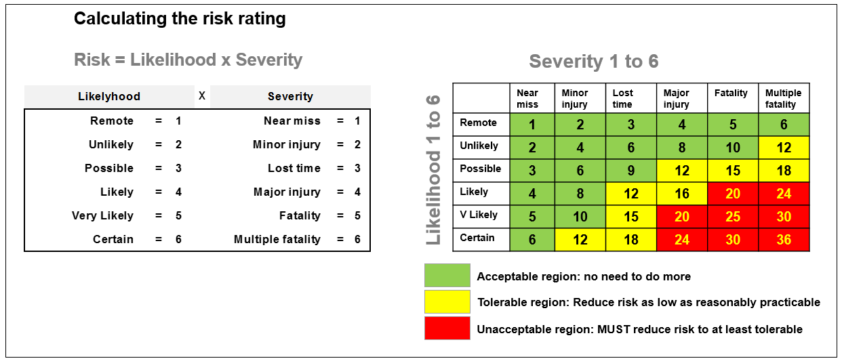

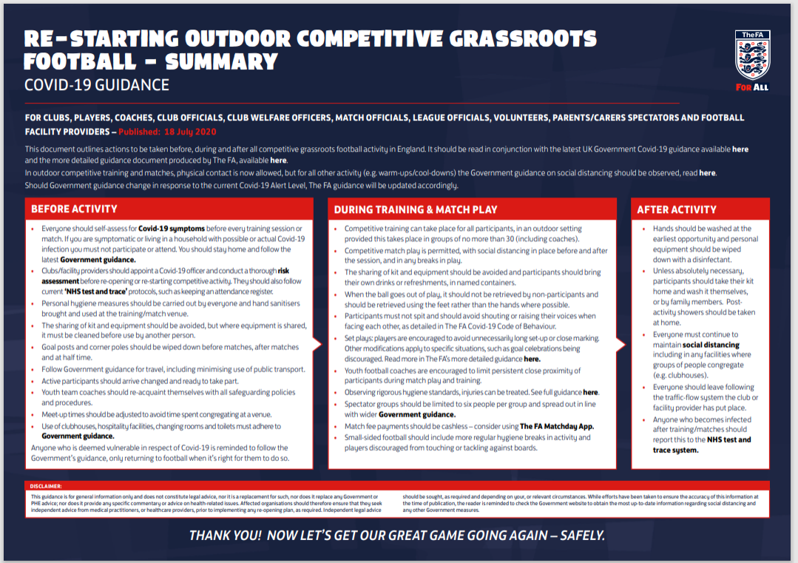
Appendix 1 from the “FA detailed Covid 19 guidance” pdf – this will be provided to managers as a laminated document.

