WFYFC – DBS Application on Whole Game System
How do I get started – Existing Coaches
Please have a look at this short video and guidance notes - you can begin your DBS registration yourself, or the club will do this on your behalf usually 2/3 months before renewal. An email will be generated either way with next steps.
How do I get started – New Coaches
You will need to be registered with WFYFC as a coach – this can be done through our Secretary – email secretary@whickhamfellsideyfc.co.uk A DBS request will be raised, and you will receive an email with next steps
What happens next?

- You will need to follow the instructions to provide documents for validation and link to the online portal which will be detailed in the email - YOU DO NOT NEED TO PAY
- Club will contact you to verify documents, (we will need to see originals) validate and pay the application
- WGS will be updated as status changes and DBS completes
- Any issues email welfare@whickhamfellsideyfc.co.uk

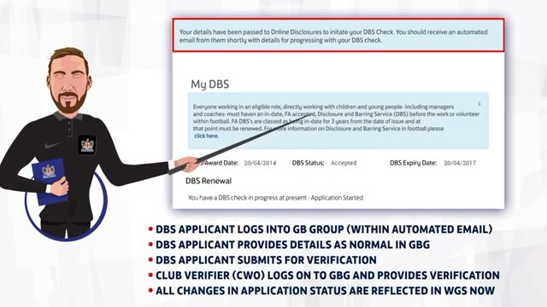



SIGN IN

