WFYFC Managers training and match Covid 19 checklist – July 2020

SELF-SCREENING CHECK LIST PRIOR TO EACH TRAINING SESSION OR MATCH – to be run through for each player

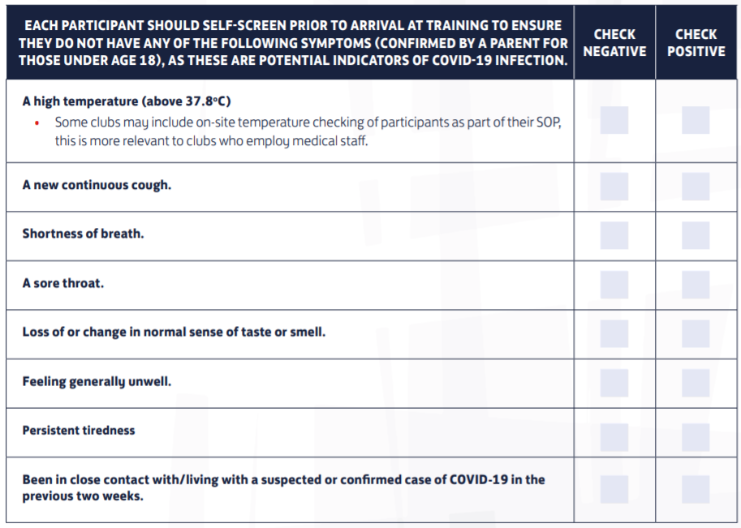

NHS Track and trace - Managers must support NHS test and trace efforts by collecting name and contact information on participants at both training and matches.
WFYFC Team name and manager name
Date and Location
Manager contact tel no and email address
Assistants attending

WFYFC Players in attendance - Name | Permission from Parent/carer to play - Signature | WFYFC Players in attendance - Name | Permission from Parent/carer to play - Signature

Away team name
Away team - manager name
Manager’s contact tel no. and email address

BEFORE THE GAME - Check list item – This will be the responsibility of the WFYFC home team manager | Completed – Please tick to confirm or NA. If unable to confirm or NA, game or training must not go ahead.
WFYFC club risk assessment most recent version read?
Self screening checklist completed?
Manager to brief their team on the expected FA Appendix 1 - Cov19 Code of behaviour?
Has the manager run through the expected FA Appendix 1 Cov19 Code of behaviour with the away manager?
Cabin lock sanitized before use?
Coaches equipment sanitized before use?
Club equipment e.g. goalposts and corner flag sanitized before use?
Bins have put out round pitch?
Respect barriers have been erected as appropriate for the pitch in use?
Spectators asked to stand in correct locations around the pitch?
Players personal equipment must be stored separately and not come in contact with other players equipment. This includes water bottles, training tops and boots.
Strong hand hygiene practices should be in place before and after – Managers / Assistants must have a supply of hand sanitizer.
Sanitiser and Hygiene pack from club available?
Difib code know to manager?
Defib machine accessible immediately – cabin door ajar for ease of access.

AFTER THE GAME - Check list item – This will be the responsibility of the WFYFC home team manager | Completed – tick
Managers must ensure their personal equipment is sanitized and washed.
Hands should be washed at the earliest opportunity.
Goals and flag posts must be wiped with sanitizer before the equipment is put away into cabin storage.
Litter is picked up from around the pitch.
Bins emptied with waste bags going to the Café bins.
New bin bags put in bins.
Cabin is locked.
Gates are locked.

WFYFC manager’s signature
Date of completion – document to be kept by manager (securely).

FA APPENDIX 1 CODE OF BEHAVIOUR
Covid-19 is a highly infectious and dangerous disease. A resumption of contact play is only achievable if those involved create and maintain a controlled environment that minimises the threat of infection.
Risk in sport cannot be completely eradicated but with caution and care these risks can be reduced.
Each player will need to decide when to return to contact football, based on their own circumstances and the arrangements that have been put in place for a safe return. This is particularly the case for players from BAME communities or those with underlying health conditions.
All those returning to competitive grassroots football must adopt the following code of behaviour:
• Be aware of your own personal health. If you show any of the Covid-19 symptoms you must stay at home, inform NHS Test and Trace and seek medical advice.
• Be responsible. Read the guidance provided by The FA and by your club so that you are aware of the changes to the game and what is expected of you. This will include things like being prepared to wash your own kit, bringing your own labelled water bottle and being aware of changes to meet-up times.
• Practice good hygiene. Wash your hands regularly and before, during and after a game.
• Where possible maintain social distancing. This will not always be possible in a competitive match environment (for example when tackling an opponent) and that is acceptable. However, before, and after a game you should maintain social distancing.
• Support NHS Test and Trace. You’re likely to be asked to provide your details so that in the event of a Covid-19 outbreak those potentially infected can be traced. This is to everyone’s benefit so please cooperate.
• Do not spit. Spitting and the rinsing out of mouths is now a recognised risk to health and must not be done. Avoid shouting or raising your voice if face to face with other players.
• After the game. Be aware that other users may be waiting to use the facilities. Changing rooms and showers are likely to be closed and any socialising must follow the Government’s guidance on social distancing.

