A VIDEO MARKETING GUIDE FOR MANUFACURERS, FABRICATORS AND OEMs

FORWARD
To achieve success your business must be an effective competitor. What you’re competing for is attention. In order to achieve your business’s important goals, it is necessary to draw and attract attention to what you do, to tell your story in order to engage your community. Also, with so many companies competing for resources it is imperative that your business make people aware of the real benefits you provide. In this document we outline how video content can help grow your business and achieve the marketing goals of your nonprofit to attract new customers, donors and volunteers, strengthen your connections and educate your community and help your community take action.

Tony Mazzarella  Owner, MazzMedia  800-583-1988  tony@mazz.com | Tony Mazzarella is an Emmy Award® winning writer and producer. He is the founder and president of MazzMedia, LLC, and Mazzarella Media, Inc, leading educational video production and video marketing companies.

TABLE OF CONTENTS

TRADITIONAL VS. ONLINE MARKETING 4
WHAT IS VIDEO CONTENT MARKETING? 7
VIDEO CONTENT MARKETING BY THE NUMBERS 8
UNDERSTANDING THE CUSTOMER’S JOURNEY 11
VIDEO CONTENT MARKETING STRATEGY 13
TACTICS AND PROMOTION 15
VIDEO CONTENT CREATION, DISTRIBUTION AND ANALYSIS 19
ANALYTICS AND REPORTING 21
WHAT ARE YOUR NEXT STEPS? 23

TRADITIONAL VS. ONLINE MARKETING
If you’re like most businesses you’ve tried traditional print and broadcast marketing and gotten little results. Why? The fact is that the way people consume media is changing and traditional forms of marketing aren’t as effective as they once were. In turn, people are spending more time on the internet and their mobile devices. (see chart below)

Kleiner Perkins Caufield & Byers
Only 23% of U.S. adults read a print newspaper regularly and radio and television engagement is constantly declining due to the rise of streaming and on-demand culture.
Even when we’re watching TV, we’re not completely engaged. (Statistica, 2018)

And it’s not just young people. It’s baby boomers, too.

You’ve probably discovered that sustaining an ongoing, online marketing campaign is cost-prohibitive, plus it’s difficult to measure the return on investment.
The strategy outlined in this document is affordable, effective and measurable. It’s called video content marketing and it allows you to:
- Consistently reach your community
- Increase traffic to your website.
- Provide tangible, almost direct response capabilities.
- Consistently advertise for volunteers and donors
- Track and measure your marketing efforts.
- Build an evergreen video asset library that can be reused again and again.

WHAT IS VIDEO CONTENT MARKETING?

Video content marketing involves the creation and sharing of video content online.
Video content marketing is not about you. It focuses on your customer and their needs.
Successful video content addresses the questions and problems you know your customers have and are online searching for answers to.
Video content is the most effective way to market your business to your community. It helps your business to:
- Stay top of mind
- Increase brand awareness
- Establish yourself as a trusted resource
- Build loyalty

Our philosophy is, if you’re not educating, you’re not marketing. Why? Because 80 percent of the questions that you get in the first meeting are the same set of questions every single time (average across all industries). So, it’s important to integrate video content into your marketing and promotional process.
The “They Ask, You Answer” content marketing formula is a proven way to make online video an effective marketing tool. Created by marketer Marcus Sheridan, “They Ask, You Answer” is based on the fact that when people have questions, they ask a search engine.
88% of all consumers research a product or service online before they ever contact a business.
If you are providing the answers, the right content strategy will get you to the top of the search results and seen by your community every day, all day.

VIDEO CONTENT MARKETING BY THE NUMBERS

Currently, online videos make up more than 74% of internet traffic.

In 2020, online videos make up more than 85% of all consumer internet traffic (in the US). Marketing research predicts that not having business videos online is paramount to a business not having a website.

A majority of marketers who use video online agree that video does influence engagement and sales.

Here are some recent statistics on the use of video on social media.
Facebook videos receive 135% more organic reach on average than a Facebook photo.
Social video generates 1200% more shares than text and image content combined.
Including video on landing pages can increase conversion rates by 80%.
Companies that use videos in their marketing have 27% higher clickthrough rate and 34%
higher conversion rates than those that don’t.
Using the word “video” in an email subject line was found to increase open rates by 19% and clickthrough rates by 65%.
Video ads have an average clickthrough rate of 1.84%, the highest of all digital ad formats.
Blog posts that incorporate video attract three times as many inbound links as blog posts without video.
On average, people spend 2.6x more time on pages with video than without.

In order for people to find you, you must be actively publishing and promoting content online. That means uploading new content to your website and posting to your social media platforms and channels.

THE BUYER’S JOURNEY
The buyer’s journey is a framework that acknowledges a customer's progression through a research and decision process ultimately culminating in becoming involved in your business.
In a nutshell, the customer’s journey is everything that someone would need to do before deciding whether or not to call you. Sixty-seven percent (67%) of the ‘decision’ is complete before a customer even reaches out to call you. When a question, problem, opportunity or need arises people begin to search for solutions. There are 4 stages of the customer’s journey.
CUSTOMER’S JOURNEY STAGE | DESCRIPTION
Awareness stage | This is beginning stage where people may learn about your business for the first time. Help them learn more about your business's mission by offering videos that are short and quickly illustrate your cause and what you do.
Consideration stage | Videos in the consideration phase should be informational and educational. The videos you choose to develop for the consideration stage need to be deeper than the awareness stage videos.
Decision stage | Your decision stage videos should show why your nonprofit has taken on its mission. At this point in your community ‘s journey, you want action. This is the stage where your videos should be very clear on what you want viewers to do.
Nurture stage | Community receives information to keep your business top of mind.

VIDEO CONTENT MARKETING STRATEGY
A video content marketing plan begins first and foremost with quality, relevant content.
Relevant content is defined as:

- Content that adds value to your business and its mission.
- Content a web user finds informative, engaging, helpful, or entertaining.

Quality content is king. If your content is boring and it doesn’t tap into the interests of your audience the strategy will fail. That’s why it’s so important to understand the psychology, emotions and behaviors at play at every stage of a customer’s journey. Know your customers’ personas.
Video is the best medium to tap into a viewer’s complex emotions. If the consumer is frustrated with a problem, cure that frustration by showing how you can solve the problem.
Emotions including fear, guilt, trust, value, belonging, competition, gratification, leadership, and inspiration can all inspire viewers to learn more about your business . Those emotions are the pillar upon which to create video content.
You need relevant content to provide answers to questions your community is looking for.
You also need to know where your community and prospective customers are consuming video.

TACTICS AND PROMOTION
It’s necessary to promote and employ a multi-platform video distribution strategy designed to give your business a strong online presence and maximize your exposure to your target audiences. A multi-platform video distribution strategy involves the use of the following online tactics:
STRATEGY | DESCRIPTION
Social media strategy | Social media strategy defines how your business will use social media to achieve its communications aims and the supporting platform and tools it will use to achieve this.
Search Engine Optimization (SEO) content strategy | SEO strategy is the process of organizing your website’s content by topic which helps search engines like Google understand a user’s intent when searching.
Influencer marketing strategy | Influencer marketing is a form of marketing in which focus is placed on influential people rather than the target market as a whole.
Video Email marketing | Video Email marketing is a way to reach consumers through direct electronic mail. The aim is to reach a targeted audience with content that might be useful for the recipient.

Social Media Strategy
Most marketers agree that you don’t have to be everywhere on the web, but you have to be somewhere. There are 260 million active users on Linkedin every month.

Linkedin

Linkedin is the #1 social network for lead generation. It’s important to note that 1/3 of all B2B marketers aren’t sure which social networks generate more leads. (Pew Research)

Search Engine Optimization
In 2020, the strategy of creating content around a specific keyword bucket will no longer exist. Today it’s all about producing content for searcher intent. Search engines can now interpret context so that content that answers a question and contains information about a topic rises to the top.
SEO is well beyond keywords and traditional ranking factors. It’s all about understanding the types of content the search engines deem relevant. In other words, SEO is all about providing quality, relevant content that educates, informs, and answers questions.
Having video content on your website will boost SEO. Video proves your content’s value to Google. Uploading the video’s transcript helps Google understand the relevancy of the video.
Adding videos specifically helps increase your search engine results page (SERP) rank in a couple of ways:
- Increases your click-through rates: Including video on your page drives a 157 percent increase in organic traffic from SERPs.
- Lowers your bounce rates: People spend over twice as long on a website with video than without.
88% of all consumers Google a product or service online before they ever contact a salesperson.

VIDEO CONTENT CREATION, DISTRIBUTION AND ANALYSIS
Producing video content and distributing the content through appropriate online channels and platforms will promote searchability and share ability.
By providing answers, video content strategy will get you to the top of the search results and engage viewers on social media platforms. Content marketing is not about selling, it is customer focused and its objective is to get found and consumed by your potential customers. Implementing a video content strategy and employing proven tactics will:
- Boost your web presence with proven methods
- Build a level of trust that generates customer evangelism
- Establish a relationship before you meet your customer, donor or volunteer
- Promote you as an industry leader and trusted resource
- Add more value to your business by improving awareness and nurturing prospects
To launch and maintain a successful video content marketing strategy that will grow your business it’s important to offer videos that are tailored to reach potential customers at the awareness, consideration and decision stage of the customer’s journey.
Your videos should also provide you the opportunity to personally introduce yourself and answer questions prospects typically have about the services your business offers and your mission. Include client, volunteer and donor testimonials that will reinforce a prospect’s decision to contact your business .
In addition to the video, it’s important to generate the following support and promotional content as well. This includes:

SUPPORT TEXT AND GRAPHIC CONTENT
Along with the video content, support text and graphic content is necessary to help people find your video content online. The support content includes:
Captioning
A majority of Facebook videos are watched without sound which is why captioning is so important. It’s also a simple way to get more views. Captioning equals more views which leads to hire rankings. Captions also tell search engines what is being said in the video and optimizes your message.
Video Transcriptions
Transcribe each video. Video transcripts will elevate your business ’s site SEO. Transcripts are a complete textual representation of the spoken content in a video. Search engines crawl text and use text for indexing purposes and a transcript enables search engines to understand video content on a deep level. Tests have shown that video transcripts lower bounce rates and match long form search queries. A visitor may not read a lot of text, but they’re more likely to find the video. For people who don’t want to sit and watch a video, a transcript allows them to consume the information.
Video Descriptions
Having a good description of your video helps people find your content. We provide brief descriptions to create interest and set the tone for the video content. The description includes links to your website, social media platforms, landing page, or another video. It ends with a strong call-to-action (CTA) that tells them what to do next and guide them to a desirable outcome.
Lead Capturing Landing Pages
A landing page is where a visitor “lands” after clicking on a link in your video content marketing campaign. Each page is centered around one objective, and one action for the viewer to take.
Blogs to with Link to Video
Some websites do not support the uploading of videos. In order to get the benefits of video content on your website, you need to create blogs with a link to the video to upload to your website.

DISTRIBUTION AND PROMOTION
You need to distribute and promote your content online. The video content is distributed to reach your different audiences. There are several ways to distribute the content:
Uploading Content

Upload your video and support content to your website and YouTube Channel. Uploading new content will help with search engine optimization (SEO).
Posting Content
Post video and support content to social media platforms.

ANALYTICS AND REPORTING

Video content marketing is a learn and test environment and measurement is important. Content marketing is not a short-term investment with quick returns, but a long-term investment that eventually will – if you produce high enough quality content and reach the right target group – generate safe returns. Video content marketing is a long-term investment for your business . That’s why it’s important to use metrics to help us determine which type of video content delvers real, measurable value.

Social Media
Social media metrics are data and statistics that give you insights into your social media marketing performance. It’s important to evaluate the effectiveness of your video content social media campaigns using key performance indicators.
KEY PERFORMANCE INDICATOR (KPI) | DESCRIPTION
Total Views (Reach) | The total number of people who saw your video(s).
Average completion percent | The average amount of time people watch. Audience retention reflects engagement.
Video Engagement | The number and types of engagement your videos receive (reactions, comments, shares).
Page growth | Follow the growth of your business ’s following
Social shares | The more shares, the better your audience loyalty.
Audience and top location | Indicates who most of the viewers are and where they’re from.

Website/ Google Analytics
The videos should also be uploaded to your business website, so it’s also important to measure website metrics. This should include total website visits which measures the effectiveness of your video content marketing campaigns. Key metrics to track include:
KEY WEBSITE METRICS TO TRACK
Traffic by individual channels: traffic sources include direct traffic (people who type your brand name directly in browsers), organic traffic (those arriving via search
Ratio of new versus returning traffic.
Time spent on your site.
Interactions per visit: track what people do on your site.
Bounce rate.

WHAT ARE YOUR NEXT STEPS?
Video content marketing works if you do it right and commit to it.
If you think it’s a process you can do in-house, you can use your cell phone to begin.
However, somebody in your business has got to own it. Begin with the “They Ask, You Answer” strategy and answer a few questions on camera. There are lots of online videos that can teach you tricks and techniques to improve your production
Come up with 20 to 30 questions every prospect asks you about your products or services. Record your answers. Get everyone in your business involved. Client testimonials are powerful and could be the key factor during the decision stage of the customer’s journey.
Distribute the videos online. Start off small, upload one or two videos a week to your website and the most appropriate social media platforms to reach your target demographic. Then, enhance or boost the post. Let your friends, employees, vendors and family know about it. Consistency is the key, so make a commitment to do at least one video per week.
You can also outsource the video production and manage the promotion and distribution in-house. Or, you can hire a company like MazzMedia to handle every phase of the process and execute your marketing strategy

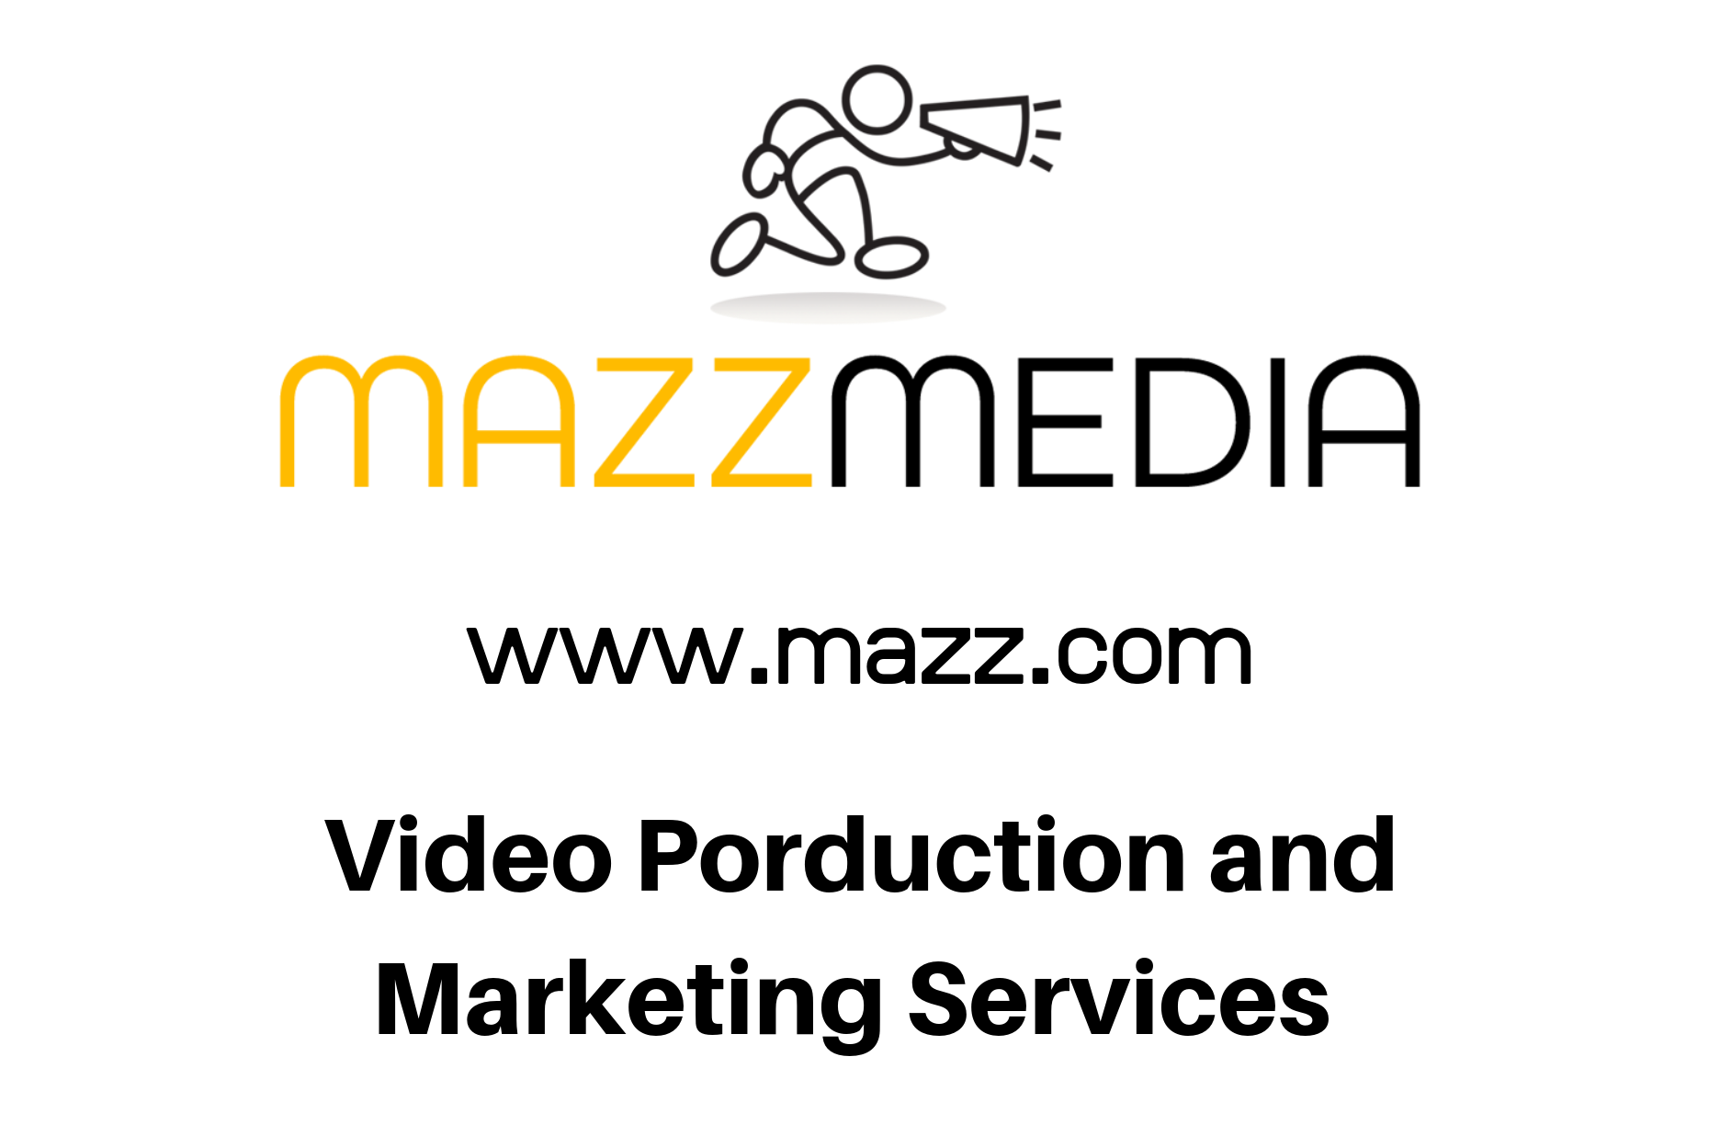
www.mazz.com
800.583.1988

