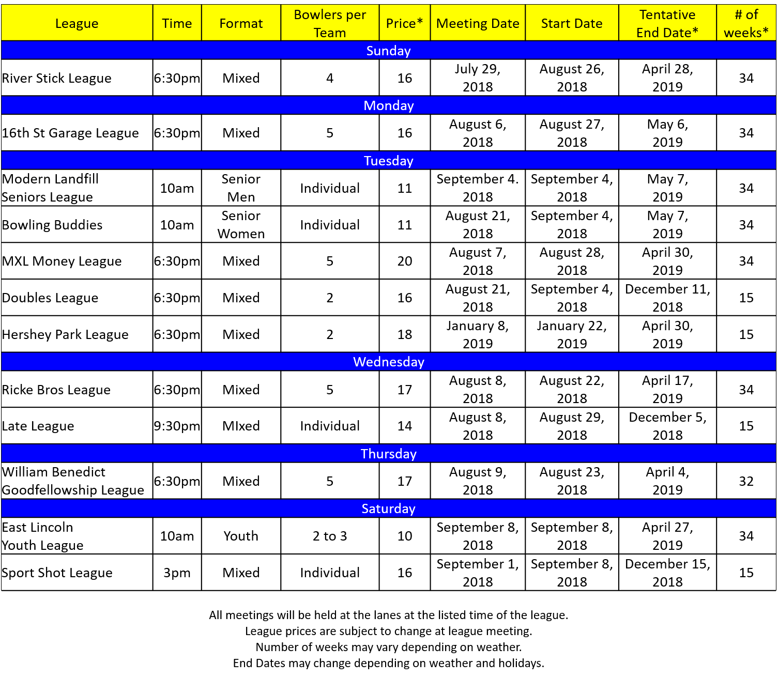

East Lincoln Lanes League Registration

Name: ___________________________ Phone: __________________

Address: _____________________________City: _________________

Zip: __________ Email Address: _______________________________

League: _______________________ Team: ______________________

Please Return to Front Counter

Before Meeting Date of League

Fall 2018-2019 Leagues