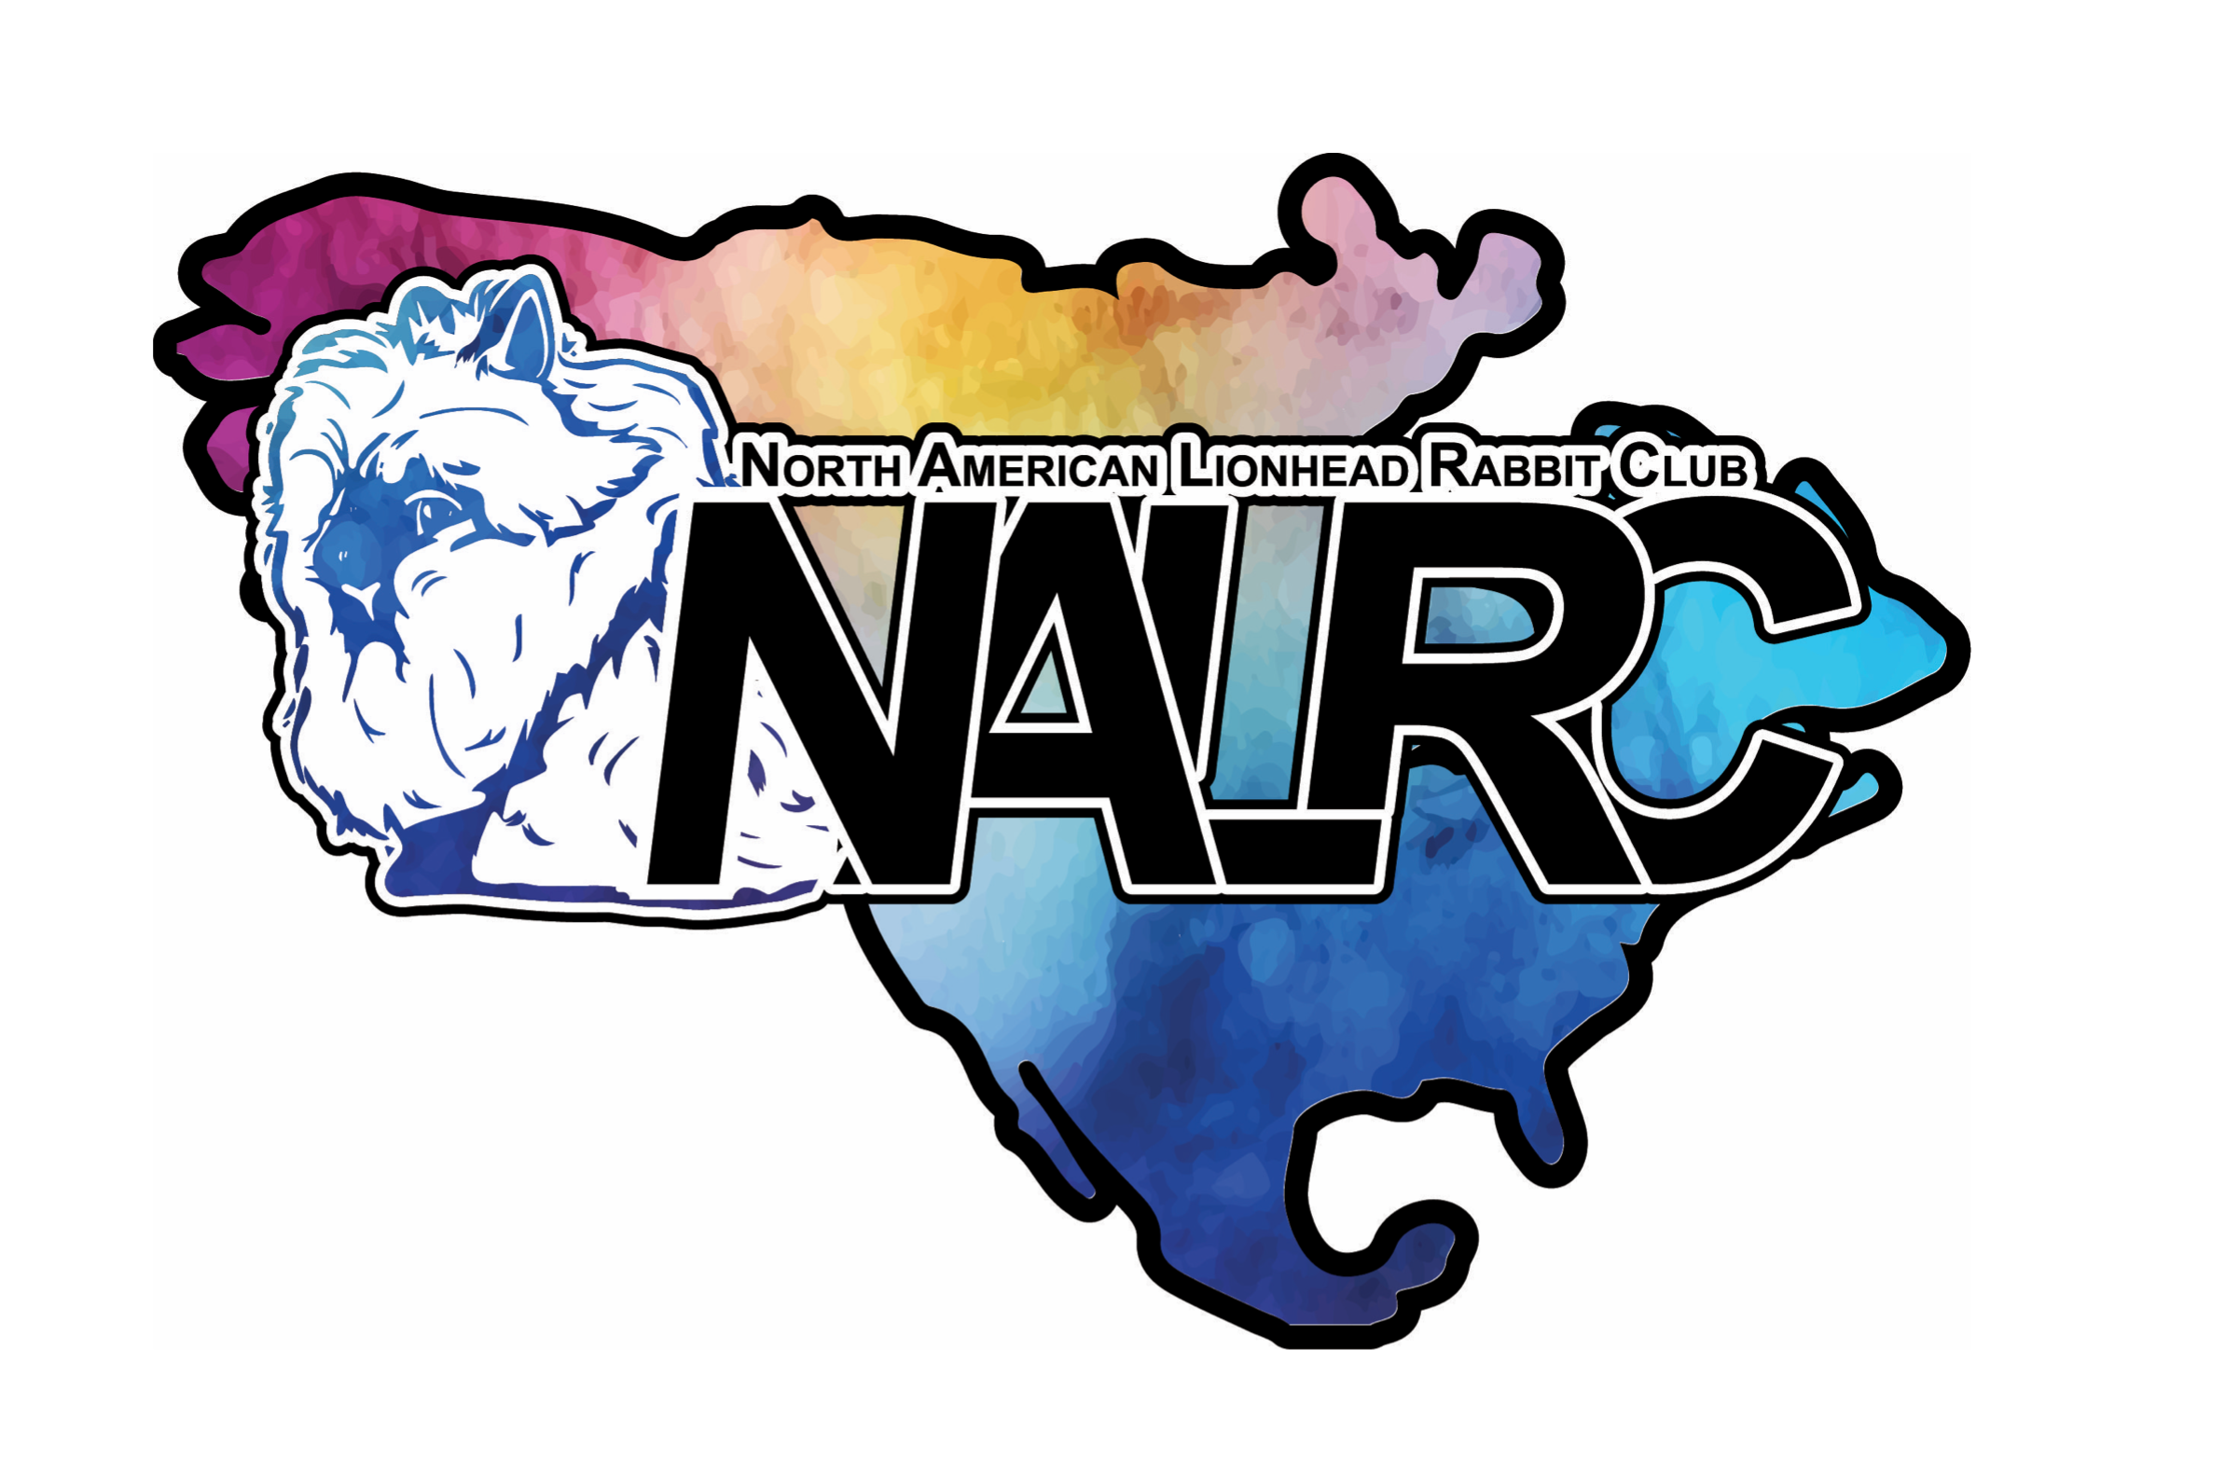

North American Lionhead Club

To whom it may concern,

Please excuse_______________________________________from school to attend the North American Lionhead club national show.

The national show will be held in Decatur, Illinois on April 6, 2024. This student will have the ability to compete at a national level and demonstrate a working knowledge of the rabbit industry. This youth will be practicing critical thinking skills, problem solving and management skills, as well as teamwork and goal-setting. These life skills enable youth members to thrive and succeed throughout their lives, within and outside of the rabbit hobby.

All students are encouraged to complete all academic assignments per your standards. They are also encouraged to prearrange such assignments prior to attending this national show and have their assignments completed prior to returning to school.

If you have any questions, please feel free to contact me at mainerabbiteersrba@gmail.com.

Thank you,

Amylynn McDevitt

NALRC Youth Chairmen