SIGN THIS PETITION NOW
TO SAVE OUR GREENBELT AND STOP ONE OF LARGEST SCOTLAND’S BATTERY STORAGE FACILITIES
-LDES/BESS AT BUSBY, MEIKLE DRIPPS, THORNTONHALL
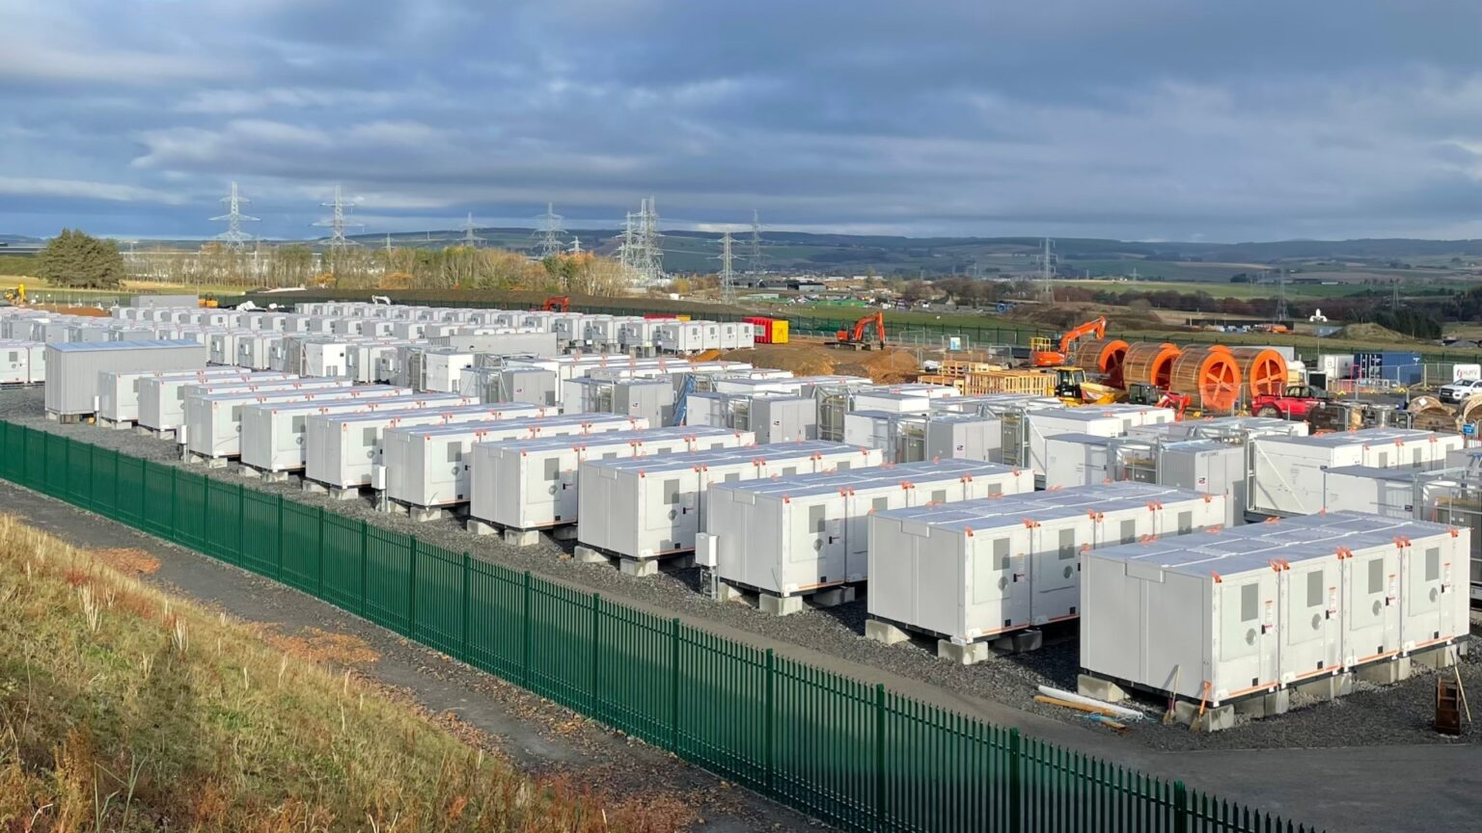
Our greenbelt is under threat from two development proposals for battery storage facilities located between Thorntonhall and Busby and with access from Waterfoot Road.
This massive project, is almost the size of 54 football pitches.
The BESS Local Action Group and the Jackton and Thorntonhall Community Council (JTCC) are fighting back against this development because of the dangers it poses — from fire risks and noise to environmental damage and traffic. We need YOUR help now. Stand with us to prevent this project from going ahead — before it’s too late.
Sign The Petition NOW –
Together, We Can STOP This Threat And Protect Our Homes, Land, And Safety for current and future generations. Tell your friends, neighbours and family to do the same.

Name:

Address:

Email:
Please download this document, save and email to bess@thorntonhallbess.com
We are looking for volunteers to help, if you can help with social media, marketing and raising awareness this would be super! We are also needing support from lawyers, journalists, wildlife and other experts.
We would like to keep you informed of the protest to stop LDES/BESS AT BUSBY, MEIKLE DRIPPS, THORNTONHALL. If you do not wish an occasional email then please email to above address stating you wish to opt out.
www.bessbusbythorntonhall.com
Why we need to oppose the Battery Storage Development
If either of these developments goes ahead, the attractive, natural rural landscape will be lost and industrialised. Instead of a peaceful village, Thorntonhall will become known for battery storage and the LDES will be Scotland’s largest industrial energy compound. There would be a negative impact on nearby residents (sight, sound, safety, disruption), and on the natural environment and biodiversity. The greenbelt is identified in planning policy, namely the Local Plan (SLLDP2) and its function is primarily for agriculture, forestry, recreation and other uses appropriate to the countryside.
The core footpath, currently ‘a green corridor’ with ancient hedges, will be replaced by a tarmac road for HGVs. Other ancient hedges will be replaced by security fencing. New planting is considered by us to be superficial.
We strongly believe that there are more suitable alternative sites that should be used for these battery storage infrastructures, like brownfield, industrial, commercial and energy parks/windfarm sites.
Being electrical infrastructure, the planning applications for these are decided by the Scottish Government ECU (Energy Consents Unit) and when these applications ‘go live’ then there will be 28 days for everyone who is concerned to submit written objections (see our links to help with this). These individual letters will be as important (and probably more important) as signing this petition. We need as many people as possible to voice their concerns in these ways. It is only by the weight of numbers, that we can influence the decision-makers at ECU.
Prior to the planning application, this type of major proposal requires a ‘Screening Opinion’ where the ECU receives recommendations from the relevant Local Authority (South Lanarkshire Council - SLC). This has been completed for both proposals.
The first development proposal (called Meikle Dripps) is a 150MW BESS on 11.4 acres which is equivalent to 7 football pitches. This facility would store approximately 2 hours of energy for export back to the national grid. This proposal involves lithium batteries (at an industrial scale) which are known to be a toxic fire risk and which need to be kept air conditioned which adds to the electrical noise emitted from the site. The ECU reference for this is 00005045 and the SLC reference is P/24/0179.
The second development proposal (called Busby) is a 150MW LDES on 86 acres (54 football pitches. This facility would store approximately 8 hours of energy for export back to the grid and would likely be more profitable. LDES are the very latest technology with just one plant in the UK (OFGEM will take a view on what goes ahead.) At this stage there is no detail about the type of battery etc, however they all have risks of leakage, pollution and fire and the infrastructure is noise emitting. The ECU reference is ECU00006198 and the SLC reference is P/25/0765.
Both BESS and LDES proposals involve the following industrial features: perimeter security fencing, lighting and camera poles, lorry size metal containers sitting on concrete plinths (approx 120 for the BESS), containers may be stacked two high (LDES), site substation, transformers, air conditioning units (for the BESS), roads within the site, parking, site office and water tanks. The sites will also be excavated, levelled and filled with stone for drainage before the concrete plinths are introduced for the battery containers.
If either of these developments goes ahead, the attractive, natural rural landscape will be lost and industrialised. Instead of a peaceful village, Thorntonhall will become known for battery storage and the LDES will be Scotland’s largest industrial energy compound. There would be a negative impact on nearby residents (sight, sound, safety, disruption), and on the natural environment and biodiversity. The greenbelt is identified in planning policy, namely the Local Plan (SLLDP2) and its function is primarily for agriculture, forestry, recreation and other uses appropriate to the countryside.
The core footpath, currently ‘a green corridor’ with ancient hedges, will be replaced by a tarmac road for HGVs. Other ancient hedges will be replaced by security fencing. New planting is considered by us to be superficial.
We strongly believe that there are more suitable alternative sites that should be used for these battery storage infrastructures, like brownfield, industrial, commercial and energy parks/windfarm sites.
Being electrical infrastructure, the planning applications for these are decided by the Scottish Government ECU (Energy Consents Unit) and when these applications ‘go live’ then there will be 28 days for everyone who is concerned to submit written objections (see our links to help with this). These individual letters will be as important (and probably more important) as signing this petition. We need as many people as possible to voice their concerns in these ways. It is only by the weight of numbers, that we can influence the decision-makers at ECU.
Prior to the planning application, this type of major proposal requires a ‘Screening Opinion’ where the ECU receives recommendations from the relevant Local Authority (South Lanarkshire Council - SLC). This has been completed for both proposals.
The first development proposal (called Meikle Dripps) is a 150MW BESS on 11.4 acres which is equivalent to 7 football pitches. This facility would store approximately 2 hours of energy for export back to the national grid. This proposal involves lithium batteries (at an industrial scale) which are known to be a toxic fire risk and which need to be kept air conditioned which adds to the electrical noise emitted from the site. The ECU reference for this is 00005045 and the SLC reference is P/24/0179.
The second development proposal (called Busby) is a 150MW LDES on 86 acres (54 football pitches. This facility would store approximately 8 hours of energy for export back to the grid and would likely be more profitable. LDES are the very latest technology with just one plant in the UK (OFGEM will take a view on what goes ahead.) At this stage there is no detail about the type of battery etc, however they all have risks of leakage, pollution and fire and the infrastructure is noise emitting. The ECU reference is ECU00006198 and the SLC reference is P/25/0765.
Both BESS and LDES proposals involve the following industrial features: perimeter security fencing, lighting and camera poles, lorry size metal containers sitting on concrete plinths (approx 120 for the BESS), containers may be stacked two high (LDES), site substation, transformers, air conditioning units (for the BESS), roads within the site, parking, site office and water tanks. The sites will also be excavated, levelled and filled with stone for drainage before the concrete plinths are introduced for the battery containers.

JOIN US! Please sign the petition and tell your friends, neighbours and family to do the same.
Join us in our effort to protect our greenbelt for current and future generations.

www.bessbusbythorntonhall.com

