

**BROAD STREET WARD CLUB**

**President Alderman Professor Michael Mainelli Chairman Richard Muir Deputy Chairman Dr Barry Laden MBE**

**Honorary Treasurer Lizette May**

**Honorary Secretary Christine Cook**

**77 Seaview Road, Brightlingsea, CO7 0PR 07775 986987**

[**secretary@broadstreetwardclub.org**](mailto:secretary@broadstreetwardclub.org)[**www.broadstreetwardclub.org**](http://www.broadstreetwardclub.org)

[**https://www.linkedin.com/company/broad-street-ward-club**](https://www.linkedin.com/company/broad-street-ward-club)

With over 370 members and a more than a dozen events per year, Broad Street Ward Club is one of the largest and most active of the City’s 25 Ward Clubs. The history of the Ward can be traced to 1278 when its first Alderman, William Bukerel, assumed office. His name lives on in Bucklersbury, the thoroughfare which connects Cheapside to Walbrook to this day. There has been an unbroken record of Aldermen for the Ward since that first day in 1278.

Exactly when Broad Street became the undisputed name for the Ward is uncertain, as there were references in 1293 and 1308 respectively to “Bradestreete” and to “Broad Street and Lothbury”. With Broad Street always being more important than Lothbury as a thoroughfare, it can he safely assumed that the change took place many centuries ago. One famous Alderman of the Ward was Richard Whytyngdone who took office in 1393 but, unfortunately for Broad Street, on election to Lord Mayor in 1398 Dick Whittington promptly transferred his allegiance to Lime Street Ward.

The Broad Street Ward Club was very active in the 18th century, with an active Volunteer Force in 1797. However, the Club fell into abeyance by the 1950’s, being reinvigorated in 1976 by the then Lord Mayor Sir Hugh Wontner – “To foster interest in and support for the welfare and traditions of the City of London and the Ward of Broad Street by means of social functions and such other activities as may be thought desirable.”

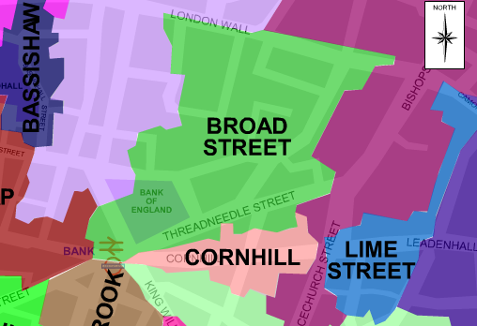The Club is very well-known for its sociability and also works closely with the Civic teams and the Corporation of London to further both of their aims

Its events over the past years have included private visits to the Speaker’s Apartments at the House of Commons, speciality tours of the House of Lords and of the Supreme Court and of many of the historic landmarks of the City itself, including being able to raise Tower Bridge! Speciality lectures, visits to historic buildings and viewing private collections are a regular feature of its annual programme, as are Civic events and an Annual Civic Lunch to mark the installation of the new Lord Mayor. The Club has a very strong association with the Civic Team, led by Alderman Professor Michael Mainelli (who is also the Club’s President) & Deputy Christopher Hayward CC alongside Shahnan Bakth CC and Antony Manchester CC, who are ex officio members of the Club Committee and all are keen and involved supporters of the Club’s work and activities. Historically, the Ward has been associated with the great Wren church of St Margaret Lothbury, whose Rector is the Honorary Chaplain of the Club, and an annual evening Summer Party is held in its Garden.

There are six livery companies in the Ward – Carpenters, Clockmakers, Drapers, Furniture Makers, Arts Scholars and Plumbers - and also the Company of Entrepreneurs and the Guild of Freemen of the City of London - all of which are enthusiastic corporate supporters of the Ward Club, along with the International Bankers who have moved away from the Ward but remain members.

Corporate membership is open to organisations with current or past associations with the Ward and costs £125 per annum, with a nominal £5.00 joining fee. This membership enables any five members of the corporate body to take part in all Ward activities.

**Application**

We are interested in becoming corporate members of Broad Street Ward Club and undertake to pay the entrance fee of £5.00 and to arrange a standing order to pay the annual subscription of £125.00. If we become members other than at the beginning of the membership year (January 01 annually), we will cover the initial payments by Bank Transfer.

Date ____________ Signed ___________________________________

**BLOCK LETTERS please**

|  |  |
| --- | --- |
| **Company Name** |  |
| **Address 1** |  |
| **Address 2** |  |
| **Address 3** |  |
| **Contact Name** |  |
| **Mobile number** |  |
| **Position** |  |
| **Business number** |  |
| **Email address** |  |

**PLEASE RETURN YOUR APPLICATION TO** [**SECRETARY@BROADSTREETWARDCLUB.ORG**](mailto:SECRETARY@BROADSTREETWARDCLUB.ORG)