Strava Beacon

Meg
Updated March 18, 2024 13:24
Follow

You can use Strava Beacon when recording with the Strava mobile app to share your real-time location with your family and friends.
- Setting up Beacon
- How it works
- Recipient View
- FAQs

Setting up Beacon
- Select Record from the bottom navigation menu.
- Either tap the Beacon icon highlighted below or select the gear icon in the upper right-hand corner and Beacon on the next page.
- Toggle Beacon to ON.
- Tap Add Safety Contacts and follow the prompts to allow Strava to access your contacts. You'll then be able to select up to three safety contacts. You can skip this step if you do not wish to allow access to your contacts.
- Save your changes then click Send Beacon Text from the record screen to send the pre-formatted text message to your safety contacts. You can choose to edit the text before you send the message if you would like.
- Start your recording and your safety contacts will be able to view your location in real-time.
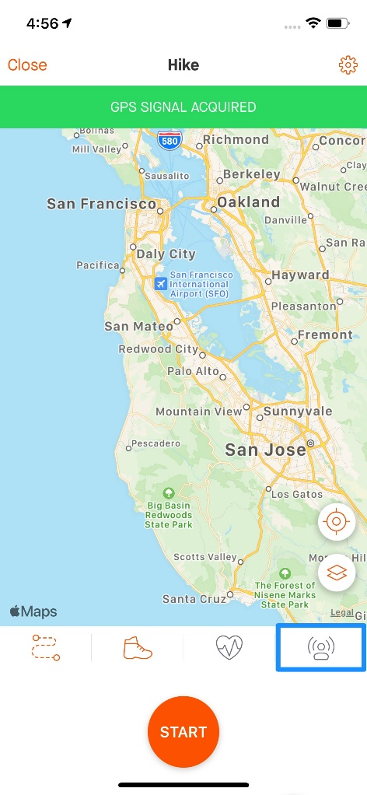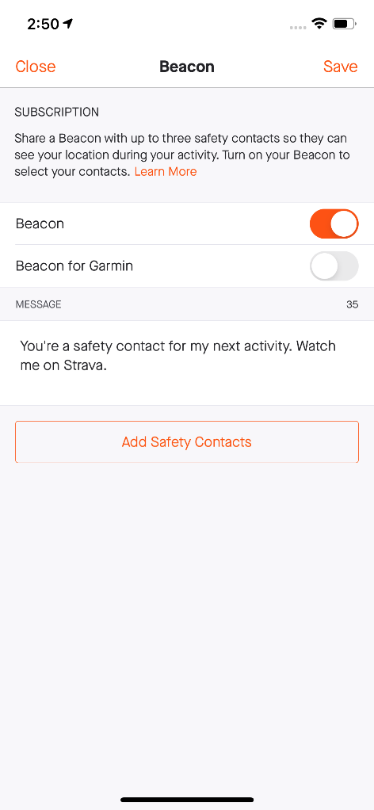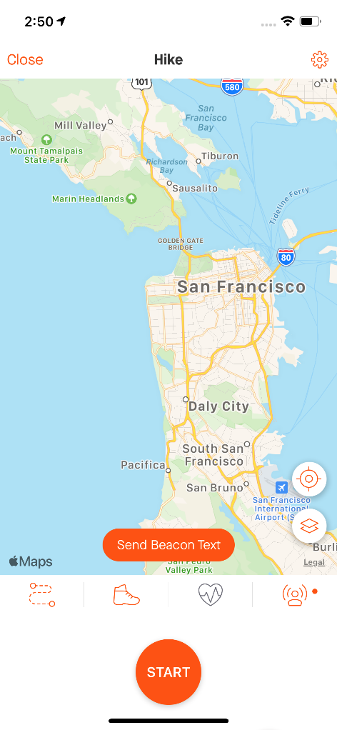

How it works
- Beacon generates a unique URL that you can share with your safety contacts via text message, allowing them to follow your activity in real-time.
- Depending on cell service, your location should update about every 15 seconds.
- Once Beacon is toggled ON, it will continue to remain ON but will prompt you to send a text message with every new recording.
- Even if Beacon is set to ON, your contacts will only receive your location if you send them the generated text message.
- The safety contacts you initially selected will continue to remain selected until you change them.
- You can choose to send a text message at any time during your recording by clicking on the Beacon icon and then sending another text message.
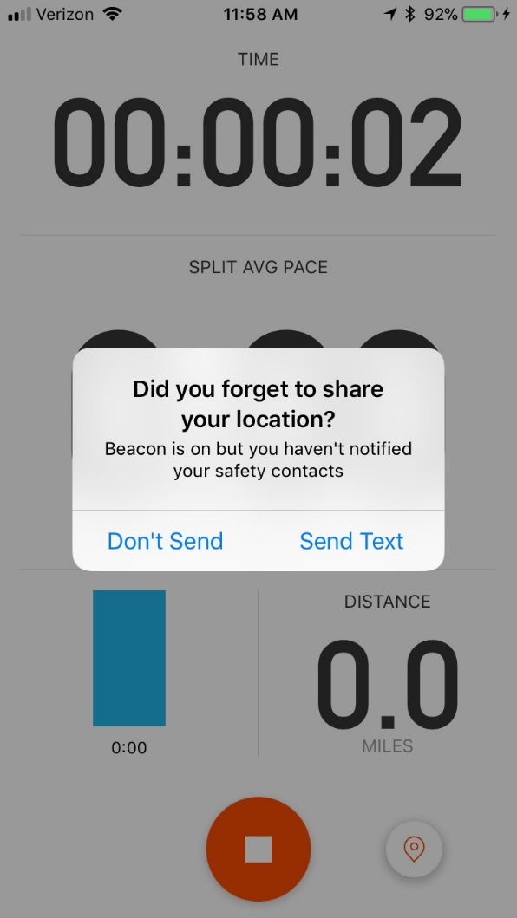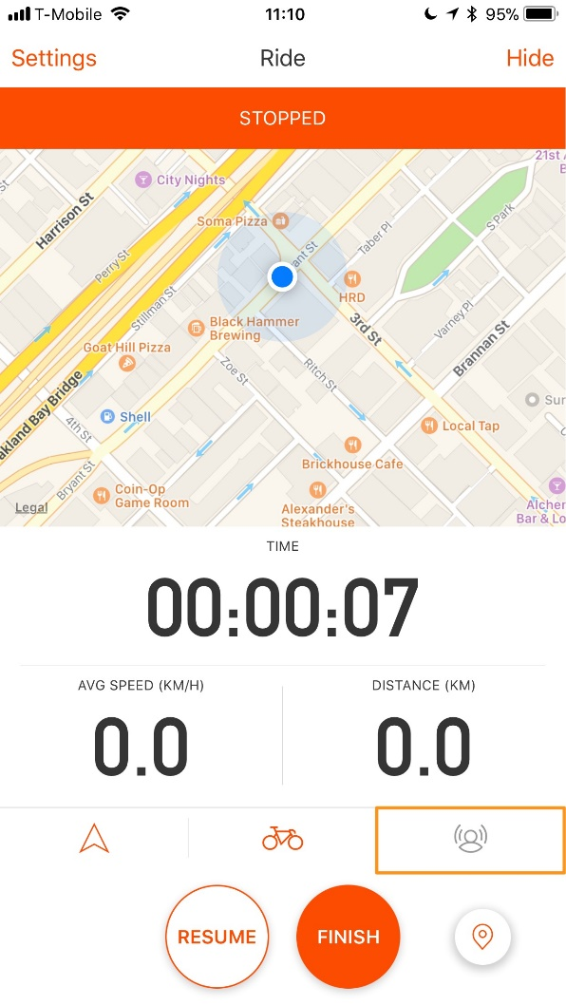

Beacon recipient view
- Your safety contact will receive a text message with a link to view your activity in real-time through their mobile browser.
- They will be able to see your current location, your past location, and where you started recording.
- The page will display your recording status and the last time this status was updated.
- They can click the down arrow to expand the view and see the activity start time, time active, and remaining battery percentage.
- Once the activity has been saved and uploaded, your contact will see a page that shows your finished activity.

FAQs

