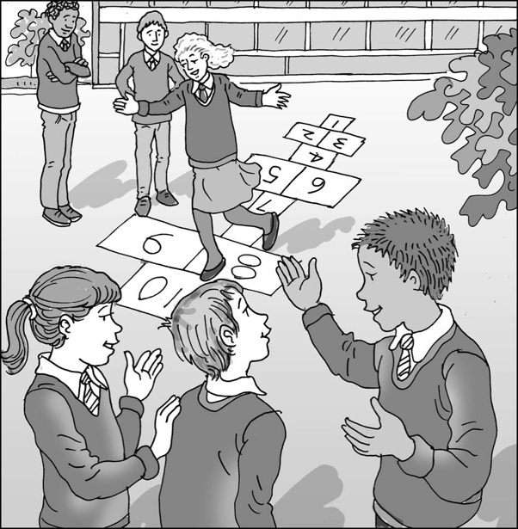

Joining in with others at playtime

My name is .

I am in class.

At playtime we all go out to play. I like   
playtimes because I get to run around.

Sometimes I just want to be on my own. This is okay.

Sometimes I want to play with other children. This is okay.

When I am playing with other children, I want to be in charge of the game and have everyone do as I say. This is bossy.

Sometimes children push and shout at each other. When children argue, no one has any fun and everyone gets upset.

We like to play some great games in our playground. Some good games ideas are:

|  |
| --- |
|  |

It is important that all the children listen to each other and let others take a turn in the game or activity. This is being fair and playing nicely.

The teachers on duty are there to help everyone to share and play nicely. My teachers will help me by reminding me of some games that are good to play. We can choose one before we go outside. This is great.

**11**

I can tell my teacher if I want to be on my own or play with others. This is good.

When I am playing with others, I can try to listen to my friends and follow the rules and they will try to do that too. This is playing fair.

When we all play nicely, we have lots of fun. I like to have fun at playtimes and so do the other children. We can have a great playtime.

# Brilliant!