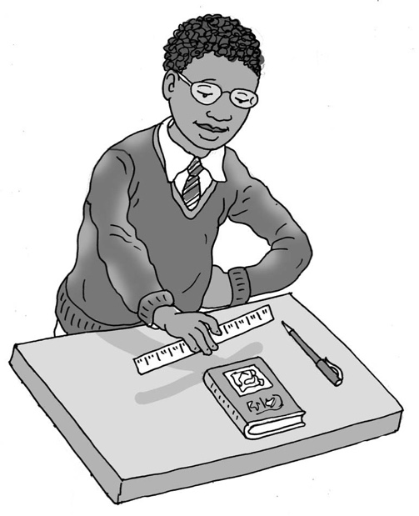

Being organised

My name is .

I am in class.

In my class we do lots of lessons. We need our own equipment, like the right book, a pencil, colouring pencils, a ruler and sometimes a rubber too.

Usually my teacher wants all the children, including me,   
to get their own equipment.

Being organised means that you can get all your equipment on your own and be ready to do your work. This is good.

I can try to get my equipment from my *tray/box/shelf* before my teacher starts the lesson. My teacher has helped me by putting all I might need in a *special box/clear pencil case*. This is helpful because I can see what is in there.

I can look at my list to help me know what I need.

If my pencil needs sharpening, I can ask my teacher if I can sharpen it or use one of the spare ones in the middle of the table. It is good if I do this quickly and quietly.

Brilliant. I can be organised in time to do my lesson.

# Well done me!

**17**