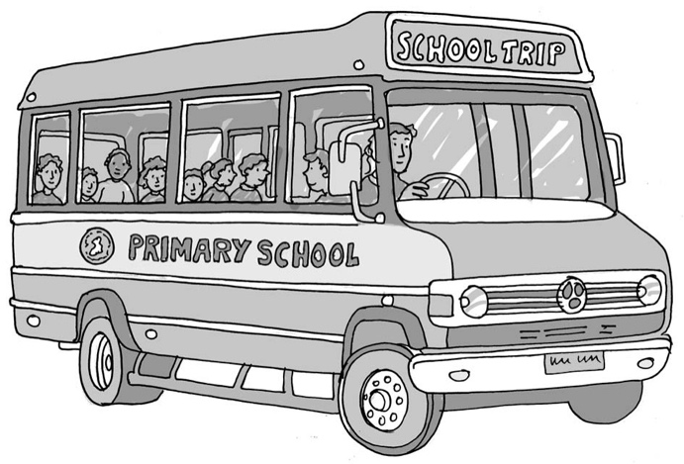Going on   
a school trip

My name is .

I am in class.

We can go out of school to visit a place that helps us learn   
more about our topic. This is good.

We have been learning about . Our trip is a visit

to .

Some children feel very nervous about going to a new place. This is okay. My teachers understand that it is a new place with unfamiliar people, different smells, different noises and new things to see and do.

We can learn about the place from pictures and the website so it seems less scary.

My teacher will help me look at the place on the computer. We will print some pictures off and put them with the pictures of the place my teacher took because *she/he* has visited it before.

We can find out all the things I want to know about the place.

My teacher will make me a visual timetable with the schedule of the day on it, including   
when we will come home.

I can take my *sensory items/special toy*, and my visual timetable will be on a keyring   
I can attach to my *belt/loop* and look at whenever I need to.

I can choose my own seat on the bus before we go. I can choose *who will sit next to*

*me/to sit in my own*. It will take about (*time*) to get there.

**34**

Here is some other information I want to know about the place and our day.

|  |
| --- |
|  |

## I can go on my school trip and it could be a good day. Brilliant.

# Well done me!