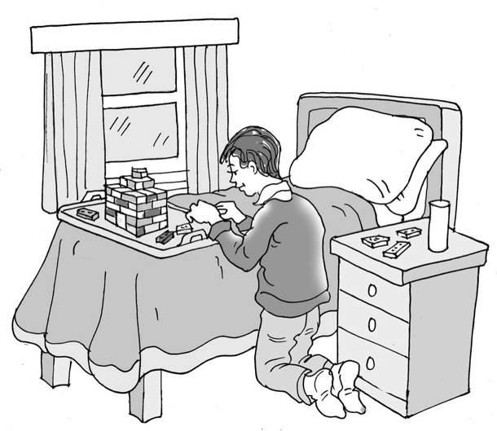

Having a rest   
when I get home from school

My name is .

I am in class.

Being at school all day is a lot of hard work. We have to sit and listen, do writing, maths and make things. We go to assembly and play outside. Being at school is   
very busy.

Being at school can be like having a bottle of fizzy pop. Each time we do something busy it’s like giving the bottle a shake. But if we keep the lid on, the fizzy pop doesn’t come out.

I try very hard to be good at school, but each thing I have to do can make me more and more tired. It can be like shaking the fizzy pop bottle up and trying to keep the lid on. I can feel more and more tired, frustrated and overwhelmed and keeping the lid on makes it worse inside.

It is hard because my teachers might not realise I’m feeling so overwhelmed.

When I get home after school, it is like taking the lid off the fizzy pop bottle. All the shaken up fizziness gushes out everywhere. It can look like I’m having a tantrum or being angry for no reason. I know I can’t help it. This is okay.

It is important that I am able to have some time to rest or do sensory activities that help me *feel better/give me a break* from all the overload.

My teachers can help me by giving me time to do some of these at school. We can make a plan to decide what the best activities and times to do them will be.

My parents can help me by giving me time to rest or do my own activities when I come home from school. They will try not to talk to me about the school day or talk to me about too many other things. We can make a plan and choose activities that we know will help me feel better and calm down from the busyness in my brain and body.

**44**

It might help if I try a visual timetable or a written list of what will be happening after school. I can try it to see if it helps. I will then know when teatime will be, if we are going out and what time bedtime will be. This is good and helpful.

Having a rest when I get home from school should be good.

# Brilliant!