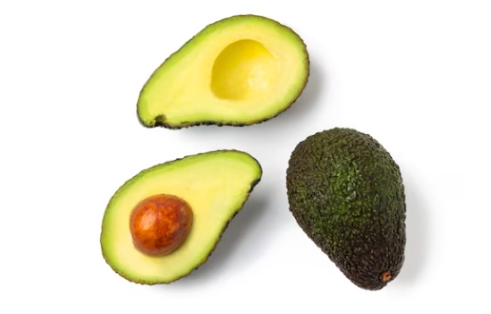

Avocados are fruits with a unique appearance, typically pear-shaped and ranging in size from small to large. They have a rough, dark green or black outer skin that becomes slightly softer as the fruit ripens. When cut open, avocados reveal a creamy, light green or yellow flesh surrounding a large central seed. This flesh has a smooth, buttery texture and a mild, nutty flavor. Avocados are rich in healthy fats, particularly monounsaturated fats, as well as vitamins and minerals such as potassium, vitamin K, vitamin E, and folate. They are a versatile ingredient used in various dishes, including salads, sandwiches, dips (such as guacamole), smoothies, and as a topping for toast or eggs.
Avocados are packed with essential nutrients that contribute to overall health and well-being. Here are some key nutrients found in avocados:
- Healthy Fats: Avocados are rich in monounsaturated fats, particularly oleic acid, which is beneficial for heart health. These healthy fats help reduce LDL (bad) cholesterol levels and may lower the risk of heart disease.
- Fiber: Avocados are a good source of dietary fiber, which aids digestion, promotes satiety, and helps regulate blood sugar levels. Fiber also supports a healthy gut microbiome.
- Potassium: Avocados contain more potassium per ounce than bananas. Potassium is essential for maintaining healthy blood pressure levels, proper muscle function, and electrolyte balance.
- Vitamins: Avocados are loaded with vitamins, including:
  - Vitamin K: Important for blood clotting and bone health.
  - Vitamin E: An antioxidant that helps protect cells from damage caused by free radicals.
  - Vitamin C: Contributes to immune function and collagen production.
  - B Vitamins (B6, folate): Support metabolism, brain health, and red blood cell formation.
- Minerals: Avocados provide various minerals necessary for bodily functions, such as magnesium, manganese, copper, and iron.
- Antioxidants: Avocados contain antioxidants like lutein and zeaxanthin, which are beneficial for eye health and may reduce the risk of age-related macular degeneration.
Including avocados in your diet can contribute to overall health and provide a range of essential nutrients that support various bodily functions.

