**Screening Tool for COVID 19**

1. Are you sick with a cold/flu or are you displaying any signs of COVID-19 and/or flu like symptoms?
2. Do you have any of the following symptoms which are new or worsened if associated with allergies chronic or pre-existing conditions: fever, cough, shortness of breath, difficulty breathing, sore throat, and/or runny nose?
3. Have you returned from outside the country in the past 14 days?
4. In the past 14 days did you have close contact with someone who has a probably or confirmed case of COVID-19?
5. In the past 14 days have you been directed by Public Health to self-isolate?

If you (or your child) have answered yes to any of the above questions please do not enter Biggar School of Dance Studio and let the teacher know your child will not be attending class.



**Biggar School of Dance Studio Safety Plan**

Sanitize your hands when entering the entrance of the studio. If you are moving between rooms once in the studio please sanitize each time you enter a new area.



Staff will be sanitizing all equipment and hard surfaces between classes.

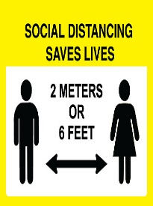

Students will be required to adhere to all social distancing guidelines.

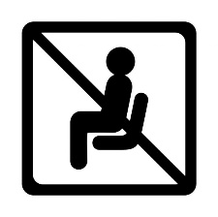Whenever possible, students should be picked up between classes instead of them staying at the studio.

We ask that parents do not enter the studio unless dropping payment off when class fees are due. Exception is for creative dance (3 & 4 year olds). Parents are permitted for these ages. If a dancer is older and feels anxious about entering the studio we understand and parents will be permitted, but it is best if they can work their way to having parents drop them off at doors.



If you are feeling unwell please do not attend your classes. Sick persons may be sent home immediately.



All students are required to bring their own water bottle to class.

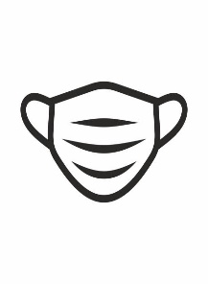

Masks are encouraged for those entering the facility, but it has been recommended that students do not wear a mask during class.

**\*Most importantly… please be patient with teachers and the Board as we work through this. We are learning as we go and trying to adapt the best we can. If you have any questions, comments, or concerns please email** [**biggarschoolofdance@gmail.com**](mailto:biggarschoolofdance@gmail.com) **so that the Board can address these.**