GRANDEUR FARM RETREAT- BREAKFAST CHOICES
Start your day with a breakfast of your choice (adaptable to dietary restrictions)
Grandeur Horses Recommend:  Vision of Grandeur loves Breakfast To-Go (Egg/ meat/ cheese/ toast sandwich with fruit)*  Timeless Grandeur loves Waffles (with side of meat)*  Teddy’s Grandeur (Bubba) loves Breakfast Bowl (hash browns, meat, egg, cheese-may be to-go cup)*  Sweet Heart Grandeur loves Quiche (meat, bell pepper, mushroom, onion, eggs, cheese, cream)*  Spirit of Grandeur loves Breakfast Burritos (sausage, cheese, eggs, salsa, tortillas)*  Savage Grandeur loves Biscuits and Gravy (spicy sausage gravy, eggs, biscuits)*  Que Se Ra Grandeur loves South of the Border Baked Eggs in Avocado (with side of meat, toast)*  Nature’s Grandeur loves Baked Eggs in Tomatoes (stewed tomatoes, side of meat, toast)*  Moment of Grandeur loves Pancakes (with eggs, side of meat)*  Julianna Grandeur loves Breakfast Casserole(sausage, hashbrowns, onion, bell pepper, cheese, eggs, mushroom soup, sour cream)*  Classic Grandeur loves French Toast (with side of meat)*  Americus Grandeur loves Everyday Southern (eggs, cheese grits/or hashbrowns, meat, toast)*  *All include choice of yogurt or cup of fresh fruit; recipes courtesy of Leslie Kirsch |  | 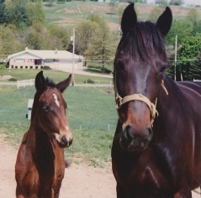  Timeless Grandeur with dam Vision of Grandeur
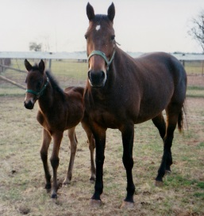
Spirit of Grandeur with dam Classic Grandeur
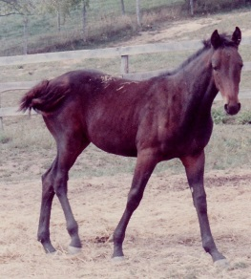
Savage Grandeur

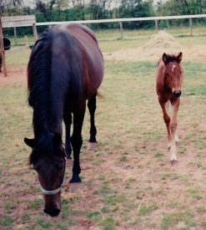
Julianna Grandeur with dam Moment of Grandeur
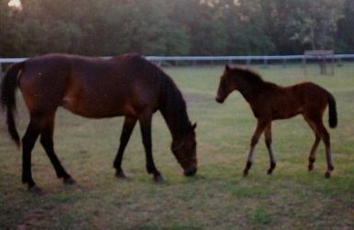  Americus Grandeur with dam Moment of Grandeur | 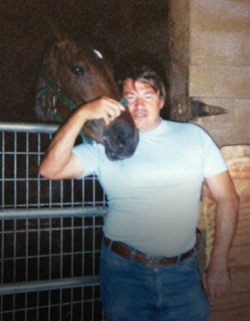  Teddy’s Grandeur with Jerry | 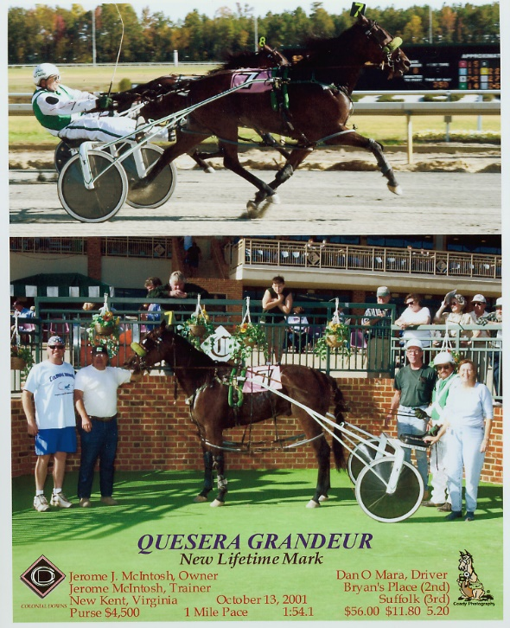  Que Se Ra Grandeur

