MJS Legal Services
____________________________

Reply to: Jane Scharf.
mjslegalservices@outlook.com
\

Commissioner Brenda Lucki
Royal Canadian Mounted Police
National Headquarters Building
73 Leikin Drive
Ottawa, Ontario K1A 0R2

August 17, 2021
Dear Commissioner Lucki: RE: Emergency Measures Act

Please find attached a letter I wrote requesting a police investigation July 26, 2021. You will note that may letter has the 1976 Ontario Emergency Measures Act attached for consideration in the request for criminal investigation that I am making.

You will also find attached unsigned an email that appears to be from the Attorney Generals Office denying the existence of the Ontario Emergency Measures Act

I am requesting your assistance to get the bottom for this matter of active legislation being removed from all official government records and internet sources. This is a very serious matter because this is the legislation that was suppose to be used for declaring an emergency. The Emergency Management and Civil Protection Act was passed for making plans to deal with a emergency after it was declared under the Emergency Measures Act.

In the Emergency Measures Act they are not suppose to be declaring an emergency on predictions for natural disaster and where more than 1 municipality is part of the emergency the Federal Government is suppose to step in under the Emergency Act 1988 which does not allow them to over ride rights and freedoms protected in the Canadian Bill of Rights and according to this Act in the preamble the rights cannot be abrogated even in the case of a national emergency.

So this matter is very serious as the harm that has been caused by mandatory masking, lockdowns, PCR testing and no vaccination and vaccination passports are all illegal.

Yours very truly,
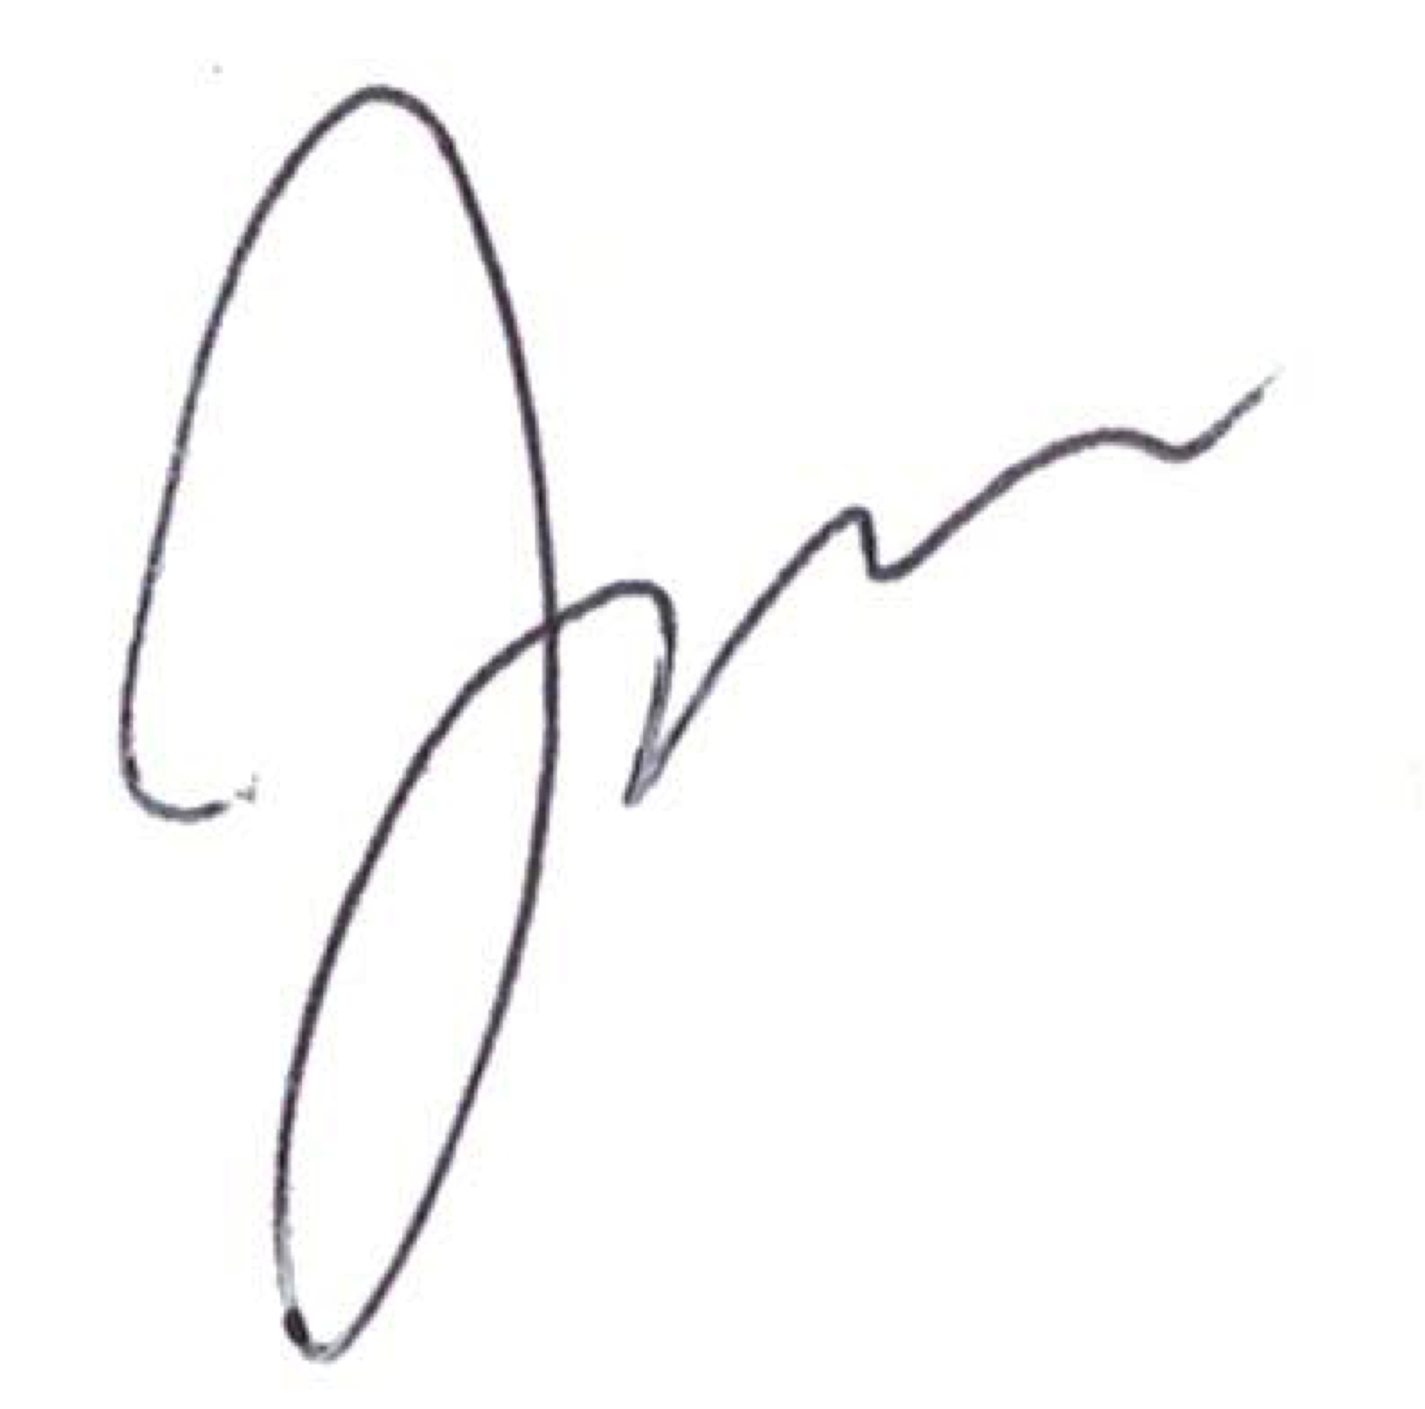
Jane Scharf
B.A./LSUC P06406

