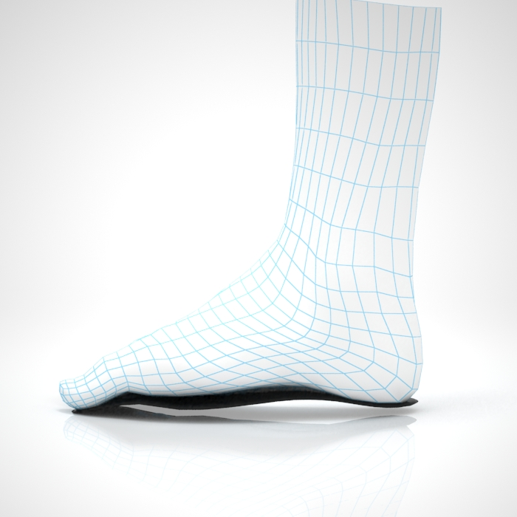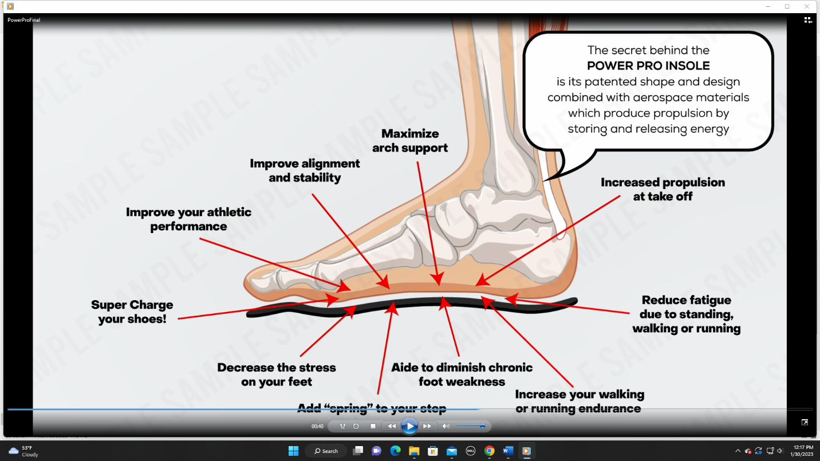

Forefoot Rocker provides a smooth transition to toe-off

Customizable arch stores and releases energy

Carbon Fiber Insole acts like a shock absorber to distribute weight evenly upon landing

Patented shape maximizes efficient gait cycle and transition from heel strike to toe-off

Ergonomic shape conforms to your foot

Lever Spring adds Propulsion

Maximize Arch Support