POLK COUNTY SHERIFF

**July 2022 - Volume 18**

**Monthly recap from Polk County sheriff’s office**

**164 Government complex dr, Columbus, nc 28722 (828) 894-3001**

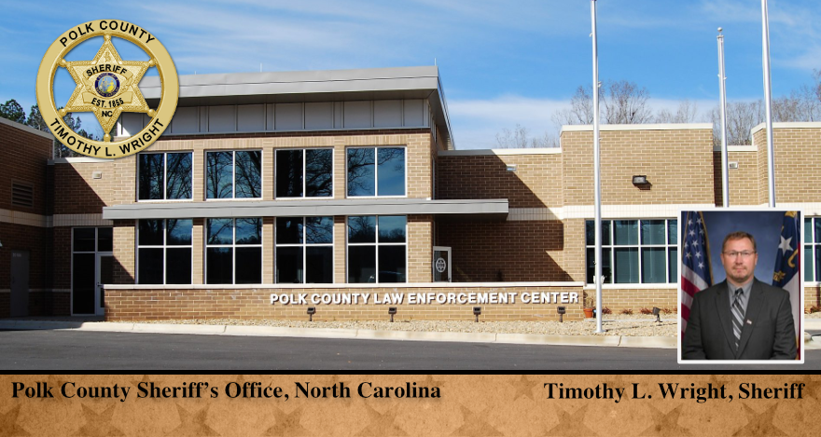

***To subscribe to our e-Newsletter, email tramsey@polknc.org***

|  |
| --- |

| During this month’s Commissioners Meeting Sheriff Wright and Capt. Jeff Smith presented Life Saving Awards to: Lt. Tim Davis, Deputy Austin Coggins and Sgt. Justin McDaniel. The Life Saving Award is awarded to officers in appreciation for the prompt and unselfish act of rendering aid and assistance to a fellow citizen that resulted in the saving of a life. |
| --- |

| **Security Checks & Rounds**  On July 9th, Deputies were performing a security check of a residence on the security checklist. A vehicle that did not belong to the residence owner was found near the home. When contacted the owner was not familiar with the vehicle and that no one had permission to be at the residence. With permission, Deputies entered the home and found Charles Ridge II inside. Ridge was charged with: Felony Breaking & Entering, Possession of a Controlled Substance, Felony Maintain Vehicle for the Sale of a Controlled Substance and Possession of Drug Paraphernalia.  *Thank you Deputies for a job well done!* | **Methamphetamine & Other Narcotics Found During Cell Search**  While conducting his rounds Jail K9 Rudik assisted the other Jail Deputies in locating 2.4 grams of methamphetamine and other narcotics. Sheriff Wright stated, “This is one of the reasons I have added the K9s to our facility. Our K9s locating these narcotics may have saved inmates’ lives that could have possibly overdosed.”  PCSO Visits with YMCA Summer Camp  Campers got an up-close look at Sheriff’s Office equipment and got a demonstration by K9 Rudik. The campers gave Sherif Wright artwork that was displayed in our front lobby. |
| --- | --- |

| **PCSO Visits with YMCA Summer Camp** | Campers got an up-close look at Sheriff’s Office equipment and got a demonstration by K9 Rudik. The campers gave Sherif Wright artwork that was displayed in our front lobby. |
| --- | --- |

This month the PCSO teamed up with The Carolina Blood Connection and hosted a blood drive to benefit the Thermal Belt Outreach. For every donor, the Blood Connection made a $10 donation to the Outreach’s “Feed A Kid” program. The day was a success! We had 26 donors come out and support this great cause. Just a few moments of your time has changed lives and for that we are forever grateful!

We accepted donations for a “Cram” the Cruiser food drive to provide shelf stable food items to benefit Outreach. Outreach provides assistance with food and financial needs to families in Polk County. The food drive began at 8 am in the parking lot of Food Lion. The food drive was a huge success. After the food drive, the collected items were transported to Outreach. Thank you to all who helped make this a success! Through your donation to Outreach, you are helping feed your neighbors in need!

***Thank you for reading our newsletter, below are some of our calls for service for the month.***

**Calls for Service**

**Alarms (Residential / Commercial) 42**

**Animal Control / Livestock 116**

**Assault / Abuse 9**

**Assist FD/EMS/Rescue 15**

**Assist Law Enforcement Agency 21**

**Assist Motorist / Public 31**

**Assist Other / Outside Agencies 2**

**Breaking & Entering 1**

**Citizen Contact / Call by Phone 57**

**Civil Related / Custody Dispute 9**

**Communicating Threats 4**

**D.O.A. 4**

**Disturbance / Dispute / Fight 28**

**Domestic Related 21**

**Drug Related 8**

**Escort (Funeral / Public) 1**

**Follow-Up Invest. / Supplemental 37**

**Fraud / Forgery Report 2**

**Harassment / Stalking 4**

**Intoxicated Person 3**

**Indecent Exposure 1**

**Involuntary Commitment / Mental Sub. 9**

**Juvenile Complaint 3**

**Larceny Report / Shoplifting 16**

**Missing Person Report 4**

**911 Follow Up / Hang Up 62**

**Noise Complaint 4**

**Property Damage 2**

**Property (Recovered/Found/Abandoned) 1**

**Shots Fired (Reports/Complaint) 5**

**Special Activity / Event 8**

**Stolen Vehicle 1**

**Suicide (Threat/Attempt/Report) 1**

**Suspicious Activity 12**

**Suspicious Person / Prowler 38**

**Suspicious Vehicle 59**

**Traffic Control / C&R Driver 122**

**Trespassing 16**

**Vandalism 2**

**Vehicle Pursuit 1**

**Warrant Process Service / Search Warrant 114**

**Welfare Check 22**