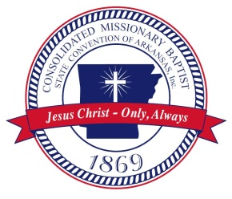

CMBSC Resolution for the Commission Election Process 11-12-18
Whereas, the Consolidated Missionary Baptist State Convention of Arkansas desires the election process to be one of integrity, and fairness to all who may desire to run for office, and to all who would be eligible to vote.
The Resolution committee has met and we would like to recommend the following procedure:
- On Tuesday, November 13, 2018, election Commission Members would be nominated in a separate caucus of each of the five areas of our Convention in this annual session.

- Each district association and church delegate will select a delegate of their area to be approved by the Convention body. (Each of the five CMBSC Vice Presidents will preside over the caucuses).

- On the morning of Wednesday, November 14, 2018, the Convention body will approve the nominated representatives from each area.

- The Vice President -At-Large will convene the commission for the purpose of their selecting a chairperson from among themselves, and then release them to their work of proposing guidelines for who is eligible to run for office; when and how individuals will announce their candidacy, overseeing the election process, etc. The Commission will present their proposals for approval to the Convention Body at the extended session, March 2019.

President Edwards this is the Committees recommendation for adoption.

