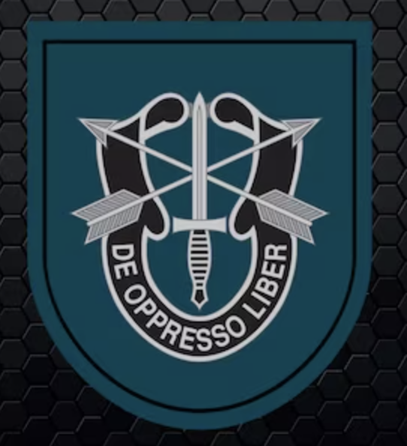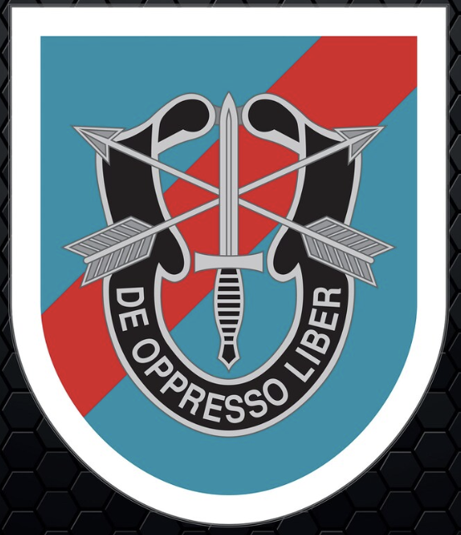

**Operator Education Series**

**September 2023**

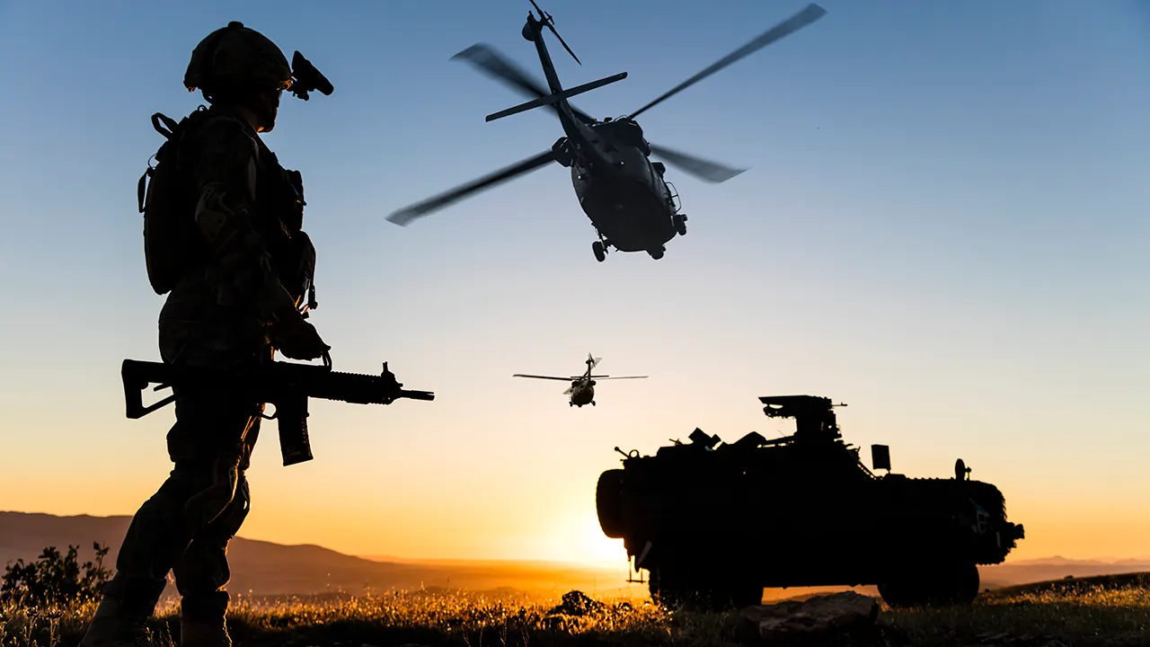



**Copyright 2023. 5by5 Performance Therapy LLC. All Rights Reserved**

**5by5 Performance Therapy & 19/20th SFG Operator Education Series**

**September Theme: Self Advocacy in the Guard**

**Every Thursday at 1700 MST**

| **7 Sep 2023** | **14 Sep 2023** | **21 Sep 2023** | **28 Sep 2023** |
| --- | --- | --- | --- |
| Military Cancers and How to Advocate for Yourself | Moral Injury | Communicating with your Civilian Healthcare Providers & Medical Documentation | Related Biomarkers and How to Improve Them through Food |

**19SFG & 20SFG,**

**5by5 Performance Therapy will be hosting a September education series with a focus on self-advocacy. Using feedback from the formation, the following subjects have been chosen: Military Cancers, Moral Injury, Biomarkers, Self-Advocacy with Civilian Providers. Live sessions take place Thursdays at 5 MST, Zoom link and overview below.   
  
Please ensure to download the September OES Education Packet HERE, and have this content on hand during the session for learning purposes.**

**Please contact Dr. Jennifer Byrne at jennifer.byrne@5by5performancetherapy.com, or directly at 860-857-1763.**

**<<BREAK>>**

**Military Cancers- HunterSeven Foundation**

**Thursday, September 7, 5:00-6:00 PM MST (Zoom Link Below)**

**Chelsey Simmoni, Army Veteran, Clinical Researcher, HunterSeven Co-Founder**

**& Jack Ratliff, Nurse Practitioner, Army Intelligence Veteran, Director of Education at HunterSeven Foundation, currently works in pain management, mental health and addiction at James Haley VA in Tampa**

**Why this matters:**

**2/19 SFG Special Forces Weapons Sergeant Dominic Hall**

**Dom Hall was 30 years old when he received his diagnosis of stage 1B pancreatic adenocarcinoma. At the time, he had recently separated from the military- a prior Marine Recon turned Army Green Beret- and joined the Appleton Police Department. He was a husband to his wife Jacole and a father to two beautiful sons Victor and Thorin. Dom didn’t drink, or smoke. He was fit and healthy, exercised often and ate well. He had multiple exposures including the Fukushima incident in Japan, exposures at PB Alcatraz in Sangin Valley, and begin hit with danger close to JDAMS.**

**Dom’s civilian care team missed multiple opportunities to provide the correct course of treatment that may have aided in saving his life. By January 22, a liver biopsy confirmed that his cancer had progressed to stage 4.**

**Instead, Dom passed away on September 4, 2022.**

**Chelsey Simmoni is the co-founder of HunterSeven Foundation, a non-profit organization that relentlessly advocates for policy creation and advocacy of military members with cancers related to military exposure. Chelsey was intimately involved with Dom’s case while he was still living, and briefly attached to 2/19 toward the end of her career in the Army. When I asked her about educating 19SFG & 20SFG about military cancers, prevalence, and prevention, she immediately responded with “absolutely, this is personal to me.”**

**Chelsey Simmoni & co-presenter Jack Ratliff will be reviewing:**

**· Military Exposures**

**· Risk Factors according to assignments & deployments**

**· How to identify symptoms and put it all together**

**· Research & Trends**

**· How 19SFG and 20SFG can advocate for themselves with civilian providers**

**· Presentation of Resources**

**Join ZoomGov Meeting**

[**https://www.zoomgov.com/j/1612338519**](https://www.zoomgov.com/j/1612338519)

**Meeting ID: 161 233 8519**

**---**

**One tap mobile**

**+16692545252,,1612338519# US (San Jose)**

**+16469641167,,1612338519# US (US Spanish Line)**

**---**

**Dial by your location**

**• +1 669 254 5252 US (San Jose)**

**• +1 646 964 1167 US (US Spanish Line)**

**• +1 646 828 7666 US (New York)**

**• +1 415 449 4000 US (US Spanish Line)**

**• +1 551 285 1373 US (New Jersey)**

**• +1 669 216 1590 US (San Jose)**

**Meeting ID: 161 233 8519**

**Find your local number:** [**https://www.zoomgov.com/u/aejfVM9JAB**](https://www.zoomgov.com/u/aejfVM9JAB)

**---**

**Join by SIP**

**• 1612338519@sip.zoomgov.com**

**---**

**Join by H.323**

**• 161.199.138.10 (US West)**

**• 161.199.136.10 (US East)**

**Meeting ID: 161 233 8519**

**------**

**Moral Injury**

**Thursday, September 14, 5:00-6:00 PM MST (Zoom Link Below)**

**Dr. Michele DeMarco, PhD**

**Moral Injury is different from PTSD. With PTSD, the primary concern is physical safety. With moral injury, it's relational safety or trust. It happens when a person's core moral foundations are violated in high stakes situations. The violation recasts the way people see themselves, others, and the world and causes changes in behavior that signal a loss of trust, connection, self-worth and meaning.**

**Many special operations members engaged in the most recent conflict in the Middle East describe moral injuries specifically related to atrocities witnessed involving children, women, and families. SGM Stclair will open up this topic by describing his own moral injury, and how he came to identify it as such.**

**Michele earned her PhD specifically researching moral injury. She will review:**

**· What is moral injury?**

**· What is moral distress?**

**· How does one develop moral resiliency?**

**· A review of a writing technique to assist with moral injury**

**· Review of additional resources**

**Join ZoomGov Meeting**

[**https://www.zoomgov.com/j/1618552412**](https://www.zoomgov.com/j/1618552412)

**Meeting ID: 161 855 2412**

**---**

**One tap mobile**

**+16692545252,,1618552412# US (San Jose)**

**+16468287666,,1618552412# US (New York)**

**---**

**Dial by your location**

**\* +1 669 254 5252 US (San Jose)**

**\* +1 646 828 7666 US (New York)**

**\* +1 646 964 1167 US (US Spanish Line)**

**\* +1 551 285 1373 US (New Jersey)**

**\* +1 669 216 1590 US (San Jose)**

**\* +1 415 449 4000 US (US Spanish Line)**

**Meeting ID: 161 855 2412**

**Find your local number:** [**https://www.zoomgov.com/u/adTgEcf2Mx**](https://www.zoomgov.com/u/adTgEcf2Mx)

**---**

**Join by SIP**

**\* 1618552412@sip.zoomgov.com**

**---**

**Join by H.323**

**\* 161.199.138.10 (US West)**

**\* 161.199.136.10 (US East)**

**Meeting ID: 161 855 2412**

**------**

**Related Biomarkers and How to Improve Them through Food**

**Thursday, September 21, 5:00-6:00 PM MST (Zoom Link Below)**

**5by5 Registered Dietitians: Andi Bair & Mary-Catherine LaBossiere**

**Biomarkers are increasingly gaining attention in the performance space, and can be very beneficial in understanding health and wellness from a physiological perspective. During this session, we will be discussing nutrition-related biomarkers to include labs like:**

**· Vitamin D**

**· Testosterone**

**· Lipid panels.**

**We will provide action steps that you can take to improve these labs through food choices. Along with this “Food First” approach, we’ll also talk about what to look for if a supplement is needed, as well as red flags to be aware of when it comes to purchasing supplements.**

**Join ZoomGov Meeting**

[**https://www.zoomgov.com/j/1604013104**](https://www.zoomgov.com/j/1604013104)

**Meeting ID: 160 401 3104**

**---**

**One tap mobile**

**+16692545252,,1604013104# US (San Jose)**

**+16468287666,,1604013104# US (New York)**

**---**

**Dial by your location**

**\* +1 669 254 5252 US (San Jose)**

**\* +1 646 828 7666 US (New York)**

**\* +1 646 964 1167 US (US Spanish Line)**

**\* +1 551 285 1373 US (New Jersey)**

**\* +1 669 216 1590 US (San Jose)**

**\* +1 415 449 4000 US (US Spanish Line)**

**Meeting ID: 160 401 3104**

**Find your local number:** [**https://www.zoomgov.com/u/aeHrvF8MwN**](https://www.zoomgov.com/u/aeHrvF8MwN)

**---**

**Join by SIP**

**\* 1604013104@sip.zoomgov.com**

**---**

**Join by H.323**

**\* 161.199.138.10 (US West)**

**\* 161.199.136.10 (US East)**

**Meeting ID: 160 401 3104**

**------**

**Self-Advocacy: Communicating with your Civilian Healthcare Providers & Medical Documentation**

**Thursday, September 28, 5:00-6:00 PM MST (Zoom Link Below)**

**5by5 Performance Therapy Occupational Therapists: Marla Harvey & Dr. Jenn Byrne**

**Seeking medical care, obtaining appropriate documentation, and explaining military-specific symptoms to civilian providers are all challenges that this population frequently encounters. This presentation will focus on how to overcome these challenges.**

**We will discuss operator syndrome and how this framework is not understood by most military or civilian providers. Education will be provided on how to explain symptoms and advocate for yourself to get the appropriate care. We will address:**

* **What blood panels may be necessary?**
* **How to obtain a sleep study and why?**
* **Brain Imaging - what may or may not be visible?**
* **Radiology Overview (X-Ray, CT, MRI with/without contrast, etc)**
* **Importance of spouse involvement**
* **Documentation from Civilian to Military Records**
* **SF-600 - What can you do now?**

**This presentation will arm you with the appropriate tools to advocate for yourself when you seek medical care (understanding that it may take several medical appointments to get the appropriate care and documentation).**

**Join ZoomGov Meeting**

[**https://www.zoomgov.com/j/1604814229**](https://www.zoomgov.com/j/1604814229)

**Meeting ID: 160 481 4229**

**---**

**One tap mobile**

**+16692545252,,1604814229# US (San Jose)**

**+16469641167,,1604814229# US (US Spanish Line)**

**---**

**Dial by your location**

**\* +1 669 254 5252 US (San Jose)**

**\* +1 646 964 1167 US (US Spanish Line)**

**\* +1 646 828 7666 US (New York)**

**\* +1 669 216 1590 US (San Jose)**

**\* +1 415 449 4000 US (US Spanish Line)**

**\* +1 551 285 1373 US (New Jersey)**

**Meeting ID: 160 481 4229**

**Find your local number:** [**https://www.zoomgov.com/u/adsqfH6OmT**](https://www.zoomgov.com/u/adsqfH6OmT)

**---**

**Join by SIP**

**\* 1604814229@sip.zoomgov.com**

**---**

**Join by H.323**

**\* 161.199.138.10 (US West)**

**\* 161.199.136.10 (US East)**

**Meeting ID: 160 481 4229**