 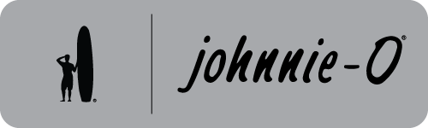 

**Give the Gift of Johnnie O**

**Bulk Purchase Gift Cards**

*Perfect for Employes, Customers, Friends & Family*

*All Denominations Available*

|  |  |
| --- | --- |
| Retail Gift Card Value | Purchase Price |
| $1,000 | **$800** |
| $750 | **$600** |
| $500 | **$400** |
| $250 | **$200** |
| $125 | **$120** |
| $100 | **$80** |

Minimum Purchase (1) Gift Card

Custom Corporate Logo Gift Cards Available

2 Week Lead Time

Minimum Purchase (12) Custom Cards

Contact [Lentzygolf4@gmail.com](mailto:Lentzygolf4@gmail.com) midwestcorpsolutions.com

For Orders, Logo Information & Questions