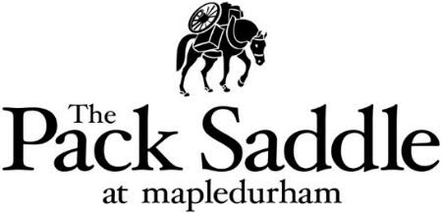
Starters

Soup of the Day
Crusty Bread £6.50 (ve)

Pork Belly Bites
Sweet Chilli Sauce £8.50

King Prawns
Garlic & Chilli Butter & Sourdough £10.00

Southern Fried Chicken Wings
Jack Daniels BBQ Sauce £9.00

Salt & Pepper Squid
Confit Garlic Mayo £9.50

Wild Mushrooms
Wild Mushroom Fondue & Toasted Sourdough £9.00 (v)

Mains

Black Gate Sausage & Mash
Confit Garlic & Chive Mash Potato, Paddock Greens & Red Onion Gravy £16.50

Chef’s Carbonara
Smoked Bacon. Linguini, Grana Padano Cheese & Crispy Prosciutto £16.00

Steak & Ale Pie
Confit Garlic & Chive Mash Potato, Paddock Greens & Gravy £19.50

Local Ale Battered Haddock
Pea Puree, Tartar & Triple Cooked Chips £17.50

Thai Red Curry
Cauliflower, Sweet Potato, Courgette & Coconut Rice £17.50 (ve)
Add Chicken £4.00

King Prawn Linguini
Garlic & Chilli Butter, Cherry Tomato & Parsley £17.00

Wild Mushroom Risotto
Wild Mushroom, Grana Padano Cheese & Truffle Oil £18.00 (v)

The Pack Saddle Beef Burger
Cheddar Cheese, Smoked Bacon, Onion Rings, Burger Sauce, Red Onion Chutney & Fries £17.00

10oz Dry Aged Bistro Rump Steak
Homemade Steak Cut Chips, Watercress Salad & Peppercorn Sauce £24.50

Desserts

Chocolate Brownie
Chocolate Sauce & Vanilla Ice Cream £9.50

Belgian Waffles
Toffee Sauce, Berries & Vanilla Ice Cream £8.00

Biscoff Cheesecake
Vanilla Ice Cream, Biscoff Crumb & Strawberry Coulis £9.00

Apple & Raspberry Crumble
Vanilla Ice Cream or Custard £9.50

