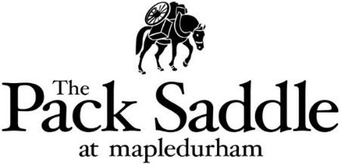

Starters

Leek & Potato Soup
Crusty Bread £6.50

Crispy Pork Bites
Sweet Chilli Dip £7.50

Halloumi Fries
Sweet Chilli Mayo £8.00

Salt & Pepper Squid
Confit Garlic Mayo £9.50

Wild Mushrooms
Wild Mushroom Fondue & Toasted Sourdough £9.00 (v)

Roasts
Garlic, Rosemary & Goose Fat Potatoes, Honey Roasted Carrot, Seasonal Greens, Yorkshire Pudding & Gravy

Dry Aged West Country Rump of Beef £22.50
(Served Pink)

Welsh Leg of Lamb £24.95
(Served Pink)

Slow Cooked Pork Belly £21.95

Beetroot & Butternut Squash Wellington
Roast Potato, Paddock Greens, Honey Roasted Carrot, Yorkshire Pudding & Veggie Gravy £17.50

Add Cauliflower Cheese £5.95

Mains

Loddon Beer Battered Haddock
Pea Puree, Tartar & Skinny Fries £17.50

Wild Mushroom Gnocchi
Wild Mushroom Ragu, Potato Gnocchi, Grana Padano Cheese & Truffle Oil £18.00 (v)

Thai Red Curry
Cauliflower, Sweet Potato, Courgette & Coconut Rice £17.50 (ve)

Desserts

Chocolate Brownie
Chocolate Sauce & Vanilla Ice Cream £9.50

Apple & Raspberry Crumble
Vanilla Ice Cream Or Custard £9.50

Biscoff Cheesecake
Vanilla Ice Cream, Oreo Crumb & Raspberry Coulis £9.00

British Cheese Board
Colton Basset Blue, Cotswolds Brie, Brockmoor Mature Cheddar, Thomas Fudge Crackers & Spiced Pumpkin Chutney £11.50

