\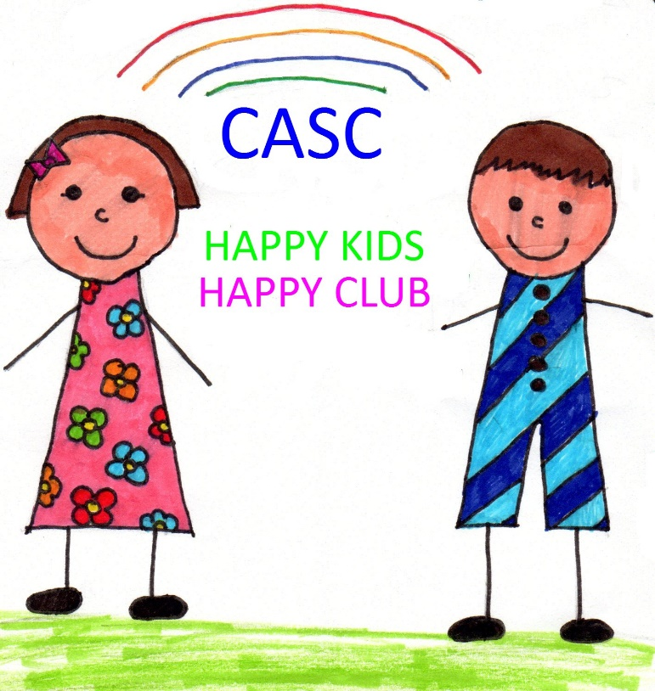
CRAIGLOCKHART AFTER SCHOOL CLUB
2017/2018 REGISTRATION PACK
CHILD/CHILDREN’S NAMES:

CURRENT CARE (2016/2017)
MONDAY | TUESDAY | WEDNESDAY | THURSDAY | FRIDAY

CARE REQUESTED (2017/2018)
MONDAY | TUESDAY | WEDNESDAY | THURSDAY | FRIDAY

P1 & P2 Sessions 2.45pm-3.15 (2017/2018)
MONDAY | TUESDAY | WEDNESDAY | THURSDAY | FRIDAY

Parent/Carer 1 - Relationship to Child e.g. mother | Parent/Carer 2 - Relationship to Child e.g. father
Do you live at the same address as the child? Yes No – If No, please provide full address:- | Do you live at the same address as the child? Yes No – If No, please provide full address:-
CHILD’S DETAILS:-
Child’s Name
Child’s Date Of Birth |  | Age = |  | Male Female
Family Telephone Numbers: | 1. | 2. |  | 3.
Address: |  |  | Email Address:

Name of any siblings attending CASC?

OTHER EMERGENCY CONTACTS/AUTHORISED COLLECTION LIST
Name(s) | Telephone No.’s | Relationship to Child
N.B. WE WILL ONLY RELEASE YOUR CHILD TO NAMED PERSONS ON THE LIST. IF YOU ARE SENDING SOMEONE TO COLLECT YOUR CHILD WHOM WE HAVE NOT MET BEFORE AND IS NOT ON THE ABOVE LIST THEN PLEASE CONTACT US TO LET US KNOW.

Doctor Name and Address | Tel No.
ADDITIONAL CHILD INFORMATION:-
Additional Support Needs e.g. physical, social, emotional, developmental, behavioural:-

Please list any medical conditions and illnesses from which your child suffers:-

Please list any prescribed medication taken regularly by your child:-

Where is this administered:-

Is your child allergic to anything Yes NO If yes, please give details:-

CASC provides a snack each day. Are there any foods your child should not have? (e.g. religious or medical reasons) Please detail:-

The following confirms the contractual agreement between CASC and You.
Our responsibilities
- To deliver high quality affordable early learning and childcare
- To support children’s health and wellbeing.
- To work in partnership with parents/carers/families/professional people linked with the child.
- To deliver a service in line with current legislation and guidance documents.
- To develop an individual plan for your child, regularly communicating your child’s progress in CASC.
- To meet the requirements of regulatory bodies including the Care Inspectorate and Scottish Social Services Council.
- To make our policy and procedures available to you at all times in the childcare settings and to provide copies of specific policies and procedures to you on request.
- To give reasonable notice of any closure of the childcare service and one month’s notice of any change to fees.
- To give written notice prior to the termination of your childcare place along with any account balances.
Your responsibilities
- To work in partnership with staff regarding the care and wellbeing of your child.
- To inform staff of any medical or additional support needs relating to your child.
- To notify staff of any concerns/issues regarding your child’s wellbeing and progress in the centre.
- To collect your child as soon as possible if s/he becomes unwell whilst in the childcare setting.
- To keep your child at home if s/he is unwell and inform staff in advance when your child is going to be absent from the childcare setting on days when sessions have been booked.
- To provide accurate and up-to-date information regarding your contact details, emergency contacts, bank details, phone numbers and all other details entered by you on the registration pack.
- To ensure your child has been collected by 5.45pm at the latest (5.30pm on Friday). A charge will be incurred for collection after 5.45pm (5.30pm on a Friday), details of which are to be found on the CASC’s Table of Fees.
- CASC requests that all children in P1-P6 be signed out by their parent/carer or responsible person.
- Children in P7 can be signed out by CASC staff and return home alone. The parent/carer needs to provide written agreement to their child returning home unaccompanied, by completing the CASC Signing-out Policy form available in the club. If a person other than the parent/carer or a named person detailed in the registration pack intends collecting the child, CASC must be informed in advance of the collection time.
- To support CASC in promoting the school’s Golden Rules at all times including children using mobile phones, behavioural issues and outdoor play.
Declaration
I/We fully understand and agree to comply with the terms of this agreement. I/We accept liability for the payment of childcare fees pertaining to my child’s placement with CASC. I/We fully understand and accept that failure to comply with the terms of this contract may lead to withdrawal of my/our childcare place(s).
Method of Payment: (Please do not include any payments in this form. Your fees will be calculated prior to the first day of care: Full term in advance Monthly Standing Order Childcare Vouchers
I consent to photographs being taken of the above named child/children, for use within Craiglockhart After School Club and also on the Club website for display purposes only: YES NO

I consent to my child/children being taken on local city-wide trips including park trips, swimming, woodland areas and other local off-site venues: YES NO
Parent/Carer 1 Full Name:- | Parent/Carer 1 Signature:- | Date:-
Parent/Carer 2 Full Name:- | Parent/Carer 2 Signature:- | Date:-
Signed on behalf of CASC

Full Name:- | Signature:- | Date:-

Craiglockhart After School Club is registered with the Care Inspectorate. In accordance with the National Care Standards (2016), the Care Inspectorate require all registered after school care providers demonstrate how its service will support the changing needs and interests of every child. It is recommended that after school care providers develop individual care plans for each child which should be updated every six months or when required. Please support CASC to demonstrate how the service supports your child by completing the information below. This will be used by the staff as the basis of your child’s plan. The staff team will liaise with you/feedback regularly. The management team will arrange a 6 monthly review. Parents/carers can contact the management to review their child’s plan at any time.

Your child’s needs and interests:

1.

2.

3.

Your aims/targets for your child’s after school club place:

1.

2.

3.

Any other information relevant to your child’s overall wellbeing needs:

Date completed: | Signed by parent
Date reviewed: | Signed by parent

