\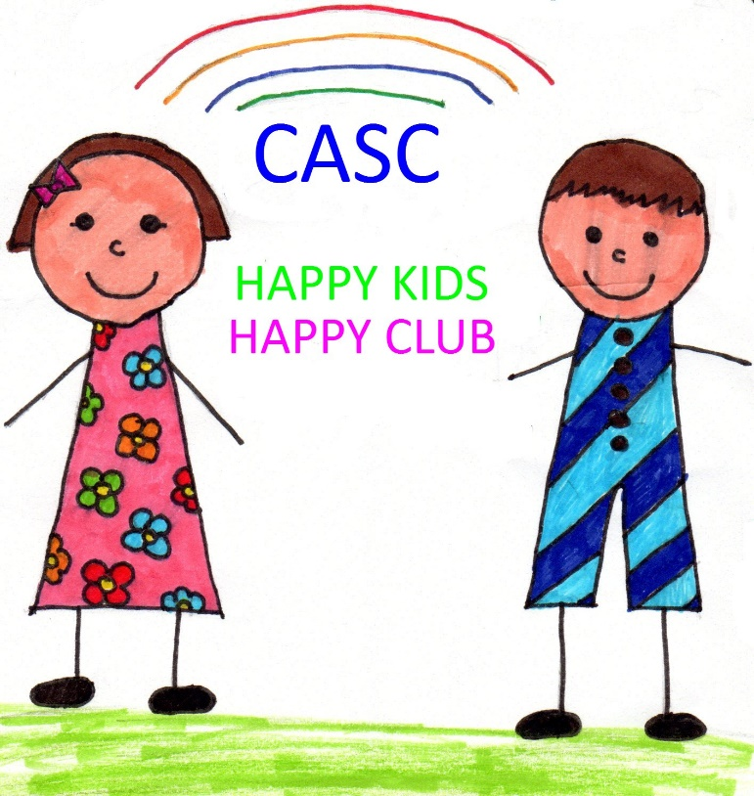

CASC Coronavirus (COVID-19) Policy

This policy has been produced in line with Scottish government Coronavirus (COVID-19) Phase 3: Guidance on reopening Early Learning and Childcare Services and in partnership with Craiglockhart Primary School, and sets out changes that have been made in order to accommodate the safe return of our staff team, service users (children) and their families. The policy is intended to be used by the staff team, parents and children of the club. The implementation of any changes will be monitored by the manager and reviewed regularly to ensure it is used in accordance with best practice. Any questions relating to this document can be directed to the manager by emailing craiglockhartasc@yahoo.co.uk

Overview

We understand that the closing of our club has had a great impact on the children who use our facilities and hope that we can make the transition back as smooth as possible.

The main changes that will be implemented in the club are:
- Enhanced hand hygiene and cleaning/hygiene practices.
- Snacks.
- Limiting children’s contacts (groups/bubbles).
- Maximising the use of outdoor spaces.
- Physical distancing between adults and older children in the setting including parents at drop-off and pick-up times.
- Active engagement with Test and Protect.

- Infection prevention and control

Before opening the club, the staff team will undertake a ‘deep clean’ of all our facilities and resources to ensure they are safe to use. We ask that children do not bring toys from home to minimise the risk of cross contamination.
We have extended our cleaning regime to ensure that high traffic areas are cleaned regularly throughout the day as well as touchpoints such as table-tops, chairs, doors, light switches, banisters, equipment and sinks, There will be routine cleaning and disinfection of other touchpoints such as door handles and hard surfaces. This will include equipment for staff use (e.g. telephones, keyboards, door handles and tables). Toys and equipment will also be cleaned before and after each session using standard detergent and disinfectant that are active against viruses and bacteria.

Enhanced hand washing

The staff will encourage all children to wash their hands at regular intervals throughout the day as well as after using the toilet or before and after eating. This will be done using soap, warm water and disposable paper towels. There are also hand sanitising stations throughout the school and at the entrance to the building. Children and staff will be encouraged/reminded to use these hand sanitisers when going outside or coming inside. CASC staff members will model good practice by following all hand washing measures at all times. Handwashing should take place:

- On arrival at the setting.
- Before and after eating.
- After using the toilet.
- At regular intervals throughout the day.
- When moving between different areas (e.g. between different rooms or between inside and outside), where the handwashing facilities are not near the entrance to the outdoor play area the service may wish to have a supply of hand gel at the door for children.

Staff members will:
- Encourage children not to touch their face.
- Use, and encourage children to use, a tissue or elbow to cough or sneeze, and dispose of tissues appropriately.
- Where appropriate, supervise children washing their hands and provide assistance if required.

Ventilation

The opening of doors and windows will be used to ensure there is enough ventilation in the room at all times and to reduce the contact of door handles.

Face coverings

The position on face coverings in CASC is:
• Face coverings should not be required for most children (other than those clinically advised to wear one).
• Where adults cannot keep 2m distance and are interacting face-to-face for a sustained period (about 15 minutes or more), face coverings should be worn.
• Anyone wishing to wear a face covering in CASC is allowed to do so.

CASC will supply face masks, aprons and gloves to staff when needed.

- Snacks.

You are asked to provide your child/children with a snack for the first term. We ask that your child has a drink too. Children will have access to regular drinks throughout the session.

- Limiting children’s contacts

It is still important to limit children’s contacts. The advisory sub-group on education and children’s issues have said that it would be reasonable for children to be managed in groups up to the size encountered in primary school, for example 25 to 30 children. CASC children will be grouped in the following way:
- P1/P2 children who attend CASC are in Group 1, these children will use the Den.
- P3 children are Group 2, these children will use the Dining Room.
- P4 children are Group 3, these children will use the Middle Hall.
- P5 children are Group 4, these children will use Room 16.
- P6 children are Group 5, these children will use the Gym.
- P7 children are Group 6, these children will use the Library.

The children should come to these areas at the start of their after school club sessions with their coats/bags/snacks. None of the above groups/bubbles exceed 30 children.

Children are not required to physically distance from other children in their groups. School age children should remain physically distanced from staff where possible. We recognise however that children need to feel secure and receive warmth and physical contact that is appropriate to their needs. Staff will need to be close to the children at times, particularly young children. Staff members will work with the same groups where possible throughout the day. If staff need to work with other groups, this should be for limited periods. Staff should ensure strict hygiene practices are carried out if they are caring for different groups. Physical distancing of 2 metres must be maintained between adults

- Maximising use of outdoor spaces

Evidence suggests that outdoor environments can limit transmission, as well as allow for better physical distancing between children. In order to limit the number of close contacts for each child and staff member we will be using the outdoor areas as much as possible. We will be using all of the grounds within the school as well as the park areas.

At the moment we will no longer be able to provide sun cream but instead ask that you provide a labelled bottle in their bags which will be applied if needed, this is aimed at reducing the chance of cross contamination between children using the same bottle of cream.

All outdoor play equipment including our loose parts will be cleaned regularly as with room resources.

- Physical distancing

Out of school care services are advised that certain public health measures are implemented where practicable. This includes physical distancing, where measures fall into two broad categories:
- increasing separation
- decreasing interaction.
CASC will ensure that a holistic approach is maintained in caring for children and that staff members are alert to the range of emotions that many of the children attending during the pandemic may be experiencing.

In order to minimise risks of transmission, staff will remain physically distanced from children where possible. Prolonged periods where adults and children are in close proximity will be limited as far as possible. CASC recognises, in line with national guidance, that it is not appropriate for young children or for some children with additional support needs to maintain the models of physical distancing that would be suitable for most older children, either practically or in terms of child development. In particular, it may not always be appropriate or possible to implement strict physical distancing between children or between a child and an adult. CASC will develop ways to support individual children, promoting their individual needs, privacy and dignity and taking account of physical distancing principles.

Moving throughout the school:

There is a one way system in place throughout the school. This supports the physical distancing measures in place. CASC staff will always follow this system and encourage/remind children to follow the system.

Collecting your children from CASC.
All parents are asked not to enter the school building. Please wait between the west gate and trim-trail and a staff member will release your child/children to you. We will sign the children out for you. Please ensure you are following all socially distancing guidelines whilst waiting in the playground. Feedback will be given at handover. If you wish to communicate with the CASC senior team and it is not possible/appropriate to do so at the time of collection then please do telephone the staff team on 0131 337 9214/07933 578429 or by emailing the club – craiglockhartasc@yahoo.co.uk

- Displaying signs of COVID-19

Where a child displays the symptoms of the virus within the club staff will take steps to isolate them until such a time that they are collected. Children will be taken to the medical room. This will be done in a respectful and confidential way following the NHS COVID-19 Guidance to Educational Settings guidance. A staff member will be present at all times. The staff member will wear the appropriate PPE.
If your child is displaying any symptoms of the virus such as a fever or cough please do not send them to the club but instead follow the guidance at https://www.nhsinform.scot/coronavirus and/or seek medical advice.

Should there be two or more cases (staff or children) the Team Manager will contact the local help protection team who may recommend the closure of the club to prevent further transmission.

In the case of staff absences due to suspected or confirmed COVID-19 it may be necessary to close the club temporarily if we are unable to meet the required staff: child ratio to provide the quality childcare we aim for.

