CRAIGLOCKHART
AFTER SCHOOL
CLUB

INFORMATION PACK

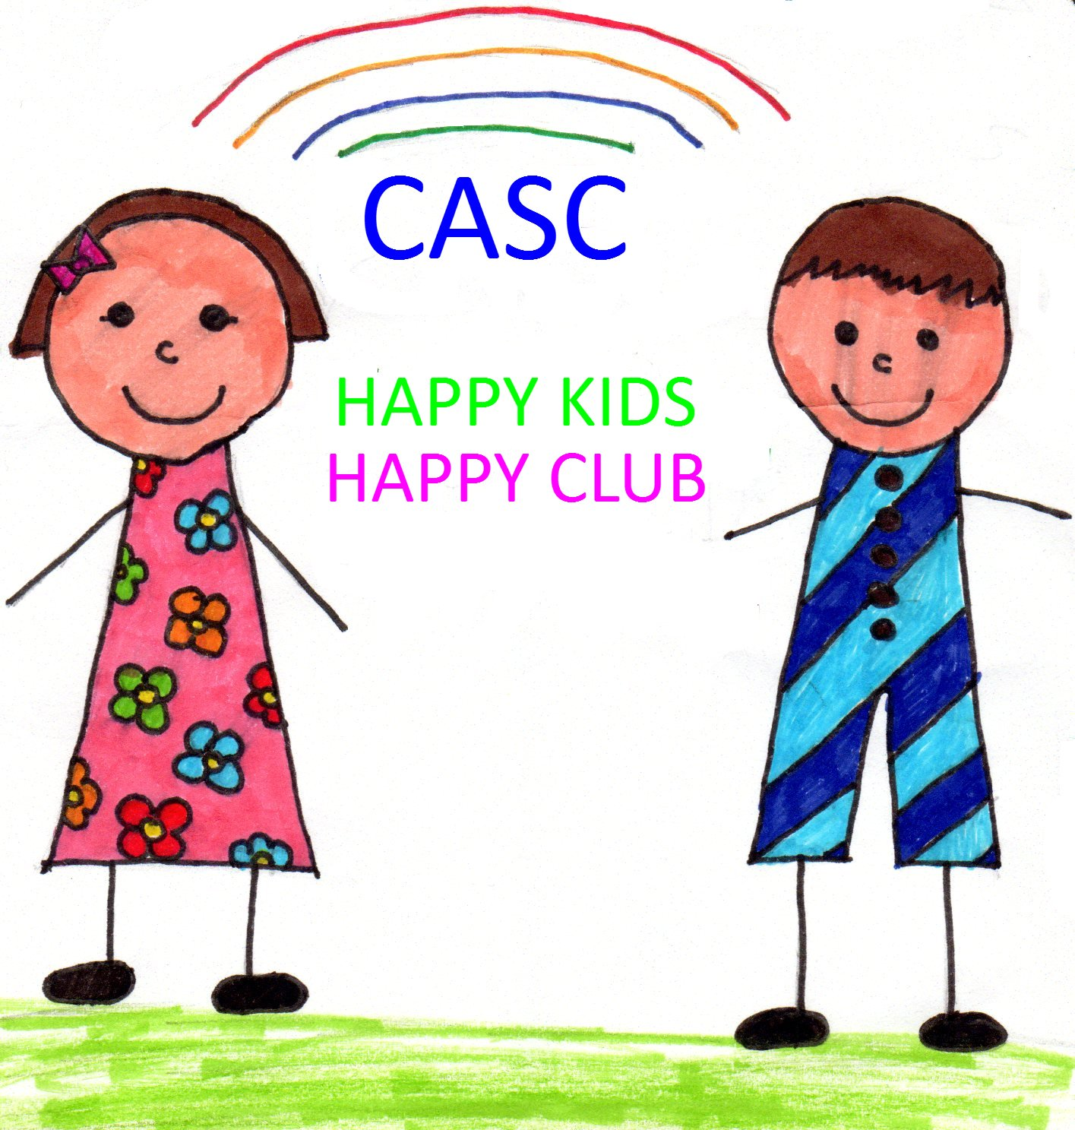

Table of Contents  - Club Opening Times  - The Aims and Objectives of Craiglockhart After School Club  - Registration  - The CASC Booking System  - Methods of Payment  - Waiting List  - Absence from CASC  - Finance Information  - Non-payment of Fees | Page Number  2  3  3  4  4  5  5  6  6
- Child Protection Statement  - Nutrition & Allergies  - Signing Out Policy  - Club Security  - First Aid and Medication  - CASC Staff  - CASC Management Committee  - Children’s Participation Strategy  - Complaints Procedure  - Contact Details  - During the Covid 19 pandemic | 7  8  9  9  10  10  11  11  12  13  13

Club Opening Times

CASC is currently open on school term days only. It is not open on school in-service days or on public holidays. The opening times are as follows:

Monday 2.25pm until 5.45pm
Tuesday 2.25pm until 5.45pm
Wednesday 2.25pm until 5.45pm
Thursday 2.25pm until 5.45pm
Friday 12.00pm until 5.30pm

Aims and Objectives of CASC

To provide the pupils of Craiglockhart Primary School with a caring, safe, friendly, fun and stimulating environment.
- To operate the Club according to all relevant and appropriate legislation and childcare regulations, ensuring best practice at all times.
- To promote Equal Opportunities for all CASC staff, children, parents and carers.

Craiglockhart After School Club was originally set up in 1991. CASC is a company limited by guarantee, and in addition, has registered charity status, operating as a non-profit making organisation. The strategic direction of the club is managed by a committee of parents. CASC is managed on a day-to-day basis by the senior team which consists of a Manager, two Assistant Managers and a Holiday Club Co-ordinator. There is a team of play workers who work in the club, supporting the day-to-day running of the service. CASC is registered with the Care Inspectorate (CS2003011990).

CASC is currently based inside the school. Our main room is Room 16, which is on the 1st floor of the school, behind the stage in the Main Hall. We have the use of a number of rooms in the school. The children can participate in a wide range of activities, including arts and crafts, games and sports, baking, dancing and music, computer games, puzzles, construction and imaginative play.

CASC has a strong commitment towards outdoor play. We plan for the children to play outside every day, using the playground space available as well as Harrison Park (East/West), local woodland areas and other offsite venues.

Registration

Each child who attends CASC must be registered with the organisation. Children are registered annually. This will begin after the Easter holidays. There is an annual registration fee of £15 per family. It is the responsibility of the parents/carers to ensure that all important details are kept up-to-date on registration forms, particularly home address and telephone number, emergency contact numbers and GP/dietary needs/medical conditions/medication details. Any changes to these details should be given to the CASC Manager as soon as possible to avoid any confusion or difficulties. Parents/carers should note that registration does not guarantee their child a place on any specific day.

The CASC Booking System

- You are required to book for a whole year and to commit to paying for set weekly sessions, which will be called your ‘contracted sessions’.
- A ‘contracted session’ means the same day(s) and the same time(s) every week for the full year. (E.g. A commitment to Monday, Wednesday and Thursday 3.15pm – 5.45pm every week for the whole year). It should be noted that contracted sessions cannot be changed or re-negotiated, except in exceptional circumstances and only if places are available.
- You will be required to re-register with the Club once a year under the terms and conditions set down, paying the appropriate annual fee for your child/children- £15 per family.
- It should be noted that no credit will be given for unused, contracted sessions: this is the pay-off required by parents/carers for securing the place(s) that you need.
- If a contracted session remains either unused or unpaid for four consecutive weeks (with the exception of long-term illness or other exceptional circumstances), it will be forfeited and offered to the next person on the waiting list. You will still be liable to pay CASC for the contracted session for the remainder of the term, however.
- Registration and booking forms must be submitted by the date specified in May. Any forms received after the specified deadline will automatically be placed on the relevant waiting lists for contracted sessions.
Methods of Payment
Although we require parents/carers to book their CASC sessions annually, payment can be made either termly or monthly. The following methods of payment are offered:
Termly: a full term of sessions paid in advance either by cheque or cash.
Monthly: by standing order or Childcare voucher, (or by cheque/cash for shift-workers or students, payable in advance). Monthly payments will be calculated for the full year and will take into account any school holidays. Payment will be by calendar month.
Payments for any ad-hoc bookings in addition to contracted sessions will be made at the time of booking (either by cash/cheque).
Any parent/carer with concerns about making payments either monthly or termly is welcome to discuss weekly or fortnightly payment with the Club Manager/Committee. Parent/carers can be assured of confidentiality in such circumstances.

Waiting Lists

CASC is currently fully booked each day. Due to the demand for places we have operated a waiting list system for some years. The club will re-register members during the Spring/Summer term, allocating all places for the following year prior to the end of term in June. Siblings of existing members are a priority group. Once these places have been allocated, those on the waiting list will be contacted and given the opportunity to register and make bookings for remaining places. These places will be allocated in the order the names were received.

The Manager will contact parents/carers by email in the first instance, then by the phone numbers provided on the waiting-list form. If, after 3 working days, no response has been received to any messages left and no contact made by the parent/carer, the Manager will move onto the next person on the list. This family will then be moved on to a non-priority waiting list and not offered childcare again in the same academic year. Parents/carers are given 48 hours from discussion with the Manager, to consider the offer of a place and accept or refuse it. If parents/carers decline an offer of care then that family will be moved on to a non-priority waiting list where they will not be offered childcare again in the same academic year.

As families’ circumstances change throughout the coming year and more spaces become available, places are allocated to families on the waiting list in the order that names have been received. If parents/carers decline an offer of care then that family will be moved on to a non-priority waiting list where they will not be offered childcare again in the same academic year.

Absence from CASC

If a child who is booked in to the Club does not turn up, the CASC staff have a responsibility to locate the child within the school. If they are unable to do so, they will then immediately contact the parent/carer of the child who will then assume responsibility for locating their child.
It is therefore very important for the Club staff to know if a “booked-in” child will not be attending for whatever reason (illness, change of plans etc) as time could be spent looking for that child. If your child will not be attending on a day they are booked for, please phone as soon as possible to let Club staff know. Children absent from school due to illness, must not attend CASC. Contact numbers are given in the final section of this handbook and both phones have a messaging service, so messages can be left at a time convenient to yourself.

Finance information

CASC is operated as a non-profit making, charitable organisation. In addition, the CASC Constitution states that a financial report will be given at each Committee meeting and that a copy of the inspected accounts will be available at the AGM.

One of the office bearers on the CASC Committee acts as Treasurer, overseeing efficient banking and accounting procedures for the Club. The Treasurer communicates with the Manager regarding any financial issues, including payment of staff salaries and general day-to-day expenses.

The fee structure is set by the Management Committee and reviewed on an annual basis. A full copy of the current fee structure is always displayed within the Club. The fees for the academic year 2020/2021 are as follows:

Monday-Thursday sessions - £8.50
Friday full session - £15.30
Friday half session - £7.15
Holiday Club Sessions- £24

Non-payment of fees:

Where payment of fees has been outstanding for more than 3 months CASC will no longer allow the child/children to remain a member of the club. The parent/carer will be advised of this in writing. Any arrears existing must be settled within six months of the missed payment occurring. For example if payment is missing for the month of September, all fees should be fully paid up by the end of the following March. If payments are not fully up to date by the six month date, again CASC will no longer accept the child/children as members of the club.

CASC cannot accept payment holidays under any circumstances. If a parent/carer knows they will be unable to pay a monthly fee they should advise the club as soon as they become aware of this. This will help avoid payment reminders for that month being sent. They shall then be subject to the outstanding fees position above.

Unfortunately CASC is not in a financial position which would allow non-payment/arrears to be treated in any other way. CASC must act to ensure its financial stability, and consequently its ability to continue to provide services to parents/carers. The club is also mindful of the fact that there is a waiting list for places, and that its options to recover outstanding fees/non-payment of fees in any other way are very limited. To ensure that all club members are treated in the same way no exceptions to the above policy will be permitted.

Child Protection Statement

CASC has developed its Child Protection Procedures in line with the requirements set out in Edinburgh and Lothians Inter-agency Child Protection Procedures. The protection and well-being of each individual child is paramount and all staff must follow the organisation’s procedures when there is a concern about a child. CASC is committed to working in partnership with parents and all concerns will be dealt with in a consistent, effective and fair way by the Manager.

In addition to this CASC has a range of other policies, procedures and guidelines that uphold children’s right to be protected from physical and emotional harm, including

- Anti-Bullying Policy and Procedures

- Equal Opportunities

- Care and guidance

- Data Protection & Confidentiality

All of our policies are available on request.

Nutrition & Allergies

NUTRITION

CASC recognises that a well-balanced diet and physical activity are essential factors in the growth and development of children. This policy aims to promote healthy eating and positive messages about food.

- Clubs provide children with varied and nutritious snacks and drinks.
- Dietary requirements are taken into account so that suitable food is made available to all of the children (this includes allergies, cultural and religious requirements).
- Parents of children who are on special diets will be asked to provide as much information as possible about suitable foods and in some cases may be asked to provide the food themselves.
- Afternoon snacks are offered to children every day after school. During holiday periods morning snacks are also offered.
- Children are encouraged to develop good eating skills and table manners and will be given plenty of time to eat.
- Parents are encouraged to provide a healthy packed lunch for their child(ren).
- During the Covid 19 pandemic, families are asked to provide snacks for their child/children.

ALLERGIES

We are aware that children can have allergies to different types of food. We will follow this policy to ensure allergic reactions are minimised and/or prevented and to allow staff to support children should he/she have an allergic reaction.

- Information is given to staff by parents at the point of registration. Staff and families will work together to ensure no foods are given which may cause the child harm.
- An allergy list will be kept in each room where food is prepared/cooked/consumed.
- All food prepared for a child with an allergy will be prepared in an area where there is no chance of contamination and served on equipment which has not been in contact with other food.
- Children with allergies will have an additional support plan which detail signs of reaction and instructions on medicines. All staff are qualified in First Aid training. Medicines will be administered as quickly as possible. At least two staff members will have Epipen training. The family will be contacted asap.
- If a child needs external medical treatment then an ambulance will be called immediately. A staff member will accompany the child and the family will be contacted immediately.
Signing Out Policy

All children in P1-P4 must to be signed out by the parent/guardian or responsible person as already stated in the current terms and conditions. Children in P5-P7 can sign themselves out and leave on their own providing a written agreement between CASC and the family is in place. In agreeing to a child going home alone, CASC will consider:
- Consideration of the child’s journey home and any risk factors
- The time of the day the child leaves the club
- Change to risk factors depending on the time of the year
- Any safety measures that need to be considered, e.g. phone call to the parent/carer when the child is leaving the club

CASC reserve the right not to agree to a child going home alone if they have concerns about the safety of a child.

During the Covid 19 pandemic, all parents/carers collecting children are asked not to enter the school. Please make yourself known to an adult in the playground and a CASC staff member will send your child/children to you. We will sign your child/children out.

Club Security

CASC operates an entry phone system, with a camera at the entrance at the top end of the school. This separate entrance helps ensure the safety of the children and staff at the Club. Parents/carers, or any other person authorised to collect children from the Club, must always use this entry buzzer to make their arrival known to a member of CASC staff. Parents/carers are requested not to try to gain entry by using the main school entrance, as CASC staff are unable to let them in if they use this entrance. This also compromises the safety of the children, who no longer use this entrance during Club-time.

We ask parents/carers not to hold the door open or give access to the school premises to other people. The children have been advised by both school and CASC staff of the need for security and we would appreciate it if parents/carers would both emphasise this message and set a good example.

If you, or one of the nominated people listed on your registration form, will not be collecting your child from the Club, please inform the CASC Manager as soon as possible. Failure to do so may mean that your child will not be allowed to leave the club until the parent/carer has been contacted for confirmation of arrangements. Further details of any aspect of CASC security are available from the Chairperson or Manager.
First Aid and Medication

CASC recognise that First Aid training as a core training element for all staff members, supporting the staff team to achieve this training qualification. Where children have specific medical conditions then CASC will strive to support the child/family by sourcing appropriate training/guidance for the staff team.
If you require a member of CASC staff to assist your child in taking prescribed medication, you must complete the appropriate form allowing them to do so, prior to the medication being administered. We would also ask that you keep CASC’s records up to date when you complete your annual registration form by noting any regular medicines, allergies or medical conditions accurately. (E.g. if your child uses an inhaler etc). Changes to Records slips are available by the signing-out desk; please use these to notify us of any changes, for instance, new work or mobile numbers. Further details of any aspect of CASC’s first aid or medical procedures are available from the Club Manager.

CASC Staff

All CASC staff have been checked for their suitability to work with children (PVG scheme) through Disclosure Scotland prior to their employment commencing. Staff are supported to continue their own training and development whilst employed by CASC by attending training courses or undertaking further work-based qualifications such as the SVQ 3 in Childcare and Education (Playwork), CCLD ( Children’s Care, Learning and Development) or equivalent courses. All CASC staff are registered with the Scottish Social Services Council or General Teaching Council.

The current CASC staff structure is as follows:

MANAGER

ASISTANT MANAGER/S & HOLIDAY CLUB COORDINATOR

PLAYWORKERS

CASC Management Committee

Craiglockhart After School Club is run by a committee of volunteer parents/carers who have the ultimate responsibility for the formation of policy and general management of CASC. The Management team issue a regular newsletter to inform all parents/carers of new developments and other items of interest. The Management Committee is made up of a number of office bearers and committee members. Any parent/carer of a child attending CASC is eligible to become a member. Committee Meetings are currently held every six weeks during term time. The Management Committee may also invite representation from the school’s teaching staff or co-opt any person whose expertise may benefit certain items of business. CASC Committee hold an AGM in November each year, where office bearers and committee members are elected. The length of service for office bearers is initially two years, with the option to be re-elected for a further two-year term. The current management committee structure is Chairperson, Treasurer, Secretary, Minutes Secretary and Ordinary Members. If you are interested in becoming involved, please contact one of the office bearers via the CASC Manager. Remember - if there are no parents willing to join the committee and help run the Club, there will be no CASC.

Children’s Participation Strategy

What do we mean by children’s participation at Craiglockhart After School Club: Participation means that all of our children are genuinely involved in realistic decision-making relating to the day-to-day planning, delivery and evaluation of the after school care service they receive. Genuine involvement is more than just listening to people’s views it is about them being actively involved in decision making processes and influencing the outcomes.

Our Vision and Aims: That children who attend CASC are able to express their wishes and views about the services they receive and feel the staff team at CASC listen to them and value their opinions. That all those using our service are given the opportunity to be involved in decision making and to influence outcomes relating to the services they receive. To promote the genuine participation of children in the planning, delivery and evaluation of our childcare and education services.

Our 7 Rules of Children’s Participation

Understand, and help us understand, our rights

Give us a chance to be regularly involved in the decision-making at CASC.

Remember- it’s our choice. Don’t ask my opinion if it won’t make a difference.

Value us- tell me my opinion is important but only ask me if I can make a difference.

Support us- check we understand what is happening and be a voice for us if needed.

Work together- we can learn from each other. We are the real play experts.

Keep us involved.

Complaints Procedure

The Management Committee recognises that individual parents/carers have the right to raise a complaint about any aspect of CASC and its operation. We would assure all parent/carers that any concerns raised will be taken seriously and investigated appropriately.

Parents/carers should make their concerns known to the CASC Manager in the first instance. The Manager will strive to resolve any problems promptly and informally.

Where the Manager cannot informally resolve an issue, your complaint will be forwarded to the CASC Management Committee and an appointed Committee member will undertake a full investigation of the complaint. A written report of the investigation and findings will then be forwarded to the Management Committee for consideration. Appropriate action may then be taken and the complainant will be informed in writing of the outcome. The complainant (and any other individual) has the right to attend a committee meeting to pursue the issue, should they wish to do so.

The CASC Management Committee will strive to resolve any concerns within 28 days of receiving notification from a parent/carer. If any delay in achieving this deadline is anticipated, the Chairperson will advise the complainant immediately.

Contact Details

CASC Landline 0131 337 9214

CASC Mobile 07933 578429

CASC E-mail: craiglockhartasc@yahoo.co.uk

During the Covid 19 Pandemic

During the Covid 19 pandemic the children will be based in groups of no more than 30 throughout each week. These will be year groups:

Children in P1/P2 are a group. This may change in the autumn to two separate groups. P3 – P7 are 5 separate groups. Children do not need to physically distance from others in their groups but should physically distance from all other children who are not in their groups.

- If your child is absent from school with the symptoms of Covid 19, please inform the club.
- Please give your child a snack for CASC. This limits the social contacts in the club and reduces the risk of infection.
- Please ensure that your child is not bringing toys/books/playing cards from home to CASC.
- Please do not enter the school building. Always make yourself known to an adult in the playground. We will bring your child/children to you and sign them out. If youy wish to speak with a senior member of staff, please make yourself known to a staff members/phone ahead/email and this will be arranged.
- Lost property that is labelled will be returned to the child’s class at the end of the night. Unnamed lost property be taken to the school’s lost property at the end of the week. We can have no responsibility for any lost property after this has happened.

