**4L80E 3rd  Gear “D3 Plus/PRO” Transbrake Instructions**

Installation of the Jake's Performance 4L80E Trans brake will require some internal modifications. These are relatively simple but are best done during a rebuild by a professional transmission technician. Instructions must be followed for proper function and results

Parts included:

l Instructions

l Wiring Pigtails (+ ONLY)

l 5/16” set screw

* Valve body assembly with separator plate
* Transbrake Manifold and solenoid
* New AC Delco Shift Solenoids

I Boost Spring

I Billet Aluminum Spring Seat (PRO)

l 8- High Rate Direct Springs (PRO)

As for internal mods, you will need to drill a bleed/release hole in the direct drum. We recommend drilling a .055-.060" hole at a slight angle as outboard as possible on the drum as seen here (see the small black hole):

|  |  |
| --- | --- |
| C:\Users\Jake\Pictures\th400bleedhole.jpg | C:\Users\Jake\Pictures\th400bleed2.jpg |

|  |  |
| --- | --- |
| We also leave the center seal off the direct drum as part of the "dual feed" process. The “center” seal seen here on the inside of the direct drum should be removed. Also remove the second sealing ring from the front of the center support. | C:\Users\Jake\Pictures\th400centerseal.jpg |
| Omit the two seals on the 1-2 accumulator piston (inner piston) shown here. | C:\Users\Jake\AppData\Local\Microsoft\Windows\Temporary Internet Files\Content.Word\accumseals.jpg |

We recommend flat sanding the servo cover to ensure the surface is flat for better sealing. Re-install the servo assembly, checking for band clearance as follows. Disassemble the rear servo. Place apply piston on the pin with washer between them but no return spring, accumulator piston, or seals.

|  |  |
| --- | --- |
| Parts shown here: | Assembled: |
|  | C:\Users\Jake\AppData\Local\Microsoft\Windows\Temporary Internet Files\Content.Word\ServoCKpartsassembled.jpg |

The rear servo pin needs to be removed from the servo piston, and a small slot or "flat" milled or ground on the portion of the pin that goes through the case bore. A small flat or groove is all that is required. .060” wide/deep is adequate.

This gives you the overall length with no interference while checking. Check band clearance by installing the piston and pin in case. (Note that the bore is actually slightly angled from the cover mating surface, the actual bore begins at the ridge.)

You should feel it engage the band, when it is in the bore push by hand firmly to judge travel. If it goes into the bore too deep, you need a longer pin. Rotate output shaft both directions to judge band engagement. Ideally you want no drag when the servo is JUST in the bore but drag as soon as you start to depress further into the bore. This helps prevent a possible no reverse condition and faster transbrake setup. Once the proper clearance is achieved you can assemble the rear servo. Approximately .080” travel is good. [400/4L80 servo check](https://youtu.be/xyvNnFXk9xg)

|  |  |  |
| --- | --- | --- |
| C:\Users\Jake\Pictures\4l80einstructionpics\4L80Echeckballlocations.jpg | | You can now install the 4 checkballs in the case at the red locations shown (left).  You can install the valve body at this time. Be sure to avoid pinching the wiring between the case and valve body. |
| The case needs a passage plugged with the 5/16” set screw provided at the location shown by the red circle. Tap the passage with a 5/16-18 tap (course), thoroughly blow out aluminum chips, and install the set screw.  Replace oem boost spring with the one provided, reuse  the small bumper spring. | | Then install the epc plug (shown) and leave the harness unplugged or plug into a “dummy” solenoid to keep the controller happy.        The wiring for the transbrake must be added to the internal and external harness. The internal harness connector must be disassembled by releasing the tab to allow the green inner portion to slide out of the grey outer portion. |
|  | C:\Users\Jake's Performance\Pictures\4L80EConnectorseperated.jpg | |

The valve body assembly will be shipped with two wires for the transbrake solenoids. One wire must be ran through the main connector to apply power from the transbrake button for transbrake operation. The second wire can be grounded to the valve body, or also pinned into the main connector to use for the ground side. This allows more versatility for using 2 steps or bump boxes. Polarity isn’t important.

Once the connector is apart, the green portion needs to be drilled 1/16th” to allow the pin to pass through. We recommend drilling on the same row as the pink “E” wire on the opposite side shown by the yellow circle here.

|  |  |
| --- | --- |
| C:\Users\Jake's Performance\Downloads\4L80EConnectorPinout.jpg | C:\Users\Jake's Performance\Pictures\4l80EConnectorintaddpin.jpg |
| The additional wire(s) from the transbrake solenoid can now be pinned into the connector. The green inner portion needs an even coating of RTV silicone before reassembly to prevent leaks.  We have also left the ground wire as a pinned wire. It can be routed to the main connector and used as needed for a two wire hookup to use with bump boxes and other electronics. Or a ring terminal can be crimped on and grounded to a valve body bolt.  D3 PRO or + use pin C&D (EPC wires) for the transbrake wires and will not have to perform these steps. | C:\Users\Jake's Performance\Pictures\80Pinintharness.jpg |
| Install the solenoids and internal harness. T into the “A” pin on the pressure switch and attach it to the silver pressure switch on the side of the valve body using a female spade connector, as shown in picture below. Install the filter and pan when everything is completed. |  |
| The external harness needs a pin added into the same location as the internal harness. The additional wire is included with the transbrake assembly. Procedure is similar for the external harness as the internal shown above. |  |

**D3 Transbrake External Wiring Instructions**

Wiring of the D3 Transbrake requires adding a pin to the external harness. This is easily accomplished using an existing unused wire if converting from a 4L60E or using a supplied extra pigtail wire.

We have found that the best location is in Pin K. This is the 2nd row, far right as the main connector goes on the trans, looking at it from the outside. Some earlier units used different pinouts and if the transbrake was installed by another builder it may not use our pinout. Please verify where the extra wire is in your internal harness to ensure proper pinout and function. If you have one of our builds we also place a pin at Pin J for an external ground. The D3 PRO uses the epc wires at pin C and D polarity is not a factor.

The photo below shows a stock pinout internal harness, as it would appear from the outside of the transmission. The top row of four wires from left to right is A, B, C, and D.

The 2nd row of one wire is Pin F. We suggest pinning into the far right of this row.

|  |  |
| --- | --- |
|  | Shown to the left, for reference purposes, is a stock external harness. If you look closely at your harness you may see the letter designation for each wire. |
|  | You must disassemble this connector to add a wire or repin it in conversions. The insert is easily removed using a pick or sharp object as shown. |
|  |  |
|  | Once this is accomplished, you can poke a hole in the silicone seal using the pick or drill bit, and insert a wire through into the proper location to mate with the wire added to the internal harness. |

**Transbrake will have to be activated for reverse , in reverse position.**

We recommend drilling a .061” hole from the line pressure to converter charge circuit in the pump as shown. This prevents the converter from suffering charge loss during max line pressure situations and potential converter drag.

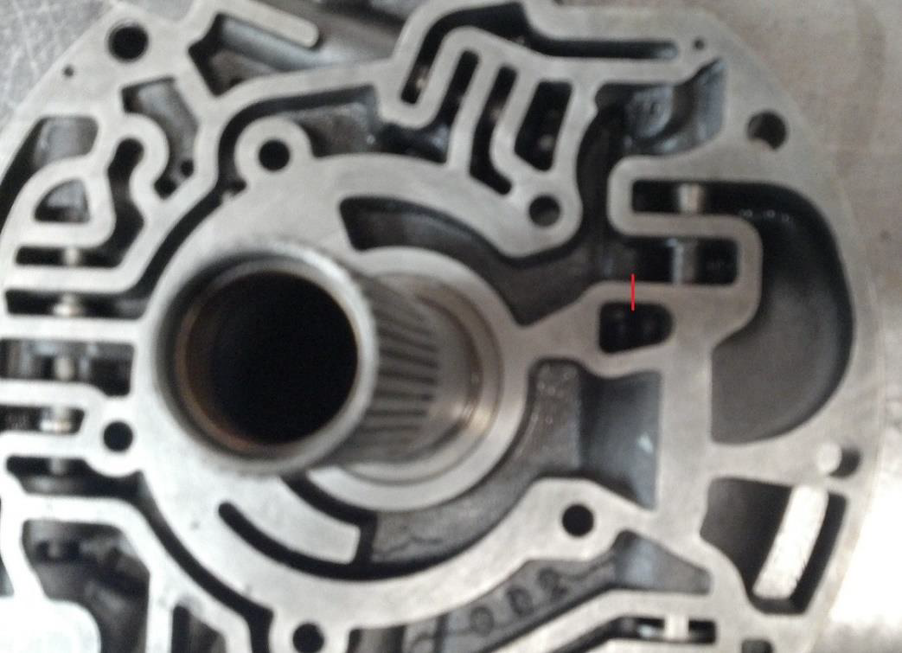

Common Problems and Possible Causes

No trans brake or reverse - Switch not engaged or providing power. Check wiring for power. Gaskets provided must be used or punched to match. Servo band clearance too loose or servo pin too short. Low pressure.

Transbrake & Reverse applies but doesn’t hold- Servo band clearance too loose or servo pin too short. Low pressure.

Transmission only has 2nd and reverse- No power to pin E. Check fuse. Check the main connector to trans & be sure it’s completely connected & not upside down (Arrow to the top).

No 1st gear, all others good- Pressure switch on the side of the valve body damaged (bad from factory) or not wired correctly. Are the supplied gaskets being used? If not, gaskets must be matched to the plate, no covered holes.

Most issues we see are installation or build related. If there is a problem after diagnosis and testing please let us know. We will need pressure readings at idle and on the footbrake at 1500 rpm in all gears before calling with issues. The D3 has oem design for shifting and tcc and they should be diagnosed as such.

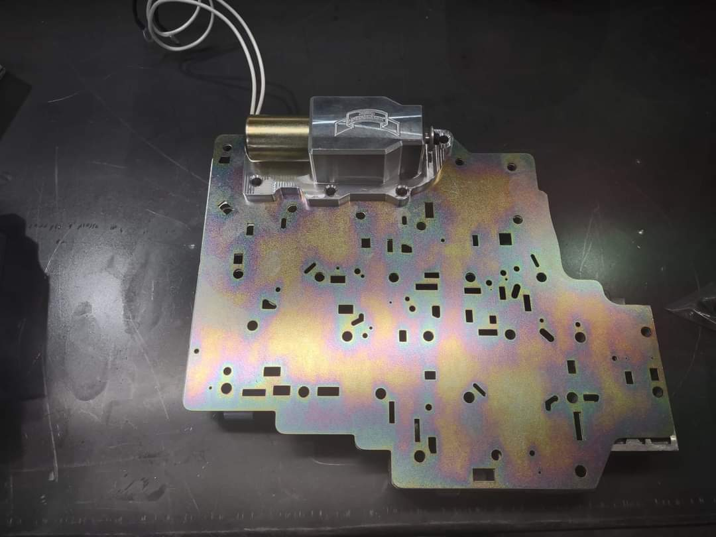*Disclaimer: Due to the nature of high performance and racing applications, the products offered by Jake’s Performance are sold without any express warranty or any implied warranty of merchantability or fitness for the intended purpose. No consequential damages of any type which may happen from the purchase, installation or use of any of this merchandise or products will be the responsibility of Jake’s Performance. Buyers understand and accept the possibility of serious injury and/or death and damage from use of any products whether used on the street or racetrack.*