**4L80E Valve Body Recalibration Kit Install**

**DO NOT USE THESE INSTRUCTIONS UNLESS YOU ARE SPECIFICALLY USING OUR RECALIBRATION/SHIFT KIT!!!!**

Our valve body kit is designed to be installed during a rebuild. It will improve the hydraulics of the transmission by increasing the 3rd gear clutch capacity, lube oil during WOT operation, preventing centrifugal apply of the 3rd gear clutches during high rpm in 1st gear, and eliminating the accumulators.

We do not recommend using this kit for off road use where frequent downshifting of the unit for engine braking is necessary. It is designed with an experienced builder in mind. The instructions show changes from stock.

During the rebuild of the direct (3rd) drum, we recommend drilling a .061” (1/16th) hole in the outer edge of the drum on all performance rebuilds. This will not be necessary on a towing or low rpm application. This prevents centrifugal apply during high rpm 1st gear operation.

| C:\Users\Jake\Pictures\th400bleedhole.jpg | C:\Users\Jake\Pictures\th400bleed2.jpg |
| --- | --- |

Leave off the center seal in the drum itself. This allows 3rd gear apply pressure to act on the entire piston instead of just the inner portion. Our plate is modified to allow this without a pressure leak into the reverse circuit.

| Also leave off the 2nd sealing ring on the center support as shown. | C:\Users\Jake\Pictures\th400centerseal.jpg |
| --- | --- |
|  | C:\Users\Jake's Performance\Downloads\Centersupportomit.jpg |

On heavy towing or any application that sees wide open throttle often, we recommend drilling a .061” (1/16”) hole in the pump from converter charge to line pressure as shown.

Next install the PR spring supplied. Use the original bumper spring with the PR spring provided.

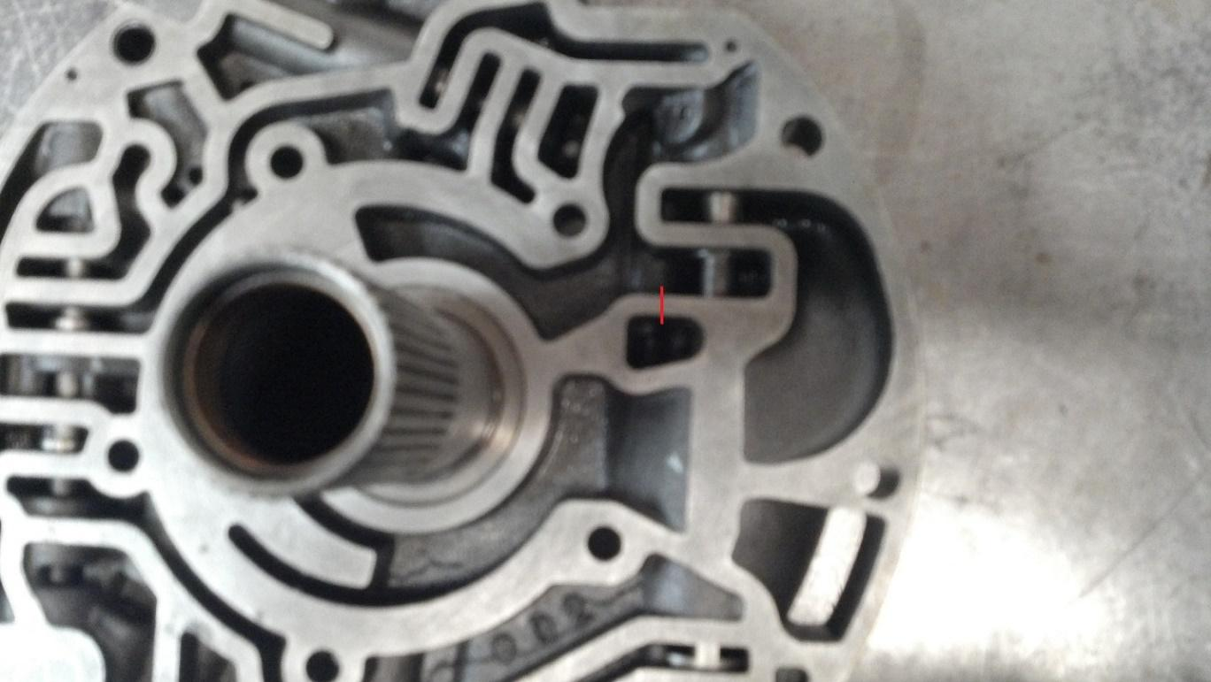

While installing the rear servo, disassemble the servo as shown.

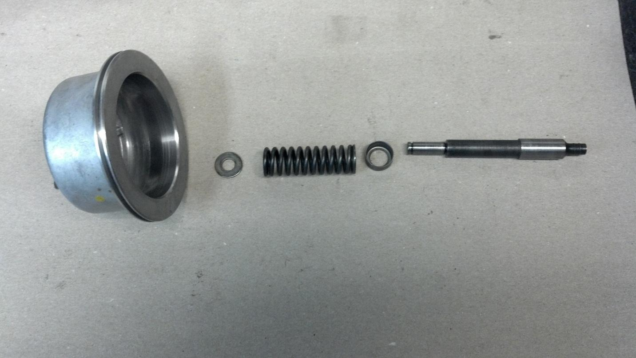

Temporarily assemble the servo apply pin, washer, and servo piston together to check servo/band clearance. You are leaving the spring off to be able to feel the band tension as it clamps the reaction carrier.

The servo bore seen here has a sealing surface for the o-ring on the servo piston. The lip shown in red is the beginning of the sealing surface. This is where you want the piston to be and allow rotation of the output shaft in both directions. (Note: It will be easier to turn one way than the other). You want minimal travel from this point to apply the band. Preferably less than .100” of servo travel by hand. This prevents loss of reverse as the band wears. Use a longer/shorter pin or weld to lengthen the pin and grind to shorten.

| C:\Users\Jake's Performance\Downloads\servobore.jpg | C:\Users\Jake's Performance\Downloads\2012-03-15_11-50-16_727.jpg |
| --- | --- |

Reassemble the rear servo as stock but omit the two sealing rings from the 1-2 accumulator piston as shown during final assembly.

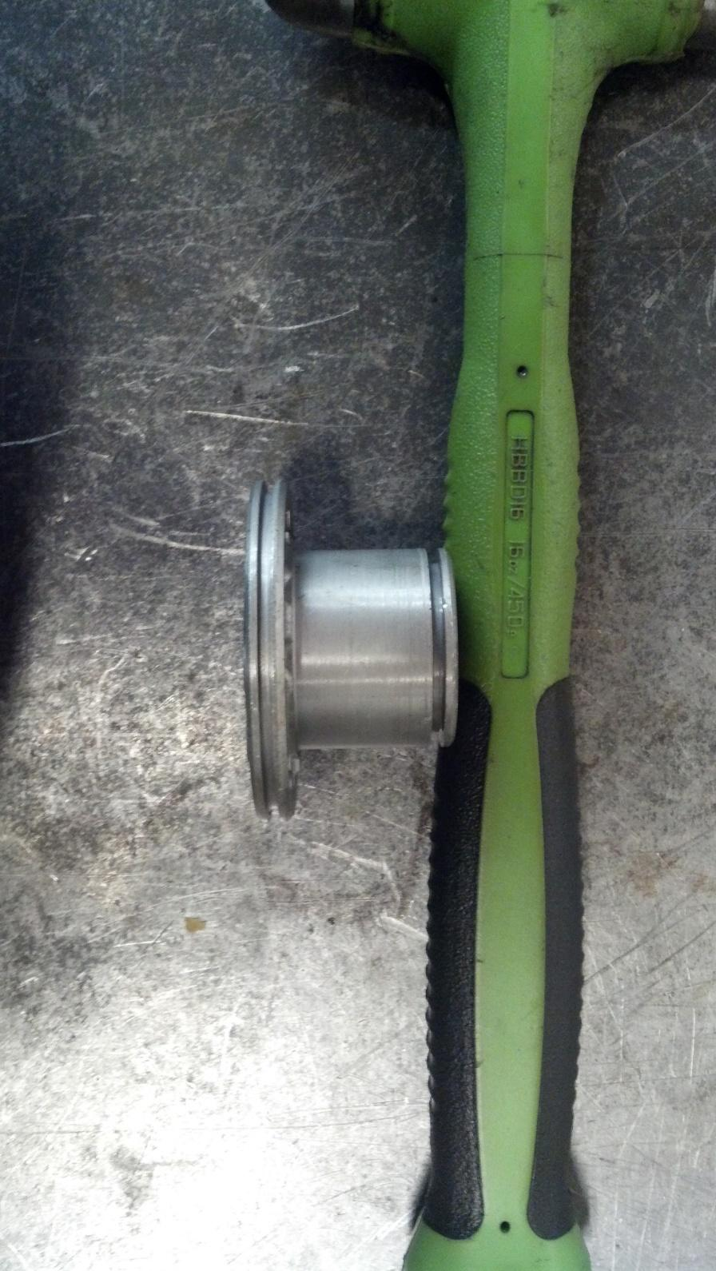

Install the checkballs in the locations shown in blue below. 4 checkballs total.

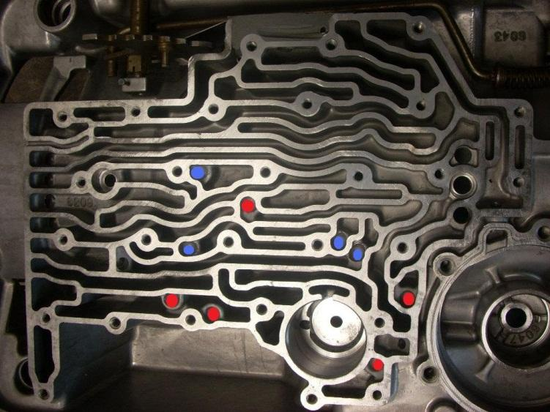

Install the VB side gasket, new separator plate provided, and new blockoff plate provided as shown. Then install the valve body normally.

