

**FOR INFORMATION CONTACT:**

Nick Braschler

Board Chair, Siloam Springs Chamber of Commerce

n[ick.braschler@gmail.com](mailto:Nick.braschler@gmail.com)

(479) 228-3270

**FOR IMMEDIATE RELEASE:**

**Subject: Siloam Springs Chamber of Commerce Welcomes Randy Torres as New President & CEO**

Siloam Springs, AR — The Siloam Springs Chamber of Commerce is pleased to announce the appointment of Randy Torres as its new President & Chief Executive Officer, effective August 18, 2025. In this key leadership role, Torres will oversee the Chamber’s strategic direction, membership engagement, advocacy efforts, and community development initiatives, ushering in a new chapter of innovation and opportunity for businesses and residents throughout Siloam Springs and the surrounding region.

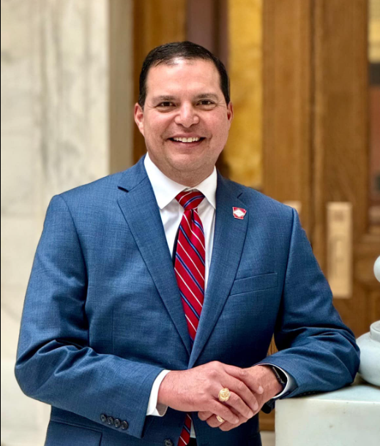

Randy will continue his tenure at Generations Bank; however, he will transition from the position of Market President to assume the Community Development Officer role within the organization. Randy will be influential in fostering relationships across NWA with local businesses, civic leaders, and stakeholders.

Randy has been a dedicated member of the Siloam Springs Chamber and has served in many capacities throughout the years. He brings to the Siloam Springs Chamber of Commerce a wealth of experience in economic development, organizational leadership, and community engagement. With a proven track record of fostering collaborative partnerships, supporting small businesses, and advocating for sustainable growth, Torres is uniquely positioned to build upon the Chamber’s legacy while charting a bold new course for the future.

“I am humbled and honored to join the Siloam Springs Chamber of Commerce as President & CEO,” said Torres. “This community is renowned for its entrepreneurial spirit and strong values. I look forward to working alongside our members, local leaders, and partners to advance our shared vision for growth and to ensure that Siloam Springs remains a vibrant place to live, work, and do business.”

# Chamber Board Expresses Enthusiasm

The Siloam Springs Chamber of Commerce Board of Directors conducted an extensive search to find the right leader for this pivotal role. In welcoming Torres, the Board highlighted their ability to inspire collaboration and drive results.

“Randy Torres stood out among an impressive group of candidates for his vision, dedication, and in-depth understanding of the unique opportunities before us,” said Siloam Springs Chamber Board Chair, Nick Braschler. “We are confident that under Randy’s leadership, the Chamber will continue to be an advocate for our members, a catalyst for economic development, and a trusted partner for the entire Siloam Springs community.”

# Community Engagement and Impact

Torres is committed to fostering transparent communication and active engagement with Chamber members and the wider community. As he steps into this new role, Torres plans to meet with business owners, civic leaders, and residents to listen to their ideas, concerns, and aspirations for the future. Through these conversations, Torres aims to ensure that the Chamber’s programs and advocacy efforts reflect the diverse perspectives and needs of Siloam Springs.

“Our success depends on the strength and unity of our community,” Torres affirmed. “My purpose in leadership is ‘Help Others Win.’ Whether in this new role at the Chamber, as a leader in business, or my role as a State Representative in Little Rock, I am driven by helping individuals, families and businesses win.”

# Upcoming Events and Initiatives

Under Torres’ leadership, the Siloam Springs Chamber of Commerce will continue to host signature events, such as First Friday Coffee, HR & CEO Roundtables, Dogwood Festival, Fourth Friday Celebrations, and many other opportunities designed to benefit local businesses and residents. Plans are underway for continued networking opportunities, professional development workshops, and community celebrations that showcase the unique character and strengths of Siloam Springs.

# About the Siloam Springs Chamber of Commerce

The Siloam Springs Chamber of Commerce has served as the voice of the local business community for the past 95 years, promoting economic vitality, supporting job creation, and enhancing quality of life in the region. The Chamber provides resources, networking opportunities, and advocacy for businesses of all sizes, working closely with partners to ensure a bright and sustainable future for Siloam Springs.

# Contact Information

For more information about the Siloam Springs Chamber of Commerce, please contact:

* Siloam Springs Chamber of Commerce
* Phone: [(479) 524-6466](https://www.google.com/search?q=siloam+springs+chamber+of+commerce&rlz=1C1GCEA_enUS960US960&oq=siloam+springs+cham&gs_lcrp=EgZjaHJvbWUqCggAEAAY4wIYgAQyCggAEAAY4wIYgAQyDQgBEC4YrwEYxwEYgAQyBggCEEUYOTIGCAMQRRg7MgcIBBAAGIAEMggIBRAAGBYYHjIGCAYQRRg8MgYIBxBFGDzSAQg0MDMwajBqOagCALACAQ&sourceid=chrome&ie=UTF-8&safe=active&ssui=on#)
* Email: [info@siloamspringschamber.com](mailto:info@siloamspringschamber.com)
* Website: [www.siloamchamber.com](https://siloamchamber.com/)