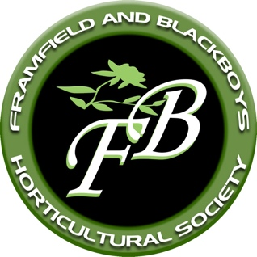

**Framfield & Blackboys**

**Horticultural Society**

**MEMBERSHIP FORM 2025**

Name .……………………………………………………………………..

Address

Telephone ………………………………… Signature…………………………………………..….

Email

Tates of Sussex Horticultural Loyalty Scheme card ‘TR number’ (if applicable *) ……………….

*Only applicable for renewals, not new members, sorry

The membership period for this year will run from 1st Jan to 31st Dec 2025

Single: £10 Family: £15 I have paid by BACS

x

Data Protection Act: We hold details of your name, address, email address and telephone number. We only use this data to operate the membership of the society and to make contact with you and keep you up to date with what’s going on in the Society. These details are not passed to any third party. We keep the data secure and password protected on any electronic device. If, at any time, you wish to be removed from our database we will remove your details and you will be ‘forgotten’ and we will no longer contact you. If you are happy for us to continue to hold your information can you **please tick the box below**.

*I consent to Framfield and Blackboys Horticultural Society holding my name, address,*

*telephone number and email address for the purpose of contacting me in connection*

*with the operation and communication of my membership****.***

Please return completed form, with your remittance ** (cheques should be made payable to ‘Framfield & Blackboys Horticultural Society’) to:

Emma Page, Little Badgers, Possingworth Park, Cross-in-Hand, TN21 0TN

Tel: 01435 863311, email:[fabhs.membership@gmail.com](mailto:fabhs.membership@gmail.com)

** For bacs payments, please tick the relevant box above and make payment to:

Lloyds Account: 40048362

Sort Code: 30-99-50

Account name: Framfield & Blackboys Horticultural Society

We hope you enjoy and benefit from your membership and look forward to seeing you during the coming year.

**www.framfieldandblackboys-hort-soc.com**