UNIT 1: INTRODUCTION

This is a fantastic time to be entering the business world, because business is going to change more in the next 10 years than it has in the last 50.”
- Bill Gates, entrepreneur and founder, Microsoft
- WHAT IS BUSINESS RESEARCH
A process of determining, acquiring, analyzing, synthesizing, and disseminating relevant business data, information, and insights to decision makers in ways that mobilize the organization to take appropriate business actions that, in turn, maximize business performance
Business research is defined as the systematic and objective process of generating information for aid in making business decisions.
- WHY STUDY BUSINESS RESEARCH
- Business research provides information to guide business decisions
- The primary purpose of research is to reduce the level of risk in a decision
- Research helps in respond to change
- WHAT’S CHANGING IN BUSINESS THAT INFLUENCES RESEARCH

Several factors increase the relevance for studying business research.
- Information overload. While the Internet and its search engines present extensive amounts of information, its quality and credibility must be continuously evaluated. The ubiquitous access to information has brought about the development of knowledge communities and the need for organizations to leverage this knowledge universe for innovation—or risk merely drowning in data. Stakeholders now have more information at their disposal and are more resistant to business stimuli.
- Technological connectivity. Individuals, public sector organizations, and businesses are adapting to changes in work patterns (real-time and global), changes in the formation of relationships and communities, and the realization that geography is no longer a primary constraint.
- Shifting global centers of economic activity and competition. The rising economic power of Asia and demographic shifts within regions highlight the need for organizations to expand their knowledge of consumers, suppliers, talent pools, business models, and infrastructures with which they are less familiar.
- Increasingly critical scrutiny of big business. The availability of information has made it possible for all a firm’s stakeholders to demand inclusion in company decision making, while at the same time elevating the level of societal suspicion.
- More government intervention. As public-sector activities increase in order to provide some minimal or enhanced level of social services, governments are becoming increasingly aggressive in protecting their various constituencies by posing restrictions on the use of managerial and business research tools.
- Battle for analytical talent. Managers face progressively complex decisions, applying mathematical models to extract meaningful knowledge from volumes of data and using highly sophisticated software to run their organizations. The shift to knowledge-intensive industries puts greater demand on a scarcity of well-trained talent with advanced analytical skills.
- Computing Power and Speed. Lower cost data collection, better visualization tools, more computational power, more and faster integration of data, and real-time access to knowledge are now manager expectations…not wistful visions of a distant future.
- New Perspectives on Established Research Methodologies. Older tools and methodologies, once limited to exploratory research, are gaining wider acceptance in dealing with a wider range of managerial problems.

- BUSINESS PLANNING DRIVES BUSINESS RESEARCH

An organization’s mission drives its business goals, strategies, and tactics and, consequently, its need for business decision support systems and business intelligence. Students need to understand the differences in these concepts to fully understand what drives a manager to seek solutions through research.
- INFORMATION SOURCES

When elements of data are organized for retrieval, they collectively constitute a business decision support system (DSS). This data is often shared over an intranet or an extranet.
- An intranet is a private network that is contained within an enterprise and is not available to the public at large. It may consist of many interlinked local area networks. It typically includes connections through one or more computers to the Internet. The main purpose of an intranet is to share company information and computing resources among internal audiences.
- An extranet is a private network that uses the Internet protocols and the public telecommunication system to share an organization’s information, data, or operations with external suppliers, vendors, or customers. An extranet can be viewed as the external portion of a company’s intranet.
- A business intelligence system (BIS) is designed to provide ongoing information about events and trends in the technological, economic, political and legal, demographic, cultural, social, and competitive areas.
- SOURCES OF BUSINESS INTELLIGENCE

- Sources of government information include speeches by elected officials, recordings of public proceedings, press releases, and agency websites.
- Sources of competitive information include presentations at conferences, literature searches, press releases, syndicated industry studies, web sites, clipping services, and business research.
- Sources of economic information include literature searches and government reports.
- Sources of cultural and social information include syndicated studies, public opinion organizations, business research, and government reports.
- Sources of technological information include patent filings, web sites, syndicated industry studies, presentations at conferences, literature searches, and clipping services.
- Sources of demographic information include syndicated studies, government reports, and business research.
- DETERMINING WHEN TO CONDUCT BUSINESS RESEARCH
- Time constraints
- Availability of data
- Nature of the decision
- Benefits versus costs

Value Should Exceed Estimated Costs

- CHARACTERISTICS OF GOOD RESEARCH

- CATEGORIES OF RESEARCH (ON THE BASIS OF APPLICATION)

- Applied research applies research to discovering solutions for immediate problems or opportunities.
- Basic (or pure) research aims to solve perplexing questions or obtain new knowledge of an experimental or theoretical nature that has little direct or immediate impact on action, performance, or policy decisions.
91. BASIC RESEARCH
- Attempts to expand the limits of knowledge.
- Not directly involved in the solution to a pragmatic problem.
For Example
- Is executive success correlated with high need for achievement?
- Are members of highly cohesive work groups more satisfied than members of less cohesive work groups?
- Do consumers experience cognitive dissonance in low-involvement situations?

9.2 APPLIED RESEARCH
- Conducted when a decision must be made about a specific real-life problem
For Example
- Should McDonalds add Italian pasta dinners to its menu?
- Business research told McDonald’s it should not?
- Should Procter & Gamble add a high-priced home teeth bleaching kit to its product line?

- TYPES OF RESEARCH (ON THE BASIS OF METHOD)
- Exploratory
- Descriptive
- Causal
Uncertainty Influences the Type Of Research

Degree of Problem Definition

10.1 EXPLORATORY RESEARCH
- Initial research conducted to clarify and define the nature of a problem
- Does not provide conclusive evidence
- Subsequent research expected
Methods used are
- Secondary data
- Experience survey
- Pilot studies
10.2 DESCRIPTIVE RESEARCH
- Describes characteristics of a population or phenomenon
- Some understanding of the nature of the problem
For Example
- Men’s fragrance market
- 1/3 size of women’s fragrance market
- But growing at a faster pace
- Women buy 80 % of men’s fragrances

10.3 CAUSAL RESEARCH
- Conducted to identify cause and effect relationships

Quantitative vs Qualitative research
On the basis of type of data involved
Longitudinal vs Cross-Sectional research
On the basis of time period involved

- MAJOR TOPICS FOR RESEARCH IN BUSINESS
- General Business Conditions and Corporate Research
- Financial and Accounting Research
- Management and Organizational Behavior Research
- Sales and Marketing Research
- Information Systems Research
- Corporate Responsibility Research

- THE RESEARCH PROCESS
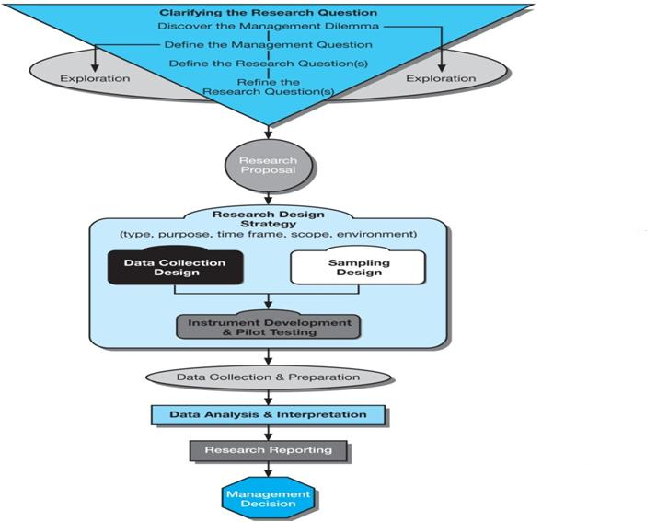

STAGE 1: CLARIFYING THE RESEARCH QUESTION

The first stage of the process, clarify the research question.
A useful way to approach the research process is to state the basic dilemma that prompts the research and then try to develop other questions by progressively breaking down the original question into more specific ones. This process can be thought of as the management-research question hierarchy.
The process begins at the most general level with the management dilemma. This is usually a symptom of an actual problem, such as rising costs, declining sales, or a large number of defects.
Key terms:
- A management dilemma is an opportunity of problem that the manager has discovered because of one or more symptoms.
- A management question is a restatement of the manager’s dilemma in question form.
- A research question is the hypothesis that best states the objective of the research; the question that focuses the researcher’s attention.
- An investigative question is the question the researcher must answer to satisfactorily answer the research question.
- A measurement question is the question asked of the participant or the observations that must be recorded.
Management-Research Question Hierarchy
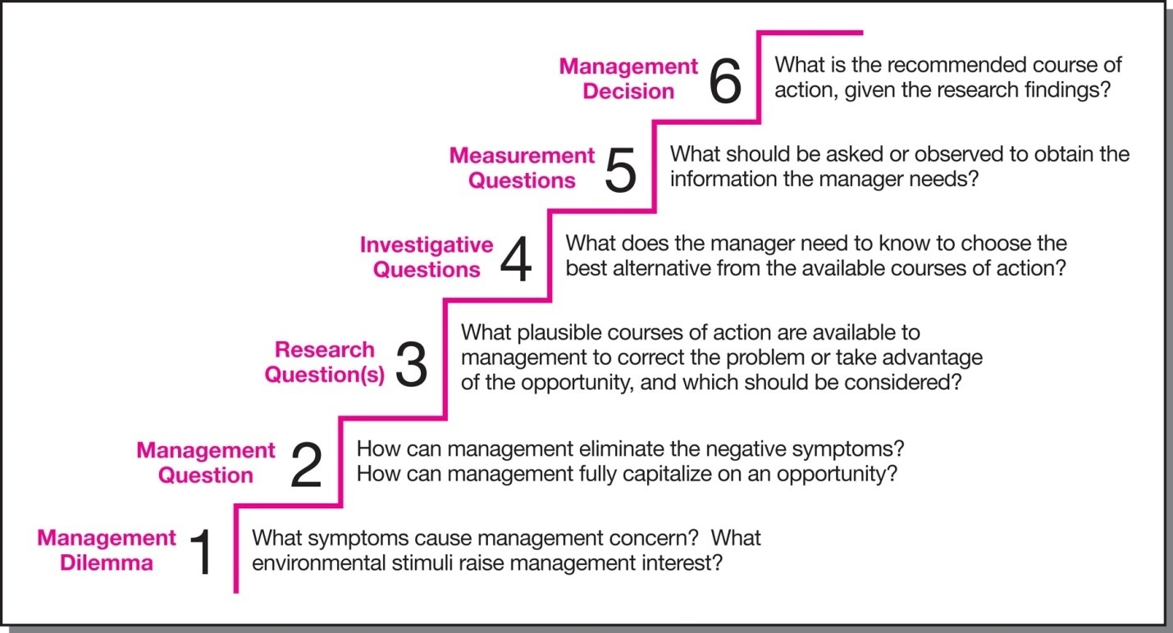
The management-research question hierarchy process is designed to move the researcher through various levels of questions, each with a specific function within the overall marketing research process.

FORMULATING THE RESEARCH QUESTION
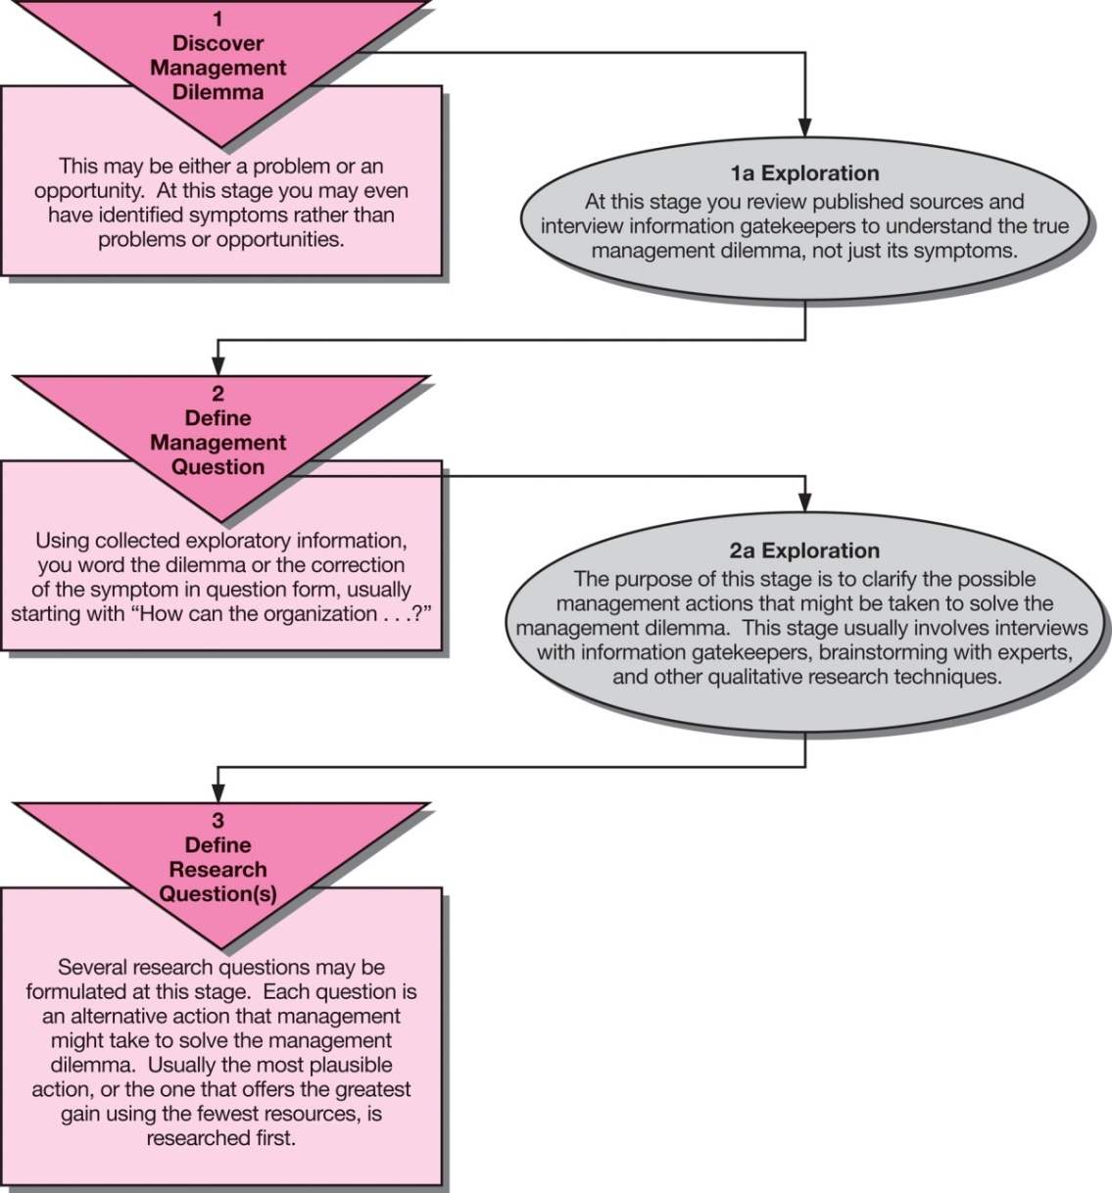
How exploration leads back into the formulation of management questions and research questions
TYPES OF MANAGEMENT QUESTIONS
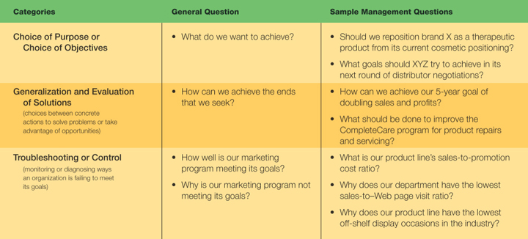
THE RESEARCH QUESTION
A research question best states the objective of the marketing research study. Incorrectly defining the research question is the fundamental weakness in the marketing research process.
After the exploration process is complete, the researcher must fine-tune the research question. At this point, the research question will have evolved in some fashion. It will have better focus.
In addition to fine-tuning the original question, other research question-related activities should be addressed in this phase to enhance the direction of the project.
  - Examine variables to be studied and assess whether they are operationally defined.
  - Review the research questions to break them down into second and third-level questions.
  - If hypotheses are used, be sure they meet the quality tests.
  - Determine what evidence must be collected to answer the various questions and hypotheses.
Set the scope of the study by stating what is not a part of the research question
INVESTIGATIVE QUESTIONS

DEFINING PROBLEM RESULTS IN CLEAR CUT RESEARCH OBJECTIVES

PROBLEM DISCOVERY AND DEFINITION
- First step
- Problem, opportunity, or monitor operations
- Discovery before definition
- Problem means management problem
STATE THE RESEARCH QUESTIONS AND RESEARCH OBJECTIVES
HYPOTHESIS
- A statement
- that can be refuted
- by empirical data

