UNIT 2 RESEARCH DESIGN

Language of Research
Several terms are used by researchers to converse about applied and theoretical business problems.
  - A concept is a bundle of meanings or characteristics associated with certain concrete, unambiguous events, objects, conditions, or situations. The importance of conceptualization is discussed in the following slide.
  - A construct is a definition specifically invented to represent an abstract phenomena for a given research project.
  - A conceptual scheme is the interrelationship between concepts and constructs.
  - An operational definition defines a variable in terms of specific measurement and testing criteria.
  - A variable is used as a synonym for the construct being studied.
  - A proposition is a statement about observable phenomena that may be judged as true or false.
  - A hypothesis is a proposition formulated for empirical testing.
  - A theory is a set of systematically interrelated concepts, definitions, and propositions that are advanced to explain or predict phenomena.
A model is a representation of a system constructed to study some aspect of that system.

Concept (or Construct)
- A generalized idea about a class of objects, attributes, occurrences, or processes that has been given a name
- Building blocks that abstract reality
- “leadership,” “productivity,” and “morale”
- “gross national product,” “asset,” and “inflation”
Scientific Business Researchers Operate at Two Levels
- Abstract level
  - concepts
  - propositions
- Empirical level
  - variables
  - hypotheses
- Abstract level -In theory development, the level of knowledge expressing a concept that exists only as an idea or a quality apart from an object.
- Empirical level -Level of knowledge reflecting that which is verifiable by experience or observation.
Abstract Level
Concepts abstract reality.
Propositions are statements concerned with the relationships among concepts.

Proposition at Abstract Level

- A hypothesis is a proposition that is empirically testable. It is an empirical statement concerned with the relationship among variables.
- A variable is anything that may assume different numerical values.
Job Redesign Constructs and Concepts
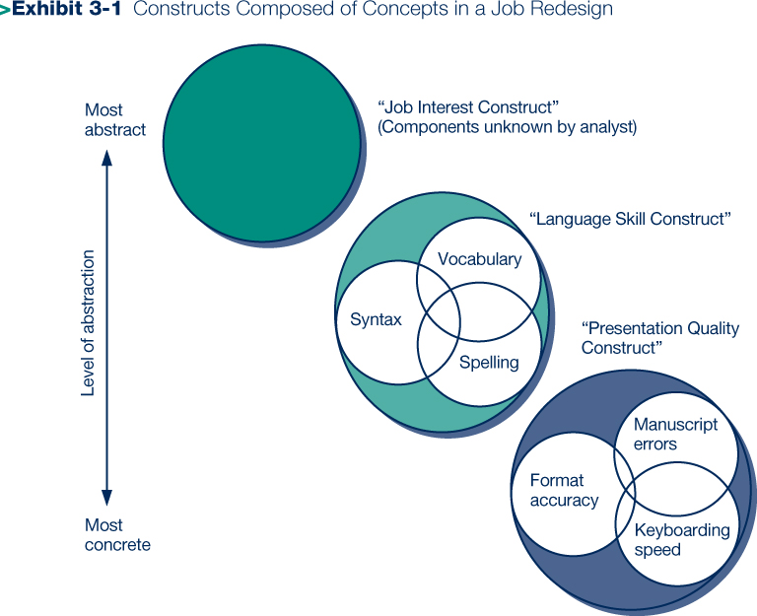

Operational Definitions

A Variable Is the Property Being Studied

Types of Variables

Independent and Dependent Variable Synonyms

Relationships Among Variable Types
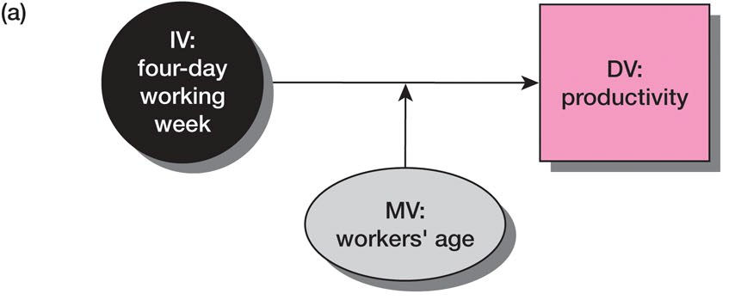
Moderating Variables (MV)
Moderating variables are variables that are believed to have a significant contributory or contingent effect on the originally stated IV-DV relationship. Whether a variable is treated as an independent or as a moderating variable depends on the hypothesis.
- The introduction of a four-day week (IV) will lead to higher productivity (DV), especially among younger workers (MV)
- The switch to commission from a salary compensation system (IV) will lead to increased sales (DV) per worker, especially more experienced workers (MV).
- The loss of mining jobs (IV) leads to acceptance of higher-risk behaviors to earn a family-supporting income (DV) – particularly among those with a limited education (MV).
Extraneous Variables (EV)
Extraneous variables are variables that could conceivably affect a given relationship. Some can be treated as independent or moderating variables or assumed or excluded from the study. If an extraneous variable might confound the study, the extraneous variable may be introduced as a control variable to help interpret the relationship between variables.
- With new customers (EV-control), a switch to commission from a salary compensation system (IV) will lead to increased sales productivity (DV) per worker, especially among younger workers (MV).
- Among residents with less than a high school education (EV-control), the loss of jobs (IV) leads to high-risk behaviors (DV), especially due to the proximity of the firing range (MV).
Intervening Variables (IVV)
An intervening variable (IVV) is a factor that affects the observed phenomenon but cannot be measured or manipulated. It is a conceptual mechanism through which the IV and MV might affect the DV.
- The switch to a commission compensation system (IV) will lead to higher sales (DV) by increasing overall compensation (IVV).
- A promotion campaign (IV) will increase savings activity (DV), especially when free prizes are offered (MV), but chiefly among smaller savers (EV-control). The results come from enhancing the motivation to save (IVV).
Propositions and Hypotheses
A proposition is a statement about observable phenomena that may be judged as true or false.
A hypothesis is a proposition formulated for empirical testing.

Hypothesis Formats
A descriptive hypothesis is a statement about the existence, size, form, or distribution of a variable. Researchers often use a research question rather than a descriptive hypothesis. Examples are provided in the slide. Either format is acceptable, but the descriptive hypothesis has three advantages over the research question.
- Descriptive hypotheses encourage researchers to crystallize their thinking about the likely relationships.
- Descriptive hypotheses encourage researchers to think about the implications of a supported or rejected finding.
- Descriptive hypotheses are useful for testing statistical significance.

Relational Hypotheses
A relational hypothesis is a statement about the relationship between two variables with respect to some case. Relational hypotheses may be correlational or explanatory (causal).
A correlational hypothesis is a statement indicating that variables occur together in some specified manner without implying that one causes the other.
A causal hypothesis is a statement that describes a relationship between two variables in which one variable leads to a specified effect on the other variable.

The Role of Hypotheses

Characteristics of Strong Hypotheses

Research Design: An Overview
There are many definitions of research design. Research design is the blueprint for fulfilling research objectives and answering questions. Its essentials include 1) an activity and time-based plan, 2) a plan based on the research questions, 3) a guide for selecting sources and types of information, 4) a framework for specifying the relationships among the study’s variables, and 5) a procedural outline for every research activity.
Design in the Research Process
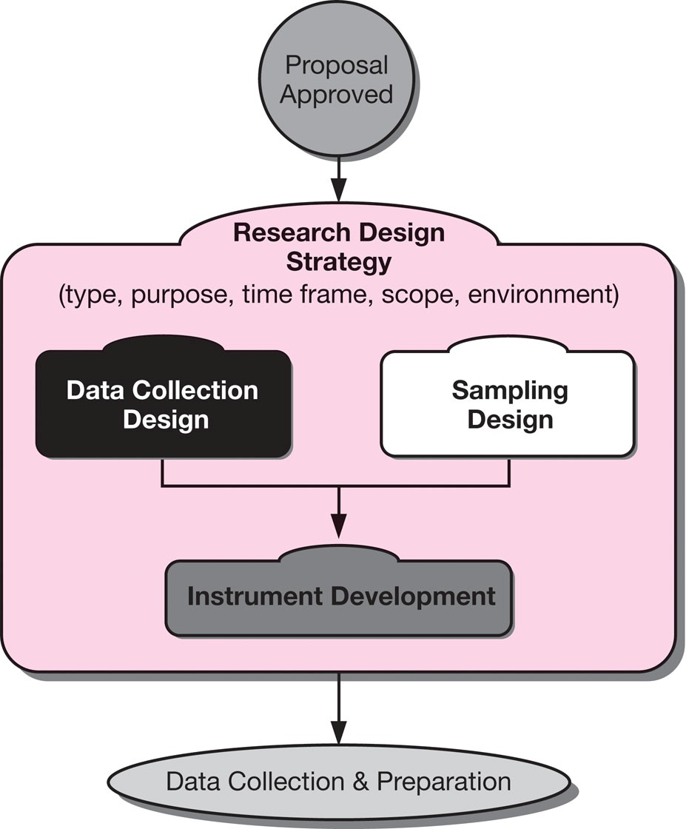

Research Design Descriptors
The degree to which the research question has been crystallized
- Exploratory study
- Formal study
The method of data collection
- Monitoring
- Communication Study
The power of the researcher to produce effects in the variables under study
- Experimental
- Ex post facto
The purpose of the study
- Reporting
- Descriptive
- Causal-Explanatory
- Causal-Predictive
The time dimension
- Cross-sectional
- Longitudinal
The topical scope—breadth and depth—of the study
- Case
- Statistical study
The research environment
- Field setting
- Laboratory research
- Simulation
The participants’ perceptional awareness of the research activity
- Actual routine
- Modified routine

Descriptive Studies

The purpose of the study asks whether the research is concerned with describing the population’s characteristics or with trying to explain the relationships among variables. Descriptive studies discover the answers to the questions who, what, when, where, or how much.

Experiments (Causal Research Design)
An experiment is a study involving intervention by the researcher beyond that required for measurement. The usual intervention is to manipulate some variable in a setting and observe how it affects the participants or subjects being studied. There is at least one independent variable (IV) and one dependent variable (DV) in a causal relationship.
There are three types of evidence necessary to support causality. First, there must be an agreement between independent and dependent variables. The presence or absence of one is associated with the presence or absence of the other. Second, beyond the correlation of independent and dependent variables, we consider the time order of the occurrence of the variables. The effect on the dependent variable should not precede the manipulation of the independent variable. The effect and manipulation may occur simultaneously or the manipulation may occur before the effect. The third source of support comes when researchers are confident that other extraneous variables did not influence the dependent variable. To ensure that these other variables are not the source of influence, researchers control their ability to confound the planned comparison.
Conducting an Experiment

Experimental Research Designs

One Group Pretest-Posttest

Pretest-Posttest Control Group Design

Posttest-Only with Control Group

Advanced Experimental Designs are More Complex
- Completely randomized
- Randomized block design
- Latin square
- Factorial
Completely Randomized Design
- An experimental design that uses a random process to assign subjects (test units) and treatments to investigate the effects of only one independent variable.

Randomized Block Design
- An extension of the completely randomized design in which a single extraneous variable that might affect test units’ response to the treatment has been identified and the effects of this variable are isolated by blocking out its effects.

Factorial Design
- An experiment that investigates the interaction of two or more variables on a single dependent variable.
Effects
- Main effect
- The influence of a single independent variable on a dependent variable.
- Interaction effect
- The influence on a dependent variable by combinations of two or more independent variables.
2 x 2 Factorial Design

Interaction Between Gender and Advertising Copy

Latin Square Design
- A balanced, two-way classification scheme that attempts to control or block out the effect of two or more extraneous factors by restricting randomization with respect to the row and column effects.

