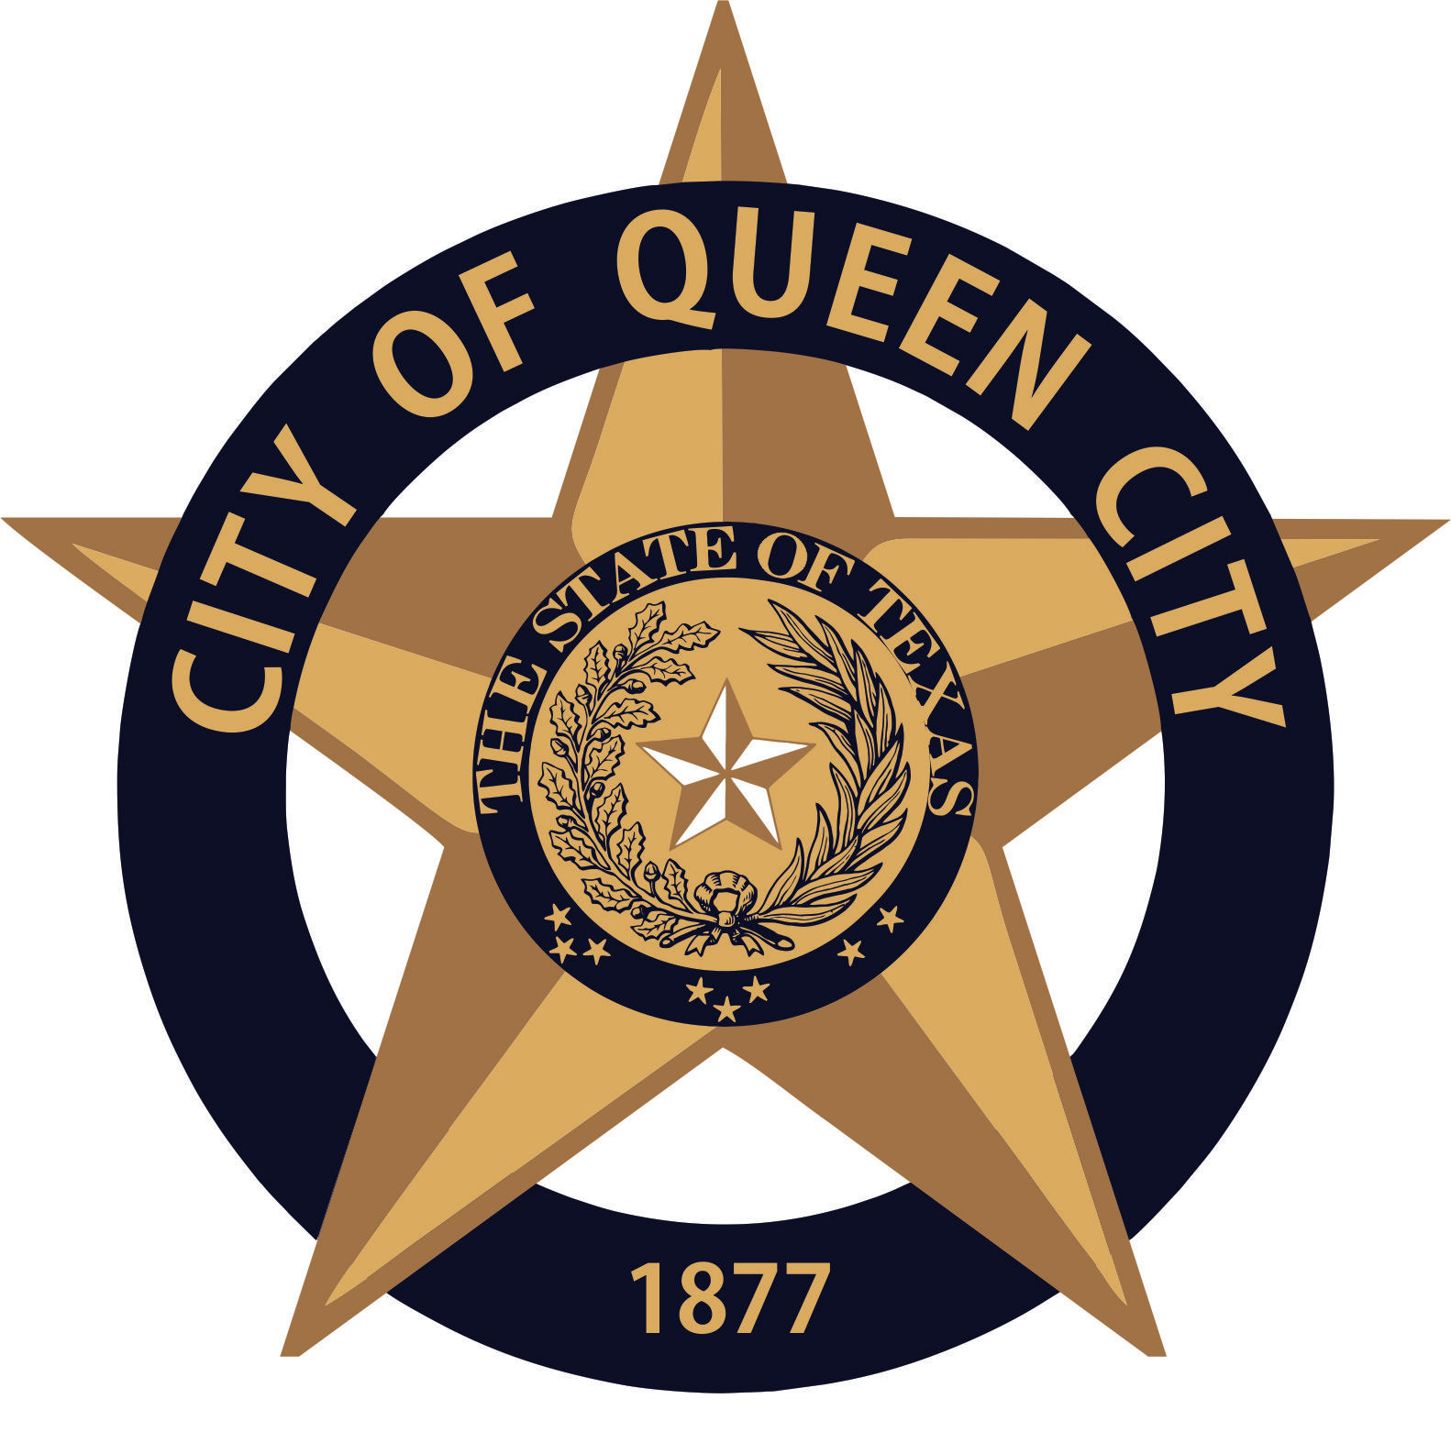
City Hall
601 Loop236
Queen City, TX
CITY OF QUEEN CITY, TX
REGULAR COUNCIL MEETING
Agenda

Thursday, April 8, 2021 6:30 P.M. City Hall

I. Call to Order
1. Invocation
2. Pledge of Allegiance

- Open Forum

- Consider, Discuss and Approve Ordinance Codification and Legal Review Services Agreement with Franklin Publishing.

- Reports:
1. Mayor
2. Chief of Police
3. Receive any other reports as necessary: City Secretary, EDC, Public Works, Tourism, City Judge, etc.
- Permits Issued: March 2021: New Business 0 / Building 0 / Electrical 2 / Plumbing 1 / Gas 0 / HVAC 0

XI. Consent Agenda
Items marked with an * are on the consent agenda will be voted on in one motion unless a Council Member asks for a separate discussion.
1. Approval of Minutes for March 11,2021*
2. Approval of Monthly Financial Statements*
3. Approval of Payment of Bills*

XII. Executive Session (If necessary)
The Council reserves the right to retire into executive session concerning any of the items listed on this Agenda or whenever it is considered necessary and legally justified under the Open Meetings Act.

XIII. Reconvene from Executive Session (If necessary)

- Adjournment

Persons with disabilities who plan to attend this meeting and who may need assistance should contact City Hall,
at 903-796-7986 two working days prior to meeting so that arrangements can be made.

I, the undersigned authority, hereby certify the notice of this meeting was conducted in accordance with the Texas Open Meetings Act, Government Code 551. Notice was posted at City Hall, readily accessible to the Public at all times,
on April 5, 2021 prior to 4:30 p.m. and remained as such preceding the convening of said meeting.

___________________________
CITY SECRETARY

