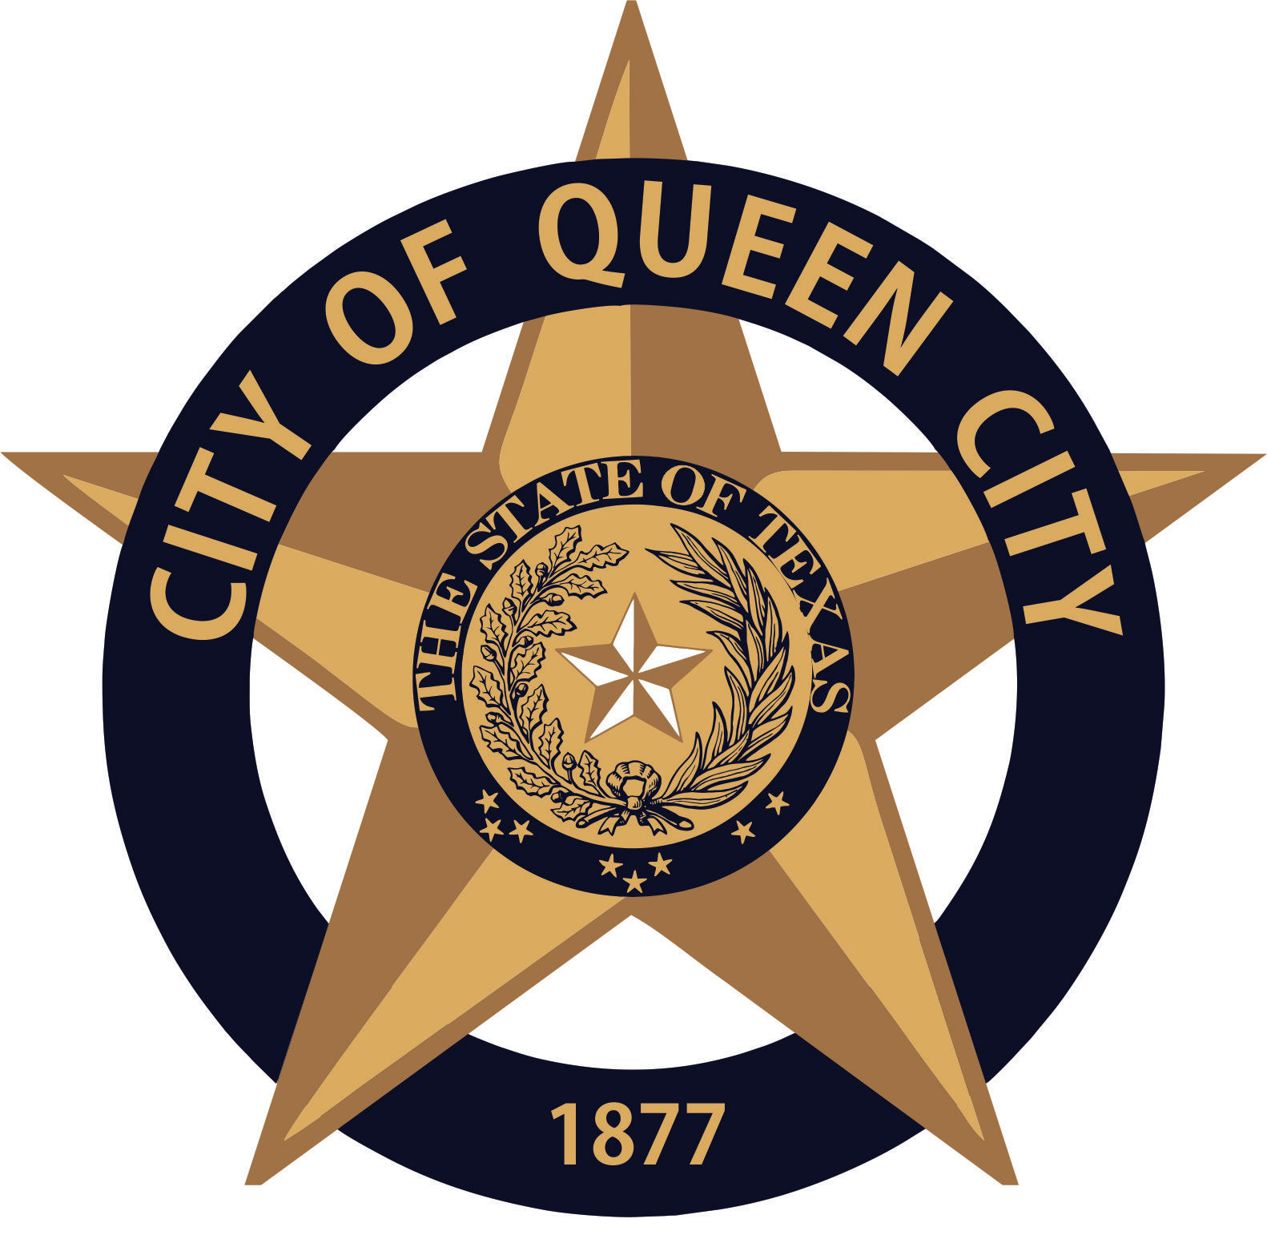

CITY OF QUEEN CITY, TX
City Hall
601 Loop236
Queen City, TX
REGULAR COUNCIL MEETING
Agenda

Thursday, August 12, 2021 6:30 P.M. City Hall

- Call to Order
1. Invocation
2. Pledge of Allegiance

- Open Forum

- Receive Report from Chief Appraiser over the 2021 Appraisal Roll Values

- Consider, Discuss and Act on Resolution No. 2021.07 to authorize the submission of an Economic Development (EDA) Grant and authorizing the Mayor to act as executive officer.
- Resolution is attached as Exhibit A

- Consider, discuss and act on changing regular council meeting times to 6:00pm.

- Consider, discuss and Act on Proposed Tax Rates for FY 2021-2022

- Consider, discuss and Act on Water Rates for FY 2021-2022

- Reports:
1. Mayor
2. Chief of Police
3. Receive any other reports as necessary: City Secretary, EDC, Public Works, Tourism, City Judge, etc.

- Consent Agenda
Items marked with an * are on the consent agenda will be voted on in one motion unless a Council Member asks for a separate discussion.
1. Approval of Minutes for the Regular Council Meeting, July 8,2021
2. Approval of Monthly Financial Statements*
3. Approval of Payment of Bills*

- Executive Session (If necessary)
The Council reserves the right to retire into executive session concerning any of the items listed on this Agenda or whenever it is considered necessary and legally justified under the Open Meetings Act.

- Reconvene from Executive Session (If necessary)

- Adjournment

Persons with disabilities who plan to attend this meeting and who may need assistance should contact City Hall,
at 903-796-7986 two working days prior to meeting so that arrangements can be made.

I, the undersigned authority, hereby certify the notice of this meeting was conducted in accordance with the Texas Open Meetings Act, Government Code 551. Notice was posted at City Hall, readily accessible to the Public at all times,
on August 9 ,2021 prior to 4:30 p.m. and remained as such preceding the convening of said meeting.

___________________________
CITY SECRETARY

