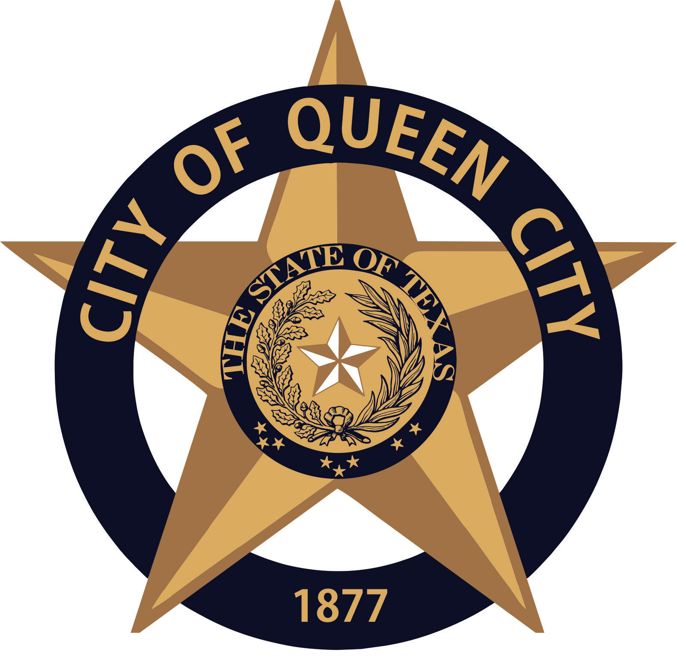
City Hall
601 Loop236
Queen City, TX
CITY OF QUEEN CITY, TX
PUBLIC HEARING
Agenda

Monday, September 21, 2020 5:30 P.M. City Hall

- Call to Order

- Public Hearing over FY Budget 2020-2021

- Consider, Discus and approve FY 2020-2021 Budget Ordinance 2020.06

- Consider, Discus and approve Water Rates for FY 2020-2021/ Ordinance 2020.07

- Adjournment

Persons with disabilities who plan to attend this meeting and who may need assistance should contact Amanda Wiley, at 903-796-7986 two working days prior to meeting so that arrangements can be made.

This is to certify that I, Amanda Wiley,___________________________________, City Secretary, posted this Agenda at the glass front door of the City Hall, facing the outside, for public viewing twenty-four hours a day, at 4:30 p.m., on September 17, 2020.

