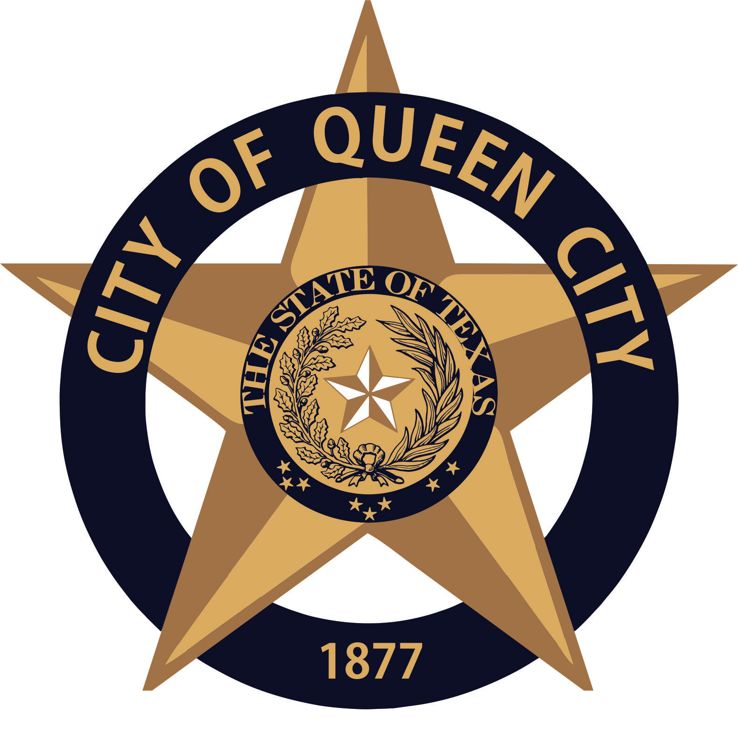
City Hall
601 Loop236
Queen City, TX
CITY OF QUEEN CITY, TX
PUBLIC HEARING
Agenda

December 10, 2020 6:15 P.M. City Hall

- PUBLIC HEARING
- Zoning for the Sale of Alcoholic Beverages in the City Limits of Queen City

Persons with disabilities who plan to attend this meeting and who may need assistance should contact Amanda Wiley, at 903-796-7986 two working days prior to meeting so that arrangements can be made.

This is to certify that I, Amanda Wiley, City Secretary, posted this Agenda at the glass front door of the City Hall, facing the outside, for public viewing twenty-four hours a day, at 4:30 p.m., on December 7, 2020.

