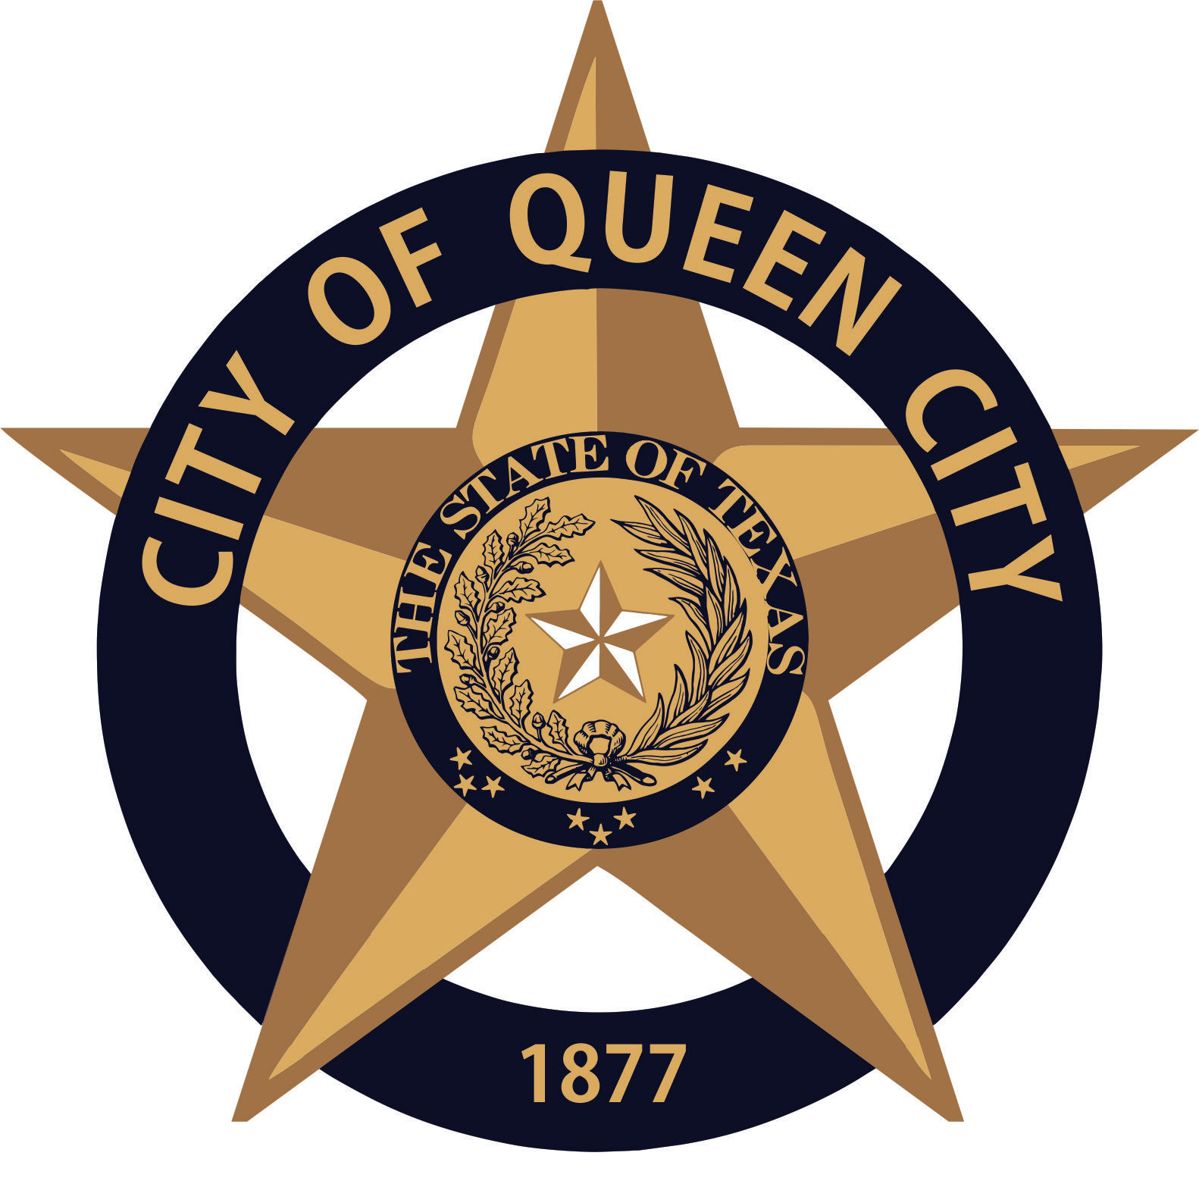
City Hall
601 Loop236
Queen City, TX
CITY OF QUEEN CITY, TX
REGULAR COUNCIL MEETING
Agenda

Thursday, February 11, 2021 6:30 P.M. City Hall

I. Call to Order
1. Invocation
2. Pledge of Allegiance

- Open Forum

- Consider, Discuss and Approve Manufactured Home application for 1108 2nd St.

- Consider, Discuss and Approve Ordinance 2021.02, regulating the speed of motor vehicles upon a certain section of SL 236 within the corporate limits of Queen City.

- Consider, Discuss and Approve Resolution, 2021.01, denying SWEPCO's proposed increase in rates; maintaining its current rates; and directing SWEPCO to reimburse the City's rate case expenses.

- Consider, Discuss and Approve a Covid-19 Policy and Procedure for all city employees

- Order of Election for the May 1, 2021 General Election

- Reports:
1. Mayor
2. Chief of Police
3. Receive any other reports as necessary: City Secretary, EDC, Public Works, Tourism, City Judge, etc.
- Permits Issued: January 2021: New Business 0 / Building 0 / Electrical 1 / Plumbing 1/ Gas 2 / HVAC 0

XI. Consent Agenda
Items marked with an * are on the consent agenda will be voted on in one motion unless a Council Member asks for a separate discussion.
1. Approval of Minutes for January 21,2021*
2. Approval of Monthly Financial Statements*
3. Approval of Payment of Bills*

XII. Executive Session (If Necessary)
The Council reserves the right to retire into executive session concerning any of the items listed on this Agenda or whenever it is considered necessary and legally justified under the Open Meetings Act.

- Adjournment

Persons with disabilities who plan to attend this meeting and who may need assistance should contact City Hall, at 903-796-7986 two working days prior to meeting so that arrangements can be made.

This is to certify that I, __________________Amanda Wiley, City Secretary, posted this Agenda at the glass front door of the City Hall, facing the outside, for public viewing twenty-four hours a day, at 4:30 p.m., on February 8, 2021.

