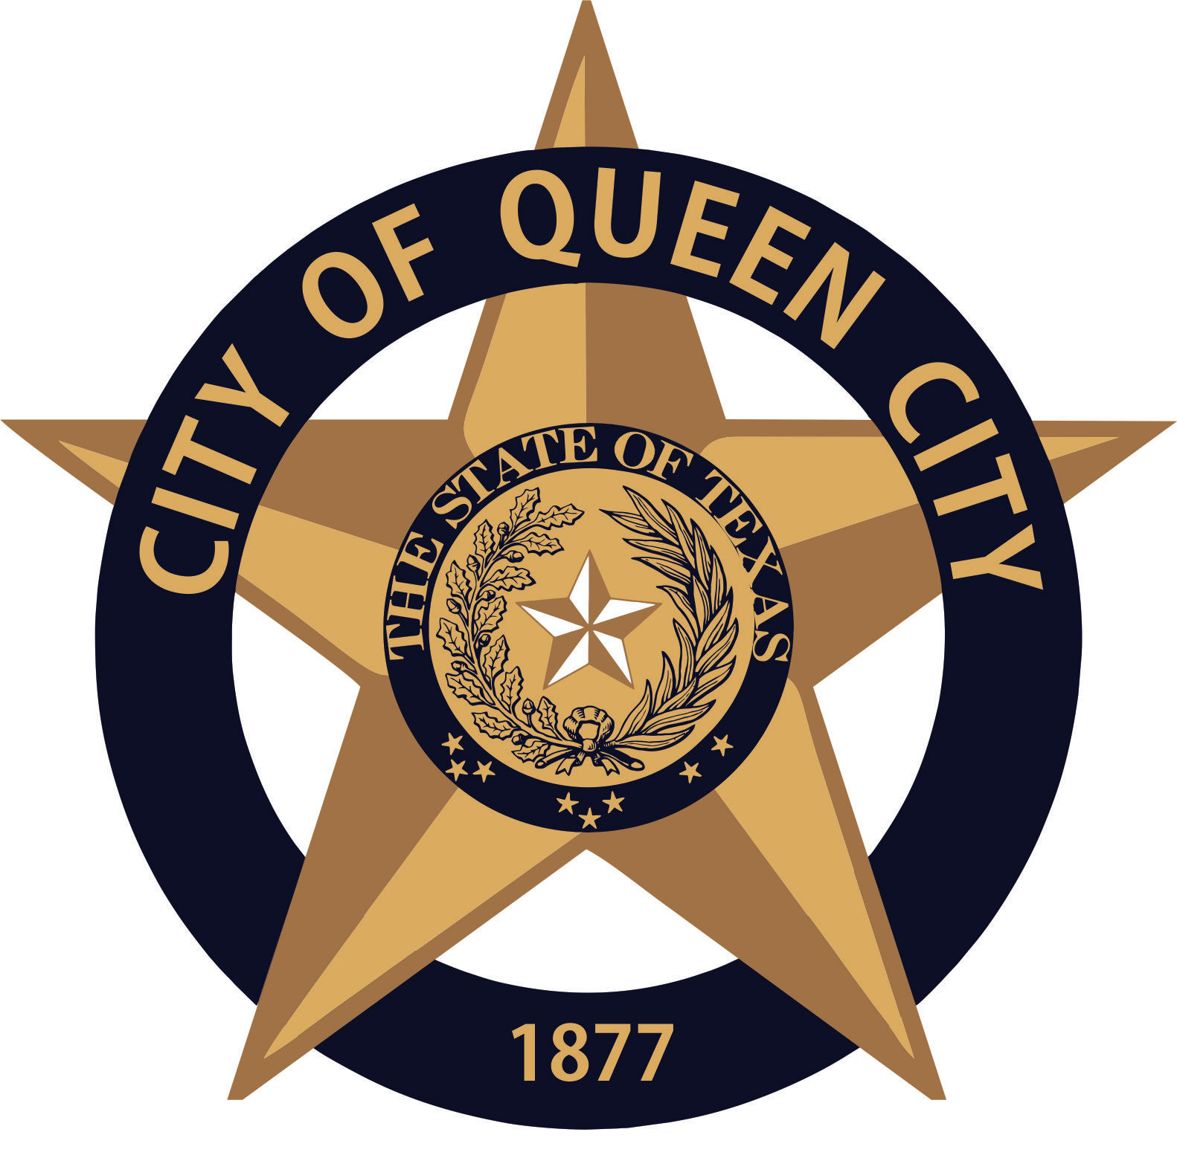
City Hall
601 Loop236
Queen City, TX
CITY OF QUEEN CITY, TX
REGULAR COUNCIL MEETING
Agenda

Thursday, January 21, 2021 6:30 P.M. City Hall

I. Call to Order
1. Invocation
2. Pledge of Allegiance

- Open Forum

- Consider, Discuss and Approve adding Melanie Beckham, assistant City Secretary, to all Bank Accounts, as a check signer, at Cass County Bank, First National Bank, Texar, State Bank and Highway District 19. Becky Walker will be removed and Amanda Wiley, Harold Martin and William Quarles will remain on accounts. Robert McGee will remain on PD Seized Fund Account.

- Consider, Discuss and Approve Ordinance 2021.01, Alcohol/ Liquor Store Zoning

- Consider and Discuss a Covid-19 Policy and Procedure for city employees

- Reports:
1. Mayor
2. Chief of Police
3. Receive any other reports as necessary: City Secretary, EDC, Public Works, Tourism, City Judge, etc.
- Permits Issued: December 2020: New Business 0 / Building 0 / Electrical 1 / Plumbing 1/ Gas 2 / HVAC 0

XI. Consent Agenda
Items marked with an * are on the consent agenda will be voted on in one motion unless a Council Member asks for a separate discussion.
1. Approval of Minutes for November 2020 & December 2020*
2. Approval of Monthly Financial Statements*
3. Approval of Payment of Bills*

XII. Executive Session (If Necessary)
The Council reserves the right to retire into executive session concerning any of the items listed on this Agenda, whenever it is considered necessary and legally justified under the Open Meetings Act.

- Adjournment

Persons with disabilities who plan to attend this meeting and who may need assistance should contact City Hall, at 903-796-7986 two working days prior to meeting so that arrangements can be made.

This is to certify that I, __________________Amanda Wiley, City Secretary, posted this Agenda at the glass front door of the City Hall, facing the outside, for public viewing twenty-four hours a day, at 4:30 p.m., on January 15, 2021.

