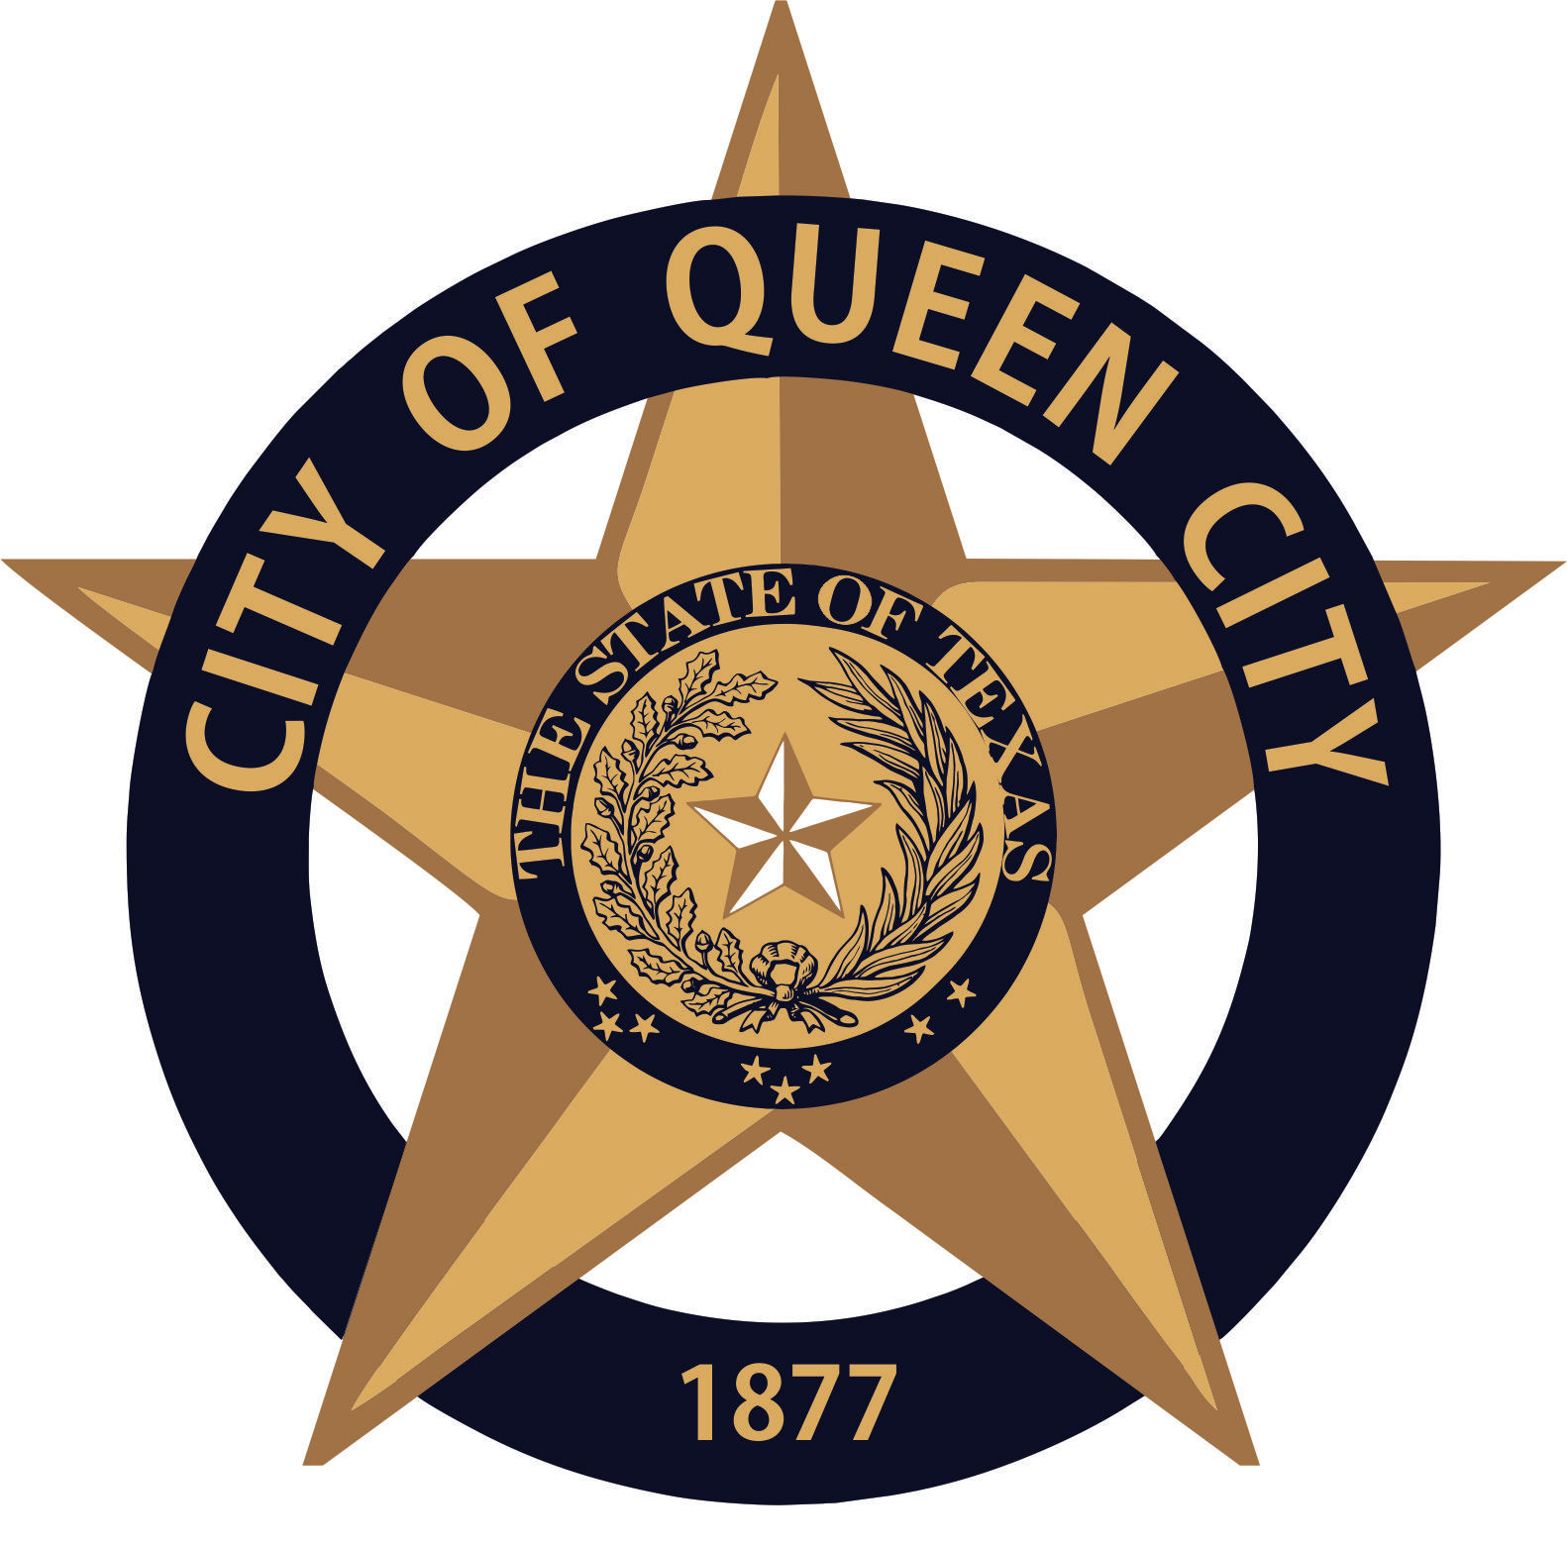
City Hall
601 Loop236
Queen City, TX
CITY OF QUEEN CITY, TX
PUBLIC HEARING
Agenda

Thursday, March 22, 2021 5:00 P.M. City Hall

- PUBLIC HEARING

COMMUNITY DEVELOPMENT BLOCK GRANTPUBLIC HEARING:
- to review performance and obtain comments regarding its 2019 Texas CDBG Program Community Development Contract 7219341.

- Adjournment

Persons with disabilities who plan to attend this meeting and who may need assistance should contact City Hall, at 903-796-7986 two working days prior to meeting so that arrangements can be made.

This is to certify that I, __________________Amanda Wiley, City Secretary, posted this Agenda at the glass front door of the City Hall, facing the outside, for public viewing twenty-four hours a day, at 4:30 p.m., on March 12, 2021.

