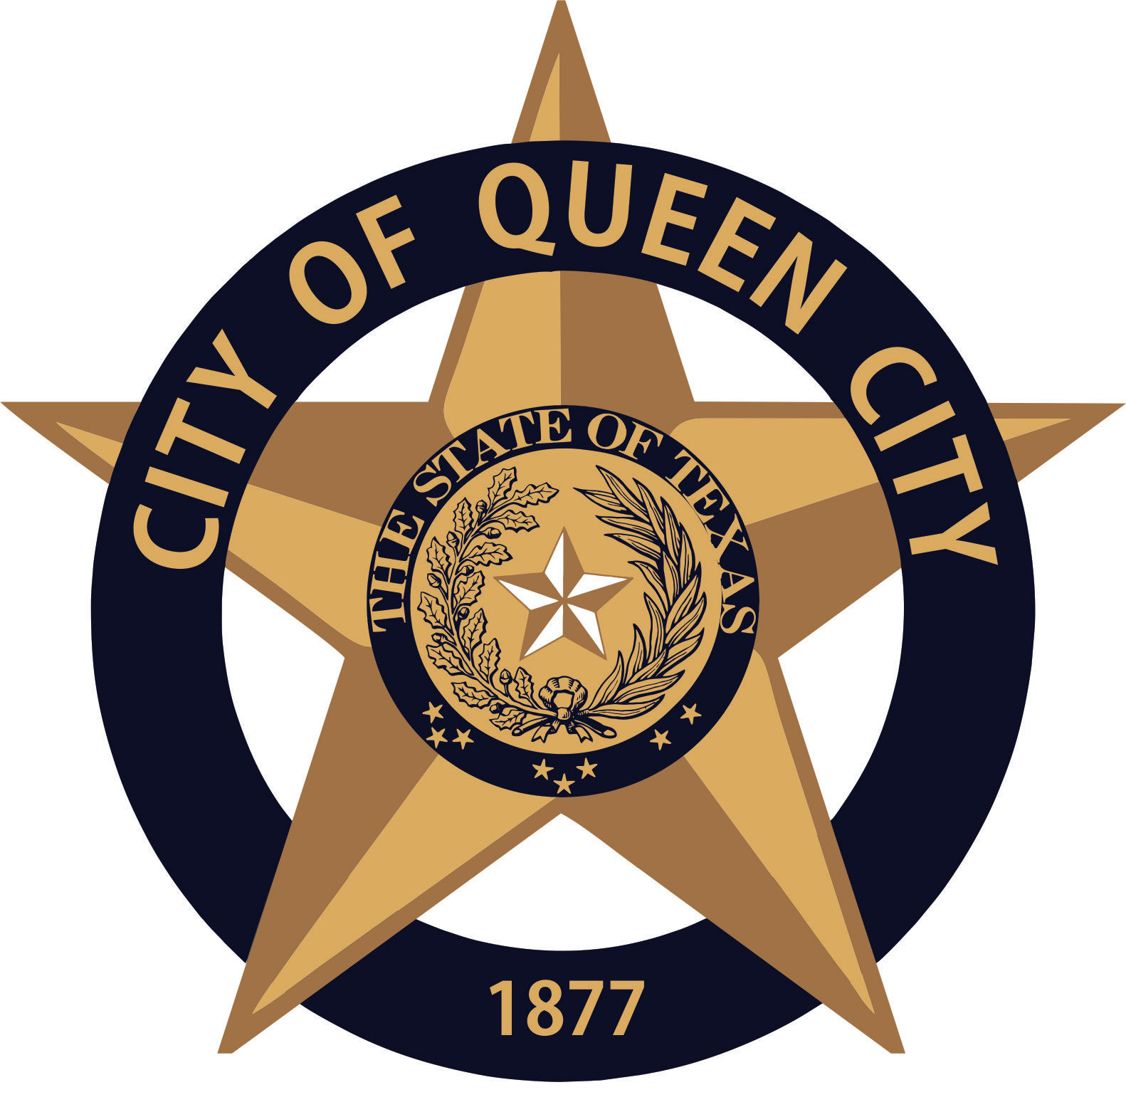
City Hall
601 Loop236
Queen City, TX
CITY OF QUEEN CITY, TX
REGULAR COUNCIL MEETING
Agenda

Thursday, May 6, 2021 9:30am City Hall

- Canvass of the May 1, 2021 Election

Persons with disabilities who plan to attend this meeting and who may need assistance should contact City Hall,
at 903-796-7986 two working days prior to meeting so that arrangements can be made.

I, the undersigned authority, hereby certify the notice of this meeting was conducted in accordance with the Texas Open Meetings Act, Government Code 551. Notice was posted at City Hall, readily accessible to the Public at all times,
on May3, 2021 prior to 4:30 p.m. and remained as such preceding the convening of said meeting.

___________________________
CITY SECRETARY

