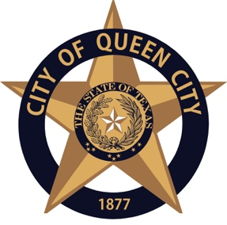
CITY OF QUEEN CITY, TEXAS
601 Loop 236/ PO Box 301: Queen City, TX 75572 | P: 903-796-7986 |F: 855-330-1186

Notice is hereby given of a meeting of the City Council of Queen City to be held on April 9, 2020, 6:00pm at Queen City, City Hall for the purpose of considering the following agenda item. All agenda items are subject to action. The City Council reserves the right to meet in closed session on any agenda item should the need arise and is applicable pursuant to authorization by Title 5, Chapter 551, or the Texas Government Code.

This meeting will be closed to in person attendance by the public. A temporary suspension of the Open Meetings Act to allow telephone or videoconference public meetings has been granted by Governor Greg Abbott. These actions are being taken to mitigate the spread of COVID-19 by avoiding meetings that bring people into a group setting and in accordance with Section 418.016 of the Texas Government Code. Telephonic capabilities will be utilized to allow the Council to convene. Emails may be submitted from citizens with questions or concerns to amanda.wiley@qcpdtx.org. The minutes will be recorded and available to the City on the website following the conclusion of the meeting.
An urgent public necessity exists requiring immediate action of the City Council due to an imminent threat to public health and safety arising from the COVID-19 pandemic.

AGENDA
- Call to Order

- Items to be considered or upon which action may be taken.

  - CONSIDER/APPROVE Financial Statement
CONSIDER/APPROVE Payment of bills for April 2020

Adjournment

This is to certify that I, Amanda Wiley, posted this Agenda for Public Viewing outside of City Hall at 4:00pm. On Monday, April 6, 2020
Amanda Wiley, City Secretary

