The Encounter
Kodály Educators of Texas
August, 2011
in this issue…
President’s Column 1 1
Southern Division President 2 2
Question for Our Members 3 3
Summer Training Review 5 5
Rich Traditions and New Creations 6 6
Workshop Information 8 8
Final Thoughts 9 9

president’s column
Brenda keen
Taking over the reigns from Lisa Roebuck gives me huge shoes to fill! Thank you Lisa for your wonderful guidance and dedication to this organization over the last 4 years! You have been an amazing spearhead for our organization and I can only hope to keep us all as focused and successful as you have been.
I am so excited for our upcoming year in KET! Your executive board met during the TCDA conference on July 28, and I am so pleased with the enthusiasm and dedication of these fine people. Please welcome Katherine Johns as our President Elect and Lauren Bain as our Vice-President/Webmaster. We want to also welcome Debra Johnson as our Central Texas Representative and Kim Nithiananda as our North Texas Representative. Continuing on in service to our organization are John Gillian as West Texas Representative (and President Elect of TMEA!) and David Dalton as our South Texas Representative. What amazing educators and what clear visions they have for our future!
One of the new items we discussed at our executive board meeting was the creation of a Facebook page for KET! It will be a great resource for all of us to stay connected and energized. Please be sure to “friend” us and pass it along to all of your friends as well. We hope it will be a wonderful sharing opportunity for our organization.
Also, we are creating a scholarship program for Texas Kodály training programs. The details will be forthcoming, so be sure to keep checking our website for the application information. This will be intended to provide a grant for a few teachers that want Kodály training and would like the financial help.
As you are reading this article, you will be in the middle of preparing for a new school year full of excitement and great teaching opportunities. Remember that the children have been “starved” for your fun and music-making all summer, so have fun playing! Reviewing is much more enjoyable when you get to play the singing games too!
Thank you again to all those who have served KET and are rotating off the executive board. You will be greatly missed, but we know you will continue to be voices of encouragement as we step forward. Our organization has so much to offer and I look forward to representing KET as its President.
Brenda Keen

southern division president Mary Neeley Stevens
Letter to the Southern Sounds,
Isn’t it interesting that we in the South do not have a sound, but rather, an enormous gulf! We are so rich in musical heritage, the envy of the rest of the nation—from the Appalachian Mountains, to the Georgia Sea Islands, to the Bayous of the Delta, to the cattle ranges of the prairies.
At the end of each school year, the teachers at my school perform a talent show for the students. This year was special. One of my third grade teachers approached me about singing “We Are Climbing Jacob’s Ladder.” She told me she learned the song when she was a little girl. I encouraged her to introduce her song to the children and “go for it.” At the talent show, she explained that her “momma” sang this song to her as the family gathered in the evenings around a big bonfire. The singing began with perfect nuance of tempo, word inflection, and dramatic adjustments to the dynamics. Her mother was definitely present in the room. There was no accompaniment, just a single female voice carrying on a tradition, a witness of faith. The music was so much more than a mere folk song. It was a testament of life’s transition from one generation to the next. Without even asking, I know her daughter has already shared this experience with her daughter. And so the tradition goes on and on.
In our Kodály training we begin with the definition of a folk song. Then, we move on to determine good folk music from the bad. We analyze song material, sequence instruction, create teaching strategies and push on to the next element. Sometimes we lose sight of the significance of our “art.”
As I ponder the end of another school year with all of the financial challenges our school districts are facing, I recall a similar situation my hometown experienced a few years ago. A rural farm community in north central Iowa, rich in performing and visual arts education, was facing budget issues and hired a district superintendent with the hope he would trim and balance the budget. To the community’s dismay, the new budget proposal cut the visual and performing arts programs to the core. The community was outraged. The superintendent was replaced by an art-friendly administrator whose wife became an inspirational choir director. The arts were reinstated and embraced by the students and their families. Please be an active advocate for the arts in our schools. You, as music educators, are the inspirational leaders in your school community!
As you rest and relax this summer, attend a training program or workshop, listen to a concert or the radio, rock your child or grandchild to sleep, remember the ladder we all climb to become better musicians, educators and people…one rung at a time, supported by others and surrounded by generations of glorious “Southern Sounds!”
Respectfully submitted,
Mary Neeley Stevens
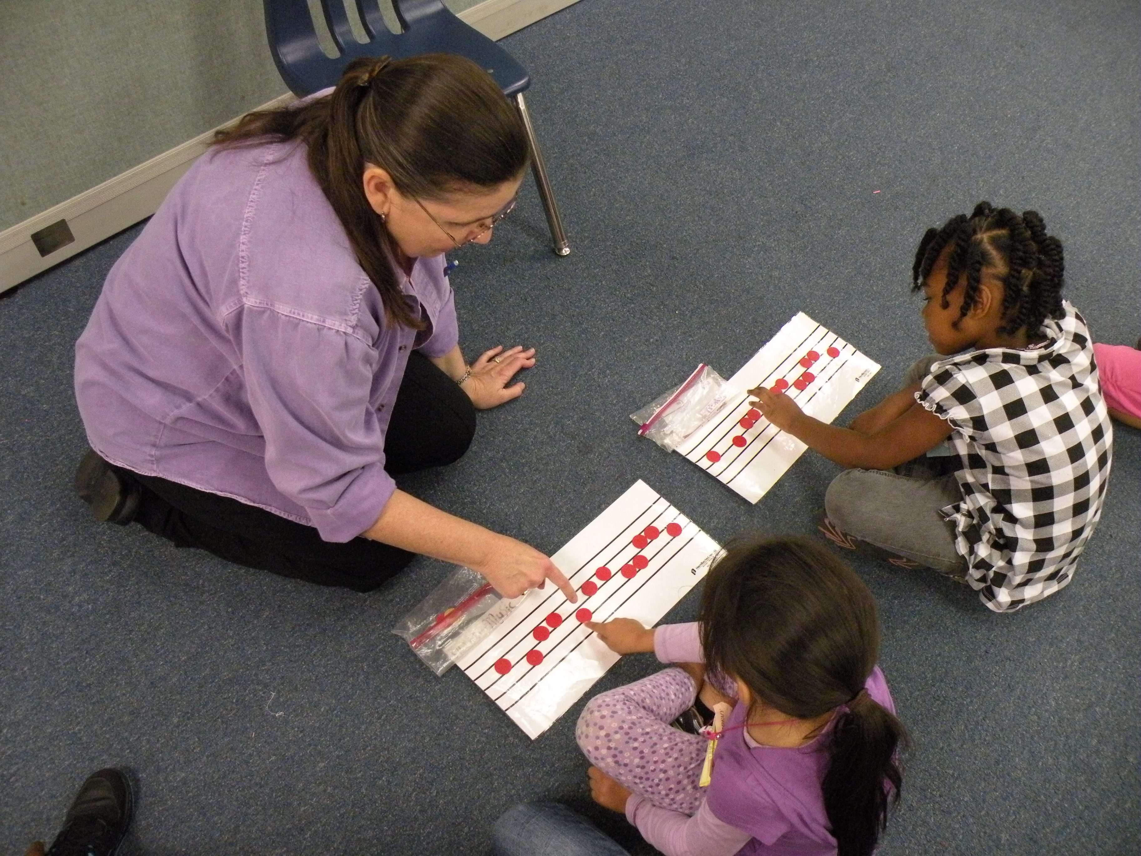
OAKE Southern Division President

a question for our members
Advocacy will play an integral role in our classrooms this year as budgets get smaller, schedules get tighter, and standardized testing continues to grow. Several members submitted answers to the question below:
QUESTION: In this climate of budget cuts and financial strain, what will you do this year (or have you done in the past) to promote and make your program invaluable to your school, without compromising your curriculum?

“Show off what you are doing by inviting parents to come into the classroom to see that you're not ‘just singing and playing games.’ Invite your administration to come into your classroom during key lessons. Hang up student work in the hallways so they can see the reading/writing they are doing. Support your classroom teachers and campus goals by doing extra recorder/drum class during intervention time. This gives higher kids enrichment so that teachers can work with students that need reading & math intervention.”
~Lori Sweet, Elgin ISD

“Fortunately, my teaching partner and I are at a school with a supportive principal and school community. However, during various discussions with my administration and parents who visit our room, I find that they have no idea what we do. We sometimes jokingly suggest that this is not a bad thing ("If they don't know what we do then they won't tell us what to do"), yet is that really beneficial to the long-term health of our program? Also, past approval does not guarantee future support. More than ever, we sense the burden to educate parents and administration about what we do to create a standard of expectation for a healthy music program. We are beginning with a two-fold approach: principal education and parent communication. We are planning to meet with our administration and give them a guide about our teaching methods and some common terminology (students are "keeping the beat" in lieu of "slapping their knees"). This will facilitate more accurate observations and build a lexicon the principals can use in the future. For our parent community, we are going to publish a newsletter for each grade. Parents see amazing programs, however, they also need to see the process that makes those programs possible. Previously we have used our teacher web sites to display important information. Yet, in light of the pressure of budget cuts, we want to make sure that parents understand the characteristics of a high quality music education that will benefit their child for life. We cannot become complacent about advocacy for our programs, district support and national support. We must keep calm, and press on.”
~Corrie Box, North East ISD

“Most administrators and parents have plenty of training and experience in the math, language arts, science, and social studies curricula, but very few of them have ever worked in or had any formal training in the fine arts. This puts fine arts teachers at a disadvantage when trying to show them the value of the fine arts, because they simply don't know what they should be looking for. In many cases, people view "programs" as the most invaluable part of the music teacher's job, simply because it is experienced and talked about by the most people. To keep these problems from happening at my school, there are several things I have done and will continue to do.

First of all, I've had ongoing curriculum conversations with my administrators and the students' parents from day one. These conversations might focus on the TEKS, the Kodály concept, the integration of music into other areas and vice versa, important skills that the students are learning, and how these skills will help them survive middle school band, choir, mariachi, or orchestra. I keep these conversations alive via newsletters sent out, informal chats in the hallway, or by appointment when necessary.

Secondly, I encourage the students to demonstrate what they are learning in music whenever they get a chance at school and at home. This has led to quite a few teachers telling me that they are tired of hearing ‘Que Llueva’ on the playground, and parents who keep hearing ‘Fed My Horse’ being played outside their bedroom windows. I probably shouldn't be so happy with their annoyance, but it always puts a smile on my face when I find out the kids don't want to stop singing. Therefore, my standard response has become, ‘I'm glad they love the song so much! The good news is - they'll learn a new song next week, so maybe you'll get a break from it!’

Finally, I try to put in as much of the music curriculum as possible into the program material I use. This might include using folk songs and rhymes, letting the students sing part or all of a song with hand signs or rhythm syllables, or projecting the written music and describing how the students have learned to read, write, and improvise from it. The more people know about what you area teaching, the more they will see the value in it!”
~Sarah Martinez, Hays CISD

summer Kodály Training review
PLANO ISD – by Kathy Kuddes
The OAKE Endorsed Plano Kodály Teacher Training Program concluded a most successful first summer on the campus of Southern Methodist University in Dallas on July 22nd with a beautiful final concert, luncheon and sharing session. A total of 36 students completed the rigorous three-week course. A new offering this summer was the Choral Track Level 1 designed for those teaching primarily in the secondary choral classroom. Special topics lessons were presented by program intern Kristin Moore and instructors Brenda Keen and Karen Gentry with 2nd and 3rd grade students participating in a Piano Institute at SMU during the second week.
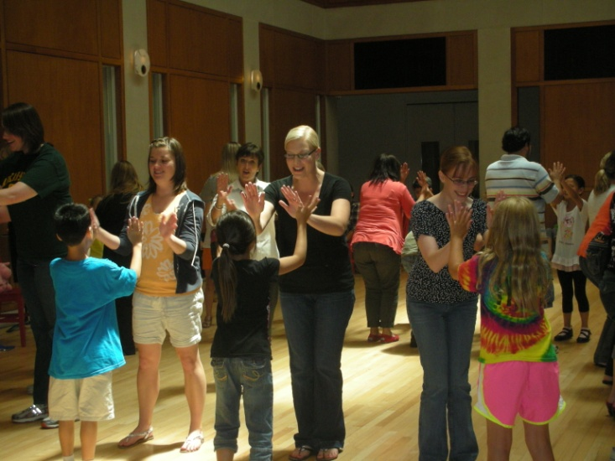
Twelve students concluded the final level of course work this summer. Three former students and one current student completed all requirements for the OAKE Endorsed Certificate: Jessica Bauchum, Kara Saldana, Theresa Turner and Karen Richard.
The training faculty were Kendall Allen, Gay Baker deMontel, Lászlo Durányik, Karen Gentry, Lenke Igo, Cecile Johnson, Brenda Keen and Kathy Kuddes and Kristin Moore served as program intern.
Plans are underway to continue the choral offerings and expand to a second level. Dates are July 5 to 20, 2012 - mark your calendars now! Join us on Facebook "Plano Kodály Training Program @ SMU"

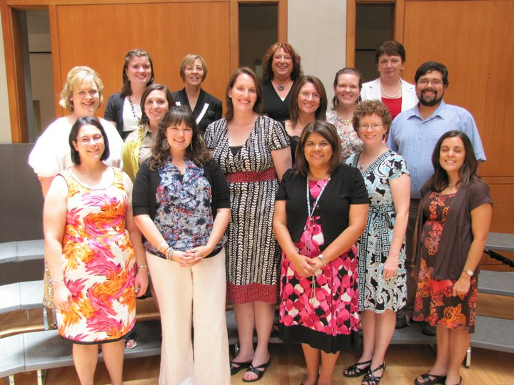
Level 3 & Instructors
Row 1: Karen Richard, Kelly Orr, Vicki Seigler, Lynette Vincent, Alana Brecheen
Row 2: Paige Nalley, Tiffany Bowen, Lisa Fisher, Kim Nithiananda, Sarah Riordan, Victor Lozada
Row 3: Janell Lippold, Cecile Johnson (instructor), Kathy Kuddes (instructor), Lenke Igo (instructor)

The Kodály Institute of Houston/Moores School of Music/UH – by David Dalton

The Institute had 18 students in four levels and 6 of the students will be receiving certificates of completion. The faculty includes Rhona Brink, Mary Neeley Stevens, Cecile Johnson, Hungarian, László Durányik, U of H professor of Music Ed, Dr. James Reifinger, and Program Director, Cara Spinks. Cecil and László are doing a “choral track” with the level III and IV students. The Institute has applied for OAKE endorsement.

Southeast Texas Kodály Certification Program/Aldine I.S.D. – by David Dalton
The OAKE endorsed Southeast Texas Kodály Certification Program/Aldine I.S.D. completed their summer training program in June. They had 20 students in three levels and had 2 graduate with their certification with OAKE endorsement. The teachers were Rhona Brink, Cecil Johnson and Mary Neeley Stevens.

Rich traditions and New creations

katherine johns, ket president-elect
Over the summer, I traveled to Hart, Connecticut the first week of July to participate in a workshop lead by Peter and Mary Alice Amidon. The description of the course described a “wealth of songs, dances, singing games, and folktales that spring from the Anglo American/African American oral traditions. We will sing and dance through a rich repertoire of old and new songs, dances and singing games that you can take back to the classroom, discuss how to make dance a successful, dynamic, ongoing experience for you and your students, and learn how to organize an evening of dancing for the school community as well as an all-school sing. The Amidons will share their discoveries of the power of connecting music and literature: telling stories, creating songs from poems, introducing songs with stories, creating a performance from a folktale, song writing, and bringing picture books alive with music. Each participant will write a song and tell a folktale.” I wasn’t sure how I felt about writing my own song, but everything else sounded wonderful.
It was like traveling to another world for a week where everyone loves to sing and dance. Every day began with singing. All the songs were from the folk tradition or had a folk-like quality. Mary Alice would play her accordion or Peter would play his guitar. Then we would get up and dance. As we danced, Peter would share insight in ways to teach tricky patterns. When the dance was completed, we returned to our seats to talk about the dance and the process of teaching the dance.
One of the surprises was that we were asked to teach something, anything. A song, game, folk dance, or anything we like to teach in our classroom. I was lucky to be with a wonderfully strong group of teachers who shared new activities that I didn’t know or a new way to teach a known activity. I learned a lot from my fellow participants.
At this point, I have a confession. I chose to teach a folk dance from the Amidon collection, “Heal and Toe Polka” which I used last year to practice quarter and two eighth patterns. After going over the practice pattern, I went into teaching the dance. Being very confident in myself since I had used the song last year, I didn’t look over it, and began to teach one of the patterns incorrectly. They didn’t say anything. They just looked at me with these encouraging smiles waiting to see what would happen next. I soon realized my mistake; hit the rewind button at my belly button making rewind sound. I laughed, collected myself, and continued to teach the dance the way I had taught it all school year. It turned out that it was incorrect according to the directions in their book. But they were so kind and said that some dance masters present the dance as I did.
Then there was creating a song. They showed us many examples of simple to complex songs written by themselves and others. We could come up with something original or take a poem to set. I decided to create a song on our next year’s school theme. I was blown away by the talent of our group. There was a beautiful setting of a child’s story as a lullaby, a trio of women’s voices, and a setting of the Obama book to his daughters to name a few. I don’t know if I will use my little song next year, but I felt I started a new process I might enjoy when I put my mind to it.
Another assignment was to learn a folk tale and retell it from memory. I chose a myth about coyotes dancing with the stars. I was lucky to find a tale that I could lead the participants into getting up and dancing like the coyotes. It was fun to lead.
I spent the whole week in the dorms with no car. I was so busy that I didn’t need a car. The campus is beautiful, but pretty vacant in the summer. The dorm price was great, but I wish I had packed my own bedding instead of renting from housing. I also purchased a pass for the sports complex, but I was so busy, I didn’t get to use it much and wish I had saved my money.
The whole week, which was squeezed into four days due to the fourth of July, was a magical week of music. I highly recommend this workshop to anyone and everyone who has an interest in folk dancing, storytelling, and singing.
Information about the workshop can be found at http://harttweb2.hartford.edu/summer-detail.php?c=13.
If you have any questions about the workshop that I didn’t cover or want more details, please contact me and I will be happy to answer any questions.
Katherine Johns kjohns@fisd.us

upcoming Workshop information
West Region
TMEA Regions 6, 16, & 22 present:
Sister Lorna Zemke in "Materials and Methodologies for Older Elementary Students"

DATE: August 13
WHERE: Odessa, Tx - Odessa Regional Medical Center, Community Room, 520 E. 6th Street
TIME: 12:15 p.m. - 6:30 p.m.
COST: $20, checks payable to TMEA Region 6
RSVP: by August 12 so that materials may be ready for you.
Region 6 Elem Chair Rhonda Gray at rsgray62@sbcglobal.net
Region 16 Elem Chair Ronda Haire at ronda.haire@abileneisd.org
Region 22 Elem Chair Mary Jane Maus at mjmaus@episd.org

Central Region
TMEA Region 8 presents:
Michael Chandler in “BEGINNING RECORDER THAT WORKS!”

DATE: Saturday, August 13, 2011 during the TMEA Region 8 Fall Meeting
WHERE: Belton High School; 600 Lake Rd., Belton, Tx 76513
TIME: 10:30 a.m. - 3:00 p.m.
COST: FREE for college students; $20 Early Bird TMEA members/$25 Early Bird for non-TMEA members; DAY OF WORKSHOP: $25 TMEA member; $30 non-TMEA member
$7.50 for Jason's Deli box lunch
DETAILS: Registration begins at 9:30 AM during Fall Regional Meeting Refreshment Time

CONTACT: For more info - Debra Johnson, 2208 E. Adams Ave, Temple, Tx 76501; epechal@sbcglobal.net

South Region
Two workshops will be offered by the Kodály Institute of Houston in September and January at U of H for the 2011-2012 school year. Dates, topics, and clinicians TBA. Registration information about both workshops can be found later on the Moores School of Music Preparatory and Continuing Studies website (pcs.uh.edu) or by calling the PCS office (713-743-3033).
The Aldine program will provide a workshop on October 29. Rhona Brink and Mary Neeley Stevens will present a workshop titled “A Treasure Chest of Transitions: Games and Activities to Keep your Lesson Moving.” For information about the workshop, please call Colleen Riddle (281 985-6105).

FInal thoughts
Lauren bain, Vice president
Hello! My name is Lauren Bain and I am the new Vice President of KET. I am honored to be a part of this organization and to work with music educators in our great state. Thank you for allowing me to serve!
A couple of new things have happened this summer with KET. As Brenda mentioned earlier, we are now on Facebook! If you have a Facebook account, search for “Kodály Educators of Texas” and click “Like”. We will be updating the site with news, lesson ideas, advocacy ideas, workshop details, and more. Stay connected with us!
Additionally, the website became my responsibility (Thank you Katherine Johns for creating it and updating it for many, many years! She is a hard worker!). The website has new look so check it out at ket.oake.org. Click on the “KET website” button in the middle of the page which will take you to the new website. Bookmark it and visit it frequently to stay informed.
It’s about time to head back to school! Did you get rest this summer? Do you feel renewed through family time, vacation time, or training? It is important to schedule time for yourself so you can recharge and give your best to the students we see every day for 9 months. It takes time and energy to be “on” all day, sing for hours, monitor behavior, maintain a positive attitude, and work with difficulties of the work load. Make it a priority to give yourself a little time each week - whether reading a good book, going to a concert, playing your instrument, calling an old friend, or watching a movie. You will be a better teacher and avoid burnout.
Good luck in the coming year. I know many of us are facing tighter schedules, more responsibilities, or perhaps facing a program cut. Each year has its own challenges so be prepared with solutions to the problems your administration will present; smile when you pass students and faculty in the hallway; remember to feed your inner musician; give the positive version when asked your opinion; and most of all, remember why you love teaching music!

Happy Back To School!
Lauren Bain

Additional Information
Have a great article or idea for an article? Email kodalyedoftx@gmail.com and we’ll see about adding it to our newsletter in the future.

