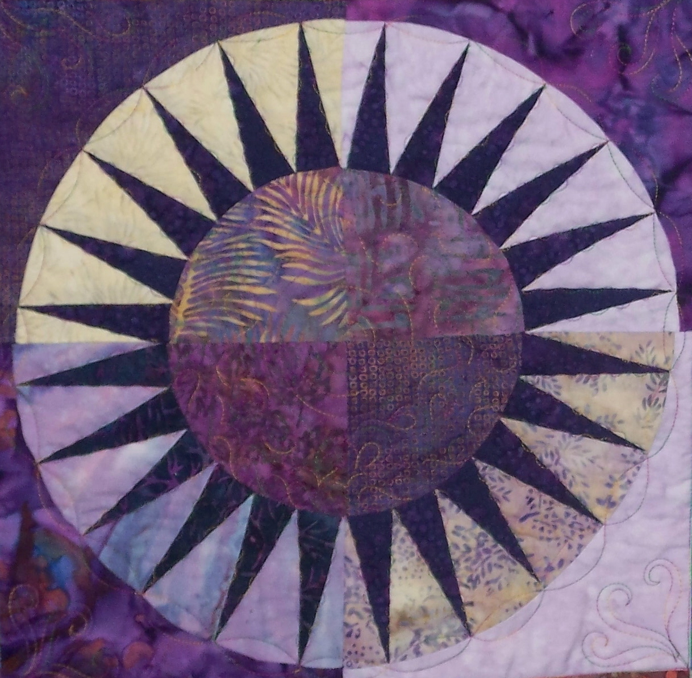

Quilting by the River

Customer Information DATE:________________
__________________________________
__________________________________ DATE NEEDED:________________
__________________________________
Phone: Cell or Home ________________________________________Email_______________________________________
TOP: Size _______________ X _______________
______________________________________________________________________________________
TOP THREAD: $5.00 an additional fee for each thread change
Solid OR Variegated
Color choice: ________________________ or have us call you to discuss
QUILTING TYPE:
$0.02 / sq inch $0.03 / sq inch
Edge to Edge Pantograph body of quilt
(Includes the borders) (borders separate design)
BACKING: Size _______________X_______________
Backing fabric should be 4" larger than the top ON EACH SIDE
BATTING: Need YES or NO
If NO, cut 4" larger than the quilt top ON EACH SIDE
If YES,
80/20 100% Cotton Silk Bamboo
$.30 /per
linear inch At current pricing At current pricing At current pricing
Additional services at a cost of $12.00 per hour; including, but not limited to:
Pressing backing fabric, if needed
Would you like your quilt trimmed? YES or NO
Would you like us to bind your quilt? Machine OR Hand
Minimum charge of $40.00. Deposit of $40 is required on all orders. CASH, Check or Credit Card accepted.
Shipping of your project to us is preferred, however; quilts may be dropped off BY APPOINTMENT ONLY. Remember to insure and receive a tracking number from your preferred shipping provider. Finished quilts can be picked up by APPOINTMENT or shipped back to you at our expense.

Accepted / Date Picked up/Received Date
_________________________________________________ _______________________________________________________

Machine Quilting Lectures Classes Workshops
Two Men and a Trunk Quilt Show
916 B Montevideo Drive Lansing MI 48917 517.614.2434

longarmquiltingbytheriver@gmail.com www.quiltingbytheriver.com

