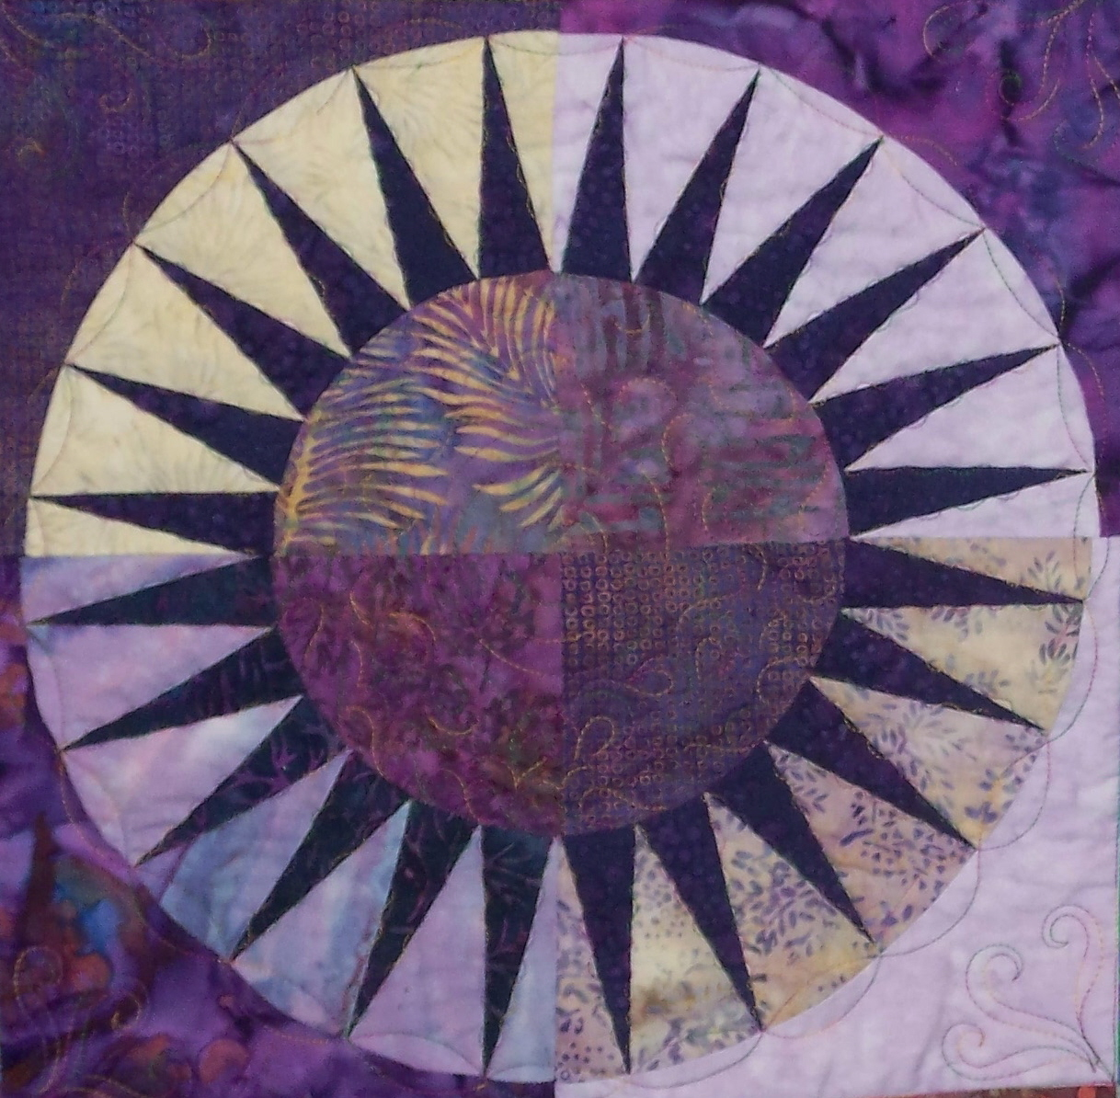

Quilting by the River

Supply list for BeColourful Patterns by
Jacqueline deJonge, The Netherlands

Needed:
A few flat head pins
A few glass head pins
6 ½” square ruler
Add a Quarter Ruler and Add Enough Ruler/Template (both optional)
Rotary cutter – 22 and/or 45 mm
Small cutting mat to use at your station
Marking Pen or white, gray or black colored pencil
Small travel iron and pressing mat to use at your station
Thread in medium grey or white….I prefer an all cotton thread
Sewing machine in good working order with an extra bobbin filled
A new needle in your machine….I like a 70
Small zip-lock bags to store your cut pieces
Chalk pencil or marking pen
Tape
Seam ripper
Glue stick
A pencil or pen and paper to take notes
A small pair of scissors.
And your other BASIC SEWING SUPPLIES

Lectures Workshops Quilt Designs Longarm Quilting
7507 River Ridge Road Stanwood MI 49346 517.614.2434
longarmquiltingbytheriver@gmail.com BeColourful Patterns www.quiltingbytheriver.com

