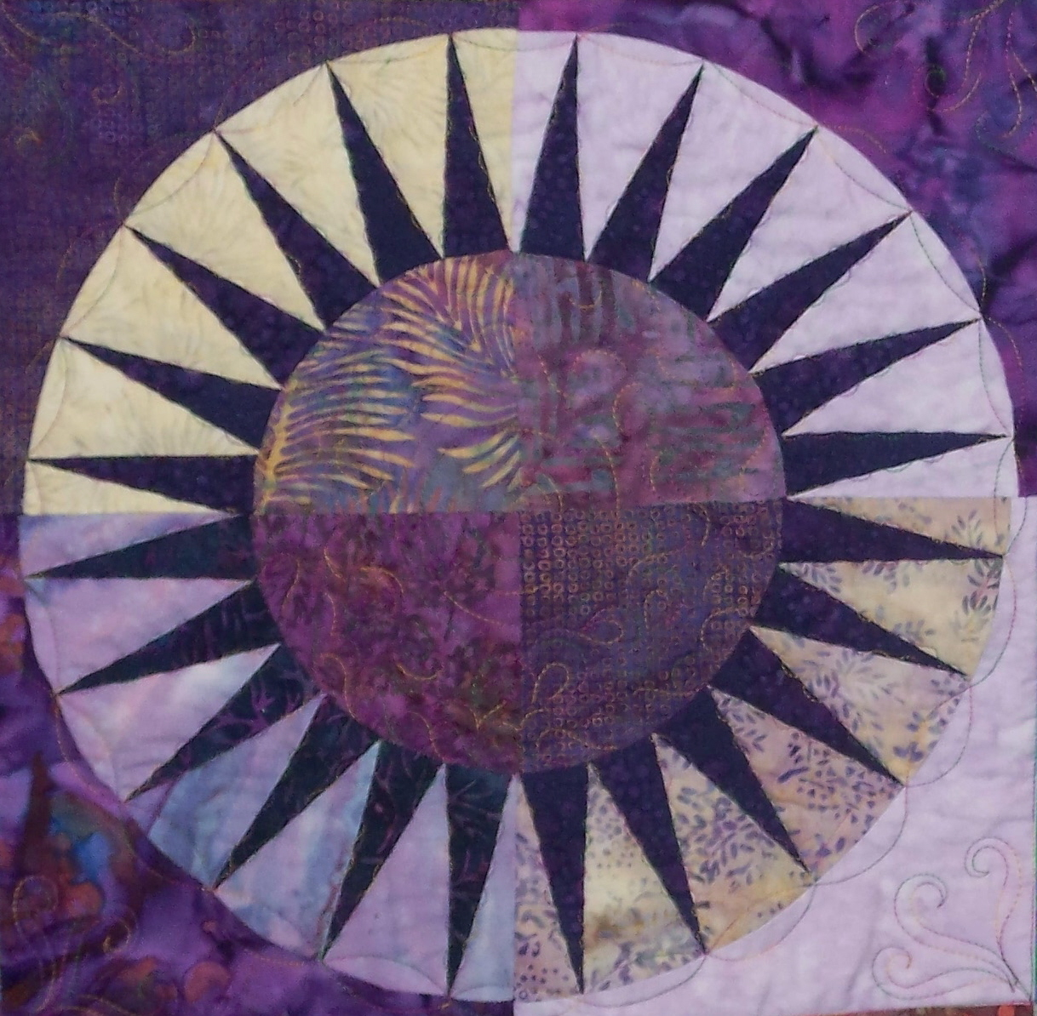

Quilting by the River

Customer Information DATE:________________
__________________________________
__________________________________ DATE NEEDED:________________
__________________________________
Phone: Cell or Home ________________________________________Email_______________________________________

TOP: Size _______________ X _______________
TOP THREAD: $5.00 additional fee for each thread change
Solid OR Variegated
Color choice: ________________________ or have us call you to discuss
BACKING: Size _______________X_______________
Backing fabric should be 4" larger than the top ON EACH SID

QUILTING TYPE:
$0.02 / sq inch Starting at $0.03 / sq inch
Edge to Edge Pantograph and Custom computerized quilting
(Includes the borders) (borders separate design)
BATTING: Need YES or NO
If NO, cut 4" larger than the quilt top ON EACH SIDE
If YES,
80/20 100% Cotton $.22 /per linear

Additional services at a cost of $12.00 per hour; including, but not limited to: Pressing backing fabric, if needed

Would you like your quilt trimmed? YES or NO

Would you like us to bind your quilt? Machine OR Hand @$.48 per inch

NOTES:

Machine Quilting Lectures Classes Workshops
Two Men and a Trunk Quilt Show
7507 River Ridge Rd, Stanwood, MI 49346
Dan 517.614.2434 - Brian 517.488.5887
longarmquiltingbytheriver@gmail.com www.quiltingbytheriver.com

