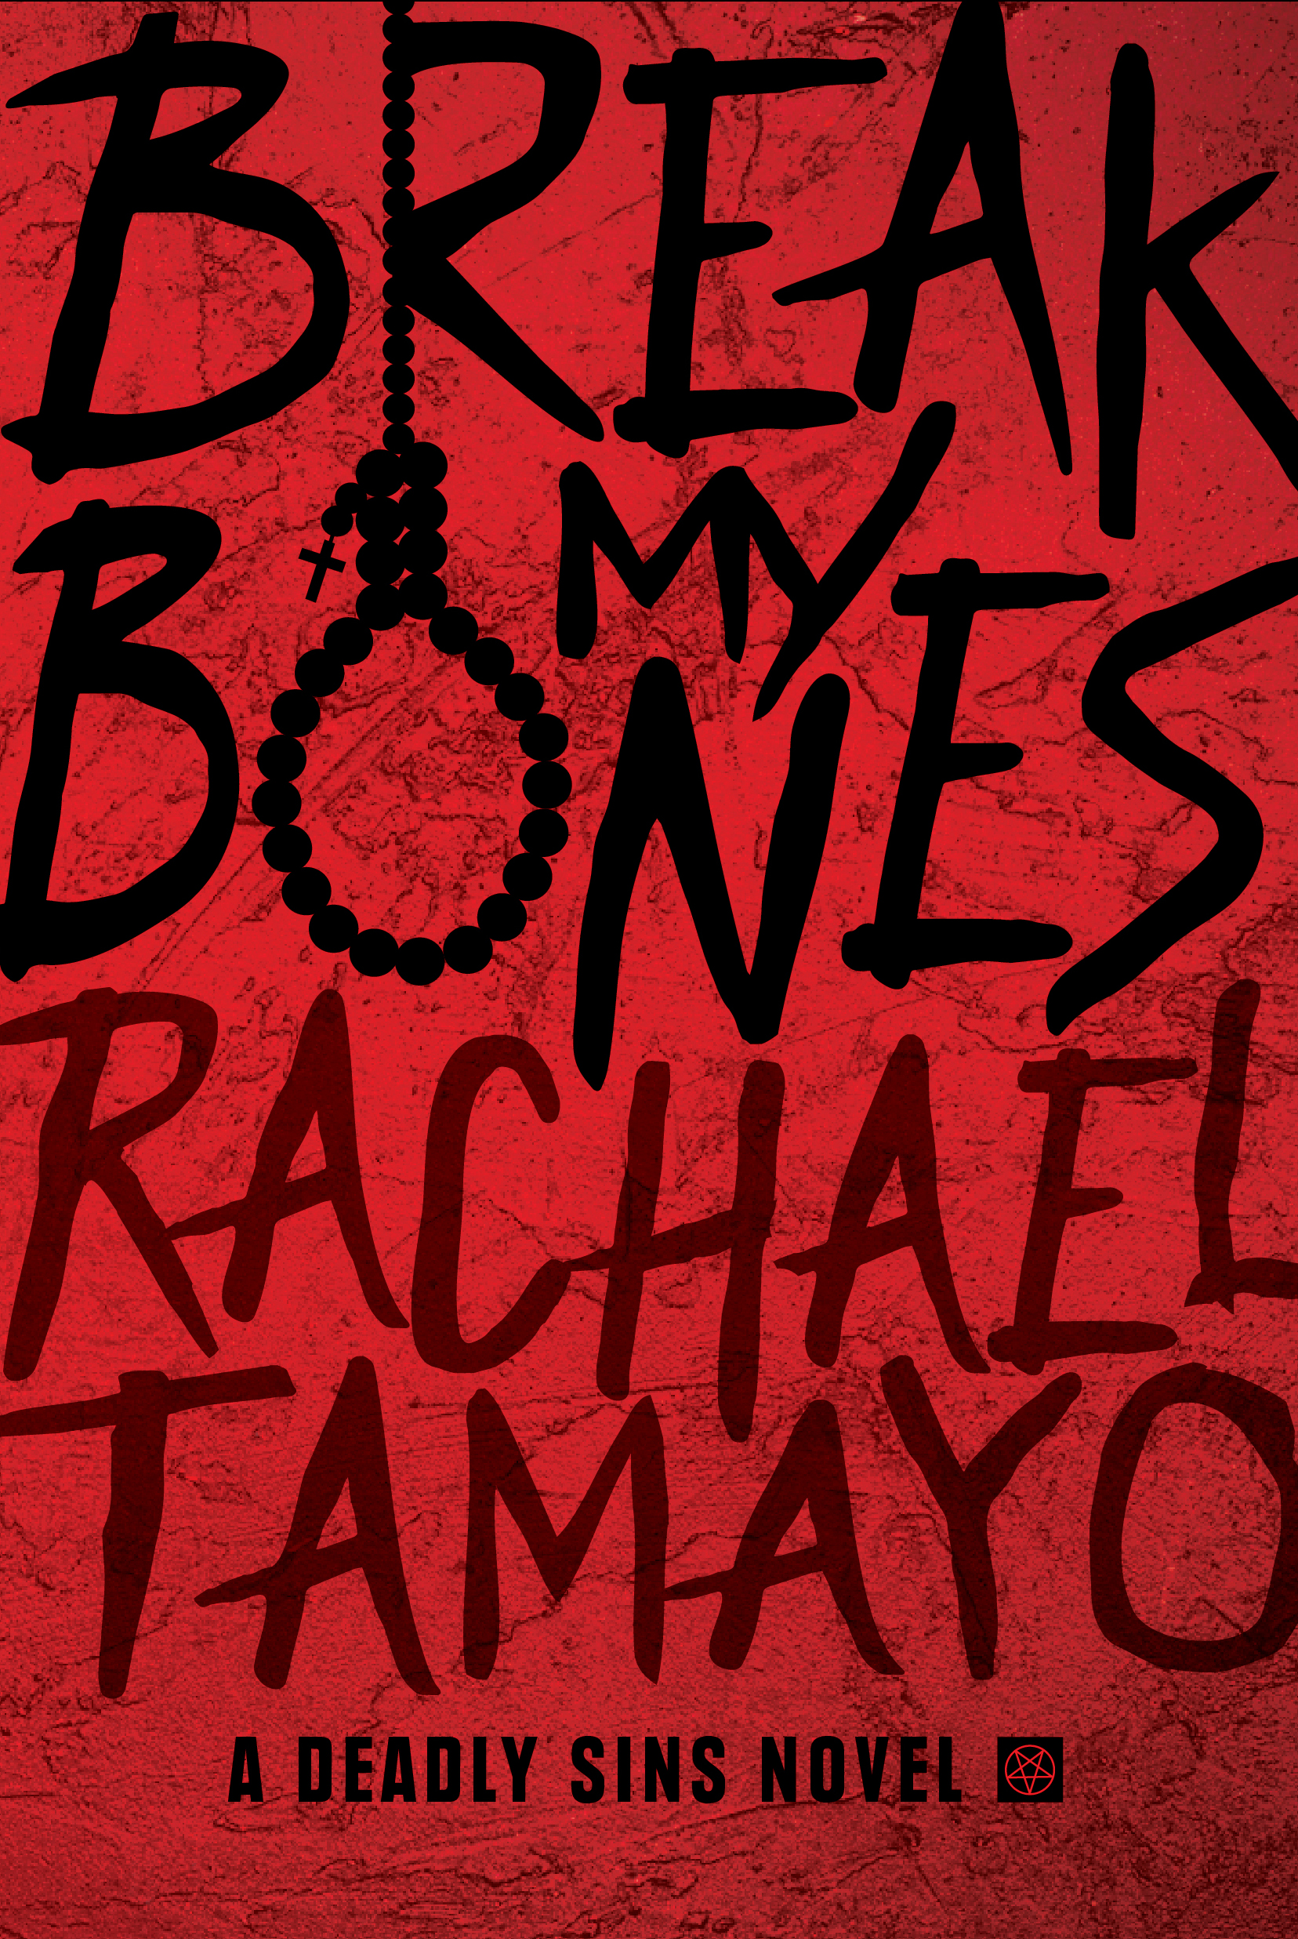
Press Kit

Title: Break My Bones
Author: Rachael Tamayo
Genre: Thriller
Subgenre: Domestic Thriller
Imprint: Tangled Tree Publishing
Format: e-book, paperback
Pages: 300
Paperback ISBN: 978-1-925853-51-3
E-book ISBN: 978-1-925853-52-0
Paperback Retail Price: $13.99
E-book Price: $3.99
Release Date: 19 October 2019
BIASC Codes: FIC030000, FIC031080, FIC031000, FIC031100

Return Address:
Ink-N-Flow Management Group
c/o T.M. Ward
210 Stagecoach Trail #252
San Marcos, TX 78666
Publicity contact information:
US: Tams M. Ward - hello@inknflowmanagementgroup.com
AU: Becky Johnson – contact@hottreepublishing.com

Book Tagline: When rage holds you together, love will tear you apart.
Hook: Sticks and stones do break bones, and words will surely hurt you.
Blurb:
Staring down the barrel of a loaded 9mm is a wake-up call, especially when it’s your husband’s finger on the trigger. Brooklyn James’s only thought is to take her baby and run. It's better to end up on the streets than suffer one more day beneath her husband's hand.
Finally back on her feet, Brooklyn is stronger, better prepared, and determined not to run. That is until she gets the call that her husband has been released from prison after serving his three years for DWI.
Cain James has his wife on his mind, always. With his friend Donovan at his side, anything is possible. He can find her, bring her home, make her love him again. While Cain has serious anger issues, Donovan is much worse. Cain can’t control his friend's sick, twisted mind and even sicker actions.
Donovan has Cain's best interest at heart, and he'll do whatever it takes to help Cain bring his wife home—including murder. After his time in prison, Cain doesn’t want to hurt his wife again and becomes a man torn—divided between the darkness inside him, his twisted love, and his lifelong protector, Donovan.
As Cain tries to convince his wife that he’s changed, he watches the bodies hit the floor one by one at the hands of his sidekick. Enraged by his estranged wife’s new love and conflicted by his own anger and need to protect his family, Cain unravels.
He can’t live without her, and he won’t let her live without him.

Break My Bones is a domestic thriller by Rachael Tamayo. It will be released on October 19th, 2019 by Tangled Tree Publishing, an imprint of Hot Tree Publishing.

Told from the alternating first-person views, Break My Bones is a dark domestic thriller with an epic twist. It's a tale of being broken and recovering because you must; it's a story of love that rips a man apart from the inside out; and a novel of a man who struggles against the rage that seems to hold him together, and the obsessive love that threatens to tear him apart. Readers are left with the one question: How many people will die so that one man might win his love back?

Author of the award-winning thriller, Crazy Love, Rachael Tamayo is a former 911 operator and police dispatcher who has firsthand experience with these true-to-life issues.

Early Praise:
“A chilling tale of domestic abuse.” – Bruce Perrin, Author
“Written in the same vein as B.A. Paris's ‘Behind Closed Doors’ this story will keep you riveted.” – Award-winning author, Andrea Roche
"A domestic thriller that really pulls you in. The further we get into the story, the crazier it becomes." - NetGalley Review
"Realistic, unique storyline." - NetGalley Review
"Great, interesting thriller." - NetGalley Review

