

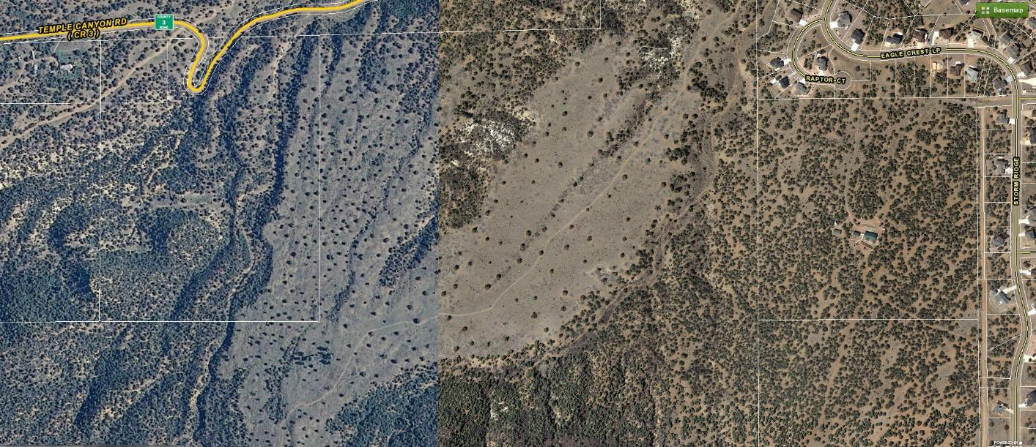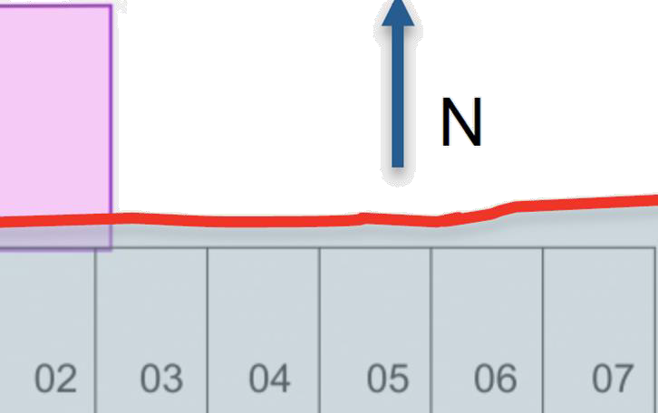

Hiking and biking trails covered by claims in this area

944 feet from Residential property

Adjacent to Residential property

1958 feet from Raptor Court

642 feet from home

Location of Zephyr claims relative to Dawson Ranch

Yellow dots represent the two homes most impacted by Zephyr.

Homes on the west end of Dawson Ranch are less than 2000 feet from the newest claims.