**CURRICULUM VITAE**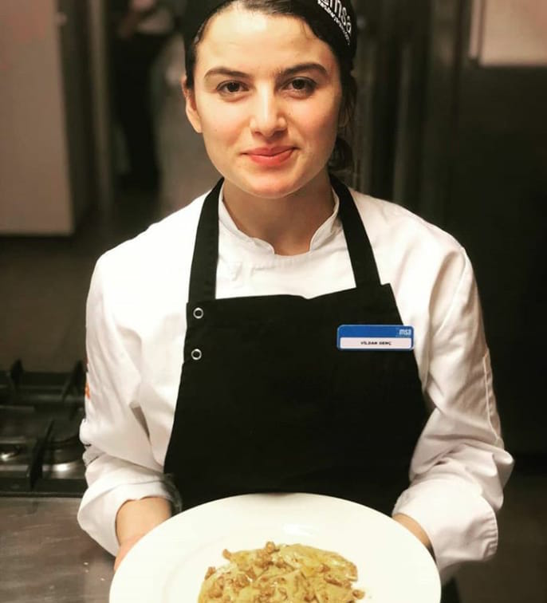

**VİLDAN GENÇ**

Konarlı Mah. Uğur Mumcu Cad. Elif Sitesi, No:64, Block 3 Apartment 3

Iskenderun, Hatay, Turkey, 31000

Email: vildangenc@outlook.com

Mobile: (+90) 541 557 72 23

# **PERSONAL PROFILE**

# Dedicated to teamwork and open to learning. Respects the culinary rules and regulations. Communicative, enthusiastic, self-confident, patient and open minded. Able to receive criticism and considers it as an advantage of self-improvement. Eager to prepare, serve and taste cultural and international dishes. Makes inferences according to the behaviors of the customers during the meal and takes care to prepare it meticulously. Able to work standing for long hours and professionally handles with pressure.

# 

# **EDUCATION**

**Dec 2012 - Present Anadolu University Paralegal Studies (Open Education)**

Anadolu University Open Education Faculty Yunus Emre Campus Tepebaşı, Eskişehir, Turkey

**Sep 2007 - Jun 2011 High School**

Bafra Anatolian Hotel Management and Tourism Vocational High School, Bafra, Samsun, Turkey

# **WORK EXPERIENCE**

**2019 - 2021**

*Still also working W Doha IRD Kıtchen commi,(Station can vary*

*Depending on density and demand)*

**Feb 2019 - Jun 2019 Demi-chef**

*Gia Coffee and Lounge, Hatay, Turkey*

Compulsory chef training based on The Culinary Arts Academy (MSA)

**Jan 2015 - Dec 2018 Order Taker (In Room Dining)**

*Cratos Premium Hotel, Çatalköy, Girne, KKTC*

Taking orders from customers, open and close checks and regular office work related to food and beverage products.

**Dec 2014 - Jan 2015 Guest Welcoming**

*Kaya Artemis Resort Hotel & Casino, Gazimağusa, KKTC*

Greeting the guests, helping them to find their seats, controlling reservations.

**Jun 2014 - Dec 2014 Bar Waitress**

*Nuhun Gemisi Deluxe Hotel & Spa, Gazimağusa, KKTC*

Greeting the customers, taking food and beverage orders and serving, open/ close checks, organizing inside/outside the bar.

# **Apr 2012 - Jun 2014 Bar Waitress**

# *Sheraton Hotel, Çeşme, İzmir, Turkey*

Greeting the customers, taking food and beverage orders and serving, open/ close checks, organizing inside/outside the bar.

**Mar 2011 - Oct 2011 Waitress (Alacarte)**

# *Majesty Hotels & Resort, Antalya, Turkey*

# Familiar with Mexican and Italian kitchen, greeting the customers, serving food and beverage, open/close checks.

# **Apr 2010 - Nov 2010 Bar Waitress**

# *Mövempick Hotel, Bodrum, Muğla, Turkey*

Greeting the customers, taking food and beverage orders and serving, open/ close checks, organizing inside/outside the bar.

# 

# **May 2009 - Nov 2010 Waitress**

# *Hanedan Sofrası, Samsun, Turkey*

# Greeting the customers, taking food and beverage orders and serving, open/close checks.

# **LANGUAGE SKILLS**

English : Good writing and reading skills

Good speaking skills

# Turkish : Native Language

**CERTIFICATES**

* Professional Chef Training Certificate, *The Culinary Arts Academy (MSA)*, 2019
* Computer Operating Certificate
* Certificate of Opening a Business, *Bafra Anatolian Hotel Management and Tourism Vocational High School*

# **HOBBIES AND INTERESTS**

# Documentaries related to culinary, kitchen art and photography, exploring new historical places, and adventurism.

# **REFERENCES**

# **HEAD SOMMELİER:ONUR BAŞKURT**