2025 DCCA Presents Dade City’s Gingerbread World | SPONSORSHIP OPPORTUNITIES

**Gumdrop Partnership $100.00**

*This is our first tier sponsorship level and it's full of benefits for your business or organization! Here's what you receive from our $100.00 Gumdrop Sponsorship Level:*

* **Business Logo and link to website on the Gingerbread Section of DCCA site**
* **Business Logo on display at the Gingerbread Exhibit and in front of your creation if you create an entry**
* **Business Logo and recognition on all Gingerbread postings on DCCA Facebook**

*Our reach on some of our more 'shareable' events is in the 10's of thousands. That's a lot of people with your business in their Facebook feed.*

* **Construct and build a gingerbread version of your business on a 12" x 12" base (if you so choose)**

*How exciting will it be to have your business, represented in Gingerbread with your logo right beside it, in front of hundreds of people that will be walking through the exhibit over the three nights of Church Street Christmas!*

**Peppermint Partnership $200.00**

*This tier of sponsorship contains all the stuff from the Gumdrop level, but a few great differences. Here's what you'll receive from our $200.00 Peppermint Sponsorship Level:*

* **Business Logo and link to website on the Gingerbread Section of DCCA site**
* **Business Logo on display at the Gingerbread Exhibit and in front of your creation if you create an entry**
* **Business Logo and recognition on all Gingerbread postings on DCCA Facebook**

*Our reach on some of our more 'shareable' events is in the 10's of thousands. That's a lot of people with your business in their Facebook feed.*

* **Construct and build a gingerbread version of your business on an 18" x 18" base (if you so choose)**

*Ooh, some extra room! Go big or go home, right?? How exciting will it be to have your business, represented in Gingerbread with your logo right beside it, in front of hundreds of people that will be walking through the exhibit over the three nights of Church Street Christmas!*

* **A SPECIAL thank you gift will be given as a thank you for sponsoring!**

**Royal Icing Partnership $300.00 (or more...)**

*If you're part of this sponsorship level, and want to create something, you really don't have any size restrictions on a base! AND you'll receive all these benefits too:*

* **Business Logo and link to website on the Gingerbread Section of DCCA site**
* **Business Logo on display at the Gingerbread Exhibit and in front of your creation if you create an entry**
* **Business Logo and recognition on all Gingerbread postings on DCCA Facebook**

*Our reach on some of our more 'shareable' events is in the 10's of thousands. That's a lot of people with your business in their Facebook feed.*

* **Construct a gingerbread creation on ANY SIZE base!**

*To build, or not to build, that is the question! If you want to sponsor and participate, but not build anything, here's the level of sponsorship where that's an option. BUT should you want to build, you have NO RESTRICTIONS on a base. Want to build some ginormous structure? Have at it!*

* **A SPECIAL thank you gift will be given as a thank you for sponsoring!**
* **BANNER SPONSORSHIP LEVEL**

*In addition to all the digital places you'd be advertised, your business logo will be featured on the banner* to be placed on Church Ave, in front of the First United Methodist Church leading up to the event and during all three nights, in front of 1000's of Church Street Christmas attenders.*

**\*Deadlines apply for the Banner Sponsorship participation, so let's talk soon!**

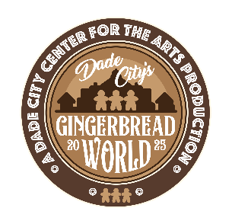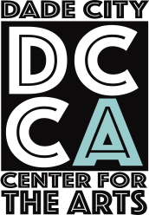

**SCAN THE QR CODE TO FILL OUT THE FORM!**